Translating Korban: Etymology and Exegesis

Reason and Rationalism

Rambam vs. Ramban - Lechatechila or Bedieved?
Ramban, Vayikra 1:9
But the Rambam said in the Guide for the Perplexed (3:46) that the reason for the sacrifices was for the sake of the Egyptians and Chaldeans, in whose lands Israel used to live and dwell, who would worship the bull and the sheep. Because the Egyptians worshipped a lamb, and the Chaldeans worshipped demons that appeared to them as goats. And the people of India to this day never slaughter a cow. For this reason (God) commanded to slaughter these three species in God's name to make known that the matter which (the pagans) thought of as the ultimate sin is what (the Israelites) will sacrifice to their Creator and their sins will be atoned for. For thus are bad beliefs healed, which are ailments of the soul, since every ailment and illness is healed through its opposite. [Ramban:] These are his words and he continues at length. This is rubbish! They have healed a great hurt and a great difficulty lightly! The table of the Eternal is made polluted. (Malachi 1:12) For they are not only to remove [false beliefs] from the hearts of the wicked and fools of the world. Doesn't Scripture say that they are "food of the gift offering, for a pleasing odor?" (Leviticus 3:16) And also due to the idiocy of the Egyptians their illness won't be healed this way. Rather it would increase suffering, because the intention of the aforementioned wicked ones was to worship the constellations of the sheep and the ox, which have power, according to their thinking. And therefore they don't eat them in deference to their power and strength. But if they are slaughtered for the Revered Name, this would be an honor for them…

Guide to the Perplexed, 3:46
Scripture tells us…that the Egyptians worshipped Aries, and therefore abstained from killing sheep…Some sects among the Sabeans worshipped demons, and imagined that these assumed the form of goats, and called them therefore "goats" [se‘irim]… For this reason those sects abstained from eating goats' flesh. Most idolaters objected to killing cattle, holding this species of animals in great estimation...Thus the very act which is considered by the heathen as the greatest crime, is the means of approaching God, and obtaining His pardon for our sins. In this manner, evil principles, the diseases of the human soul, are cured by other principles which are diametrically opposite.
This is also the reason why we were commanded to kill a lamb on Passover, and to sprinkle the blood thereof outside on the gates. We had to free ourselves of evil doctrines and to proclaim the opposite, that the very act which was then considered as being the cause of death would be the cause of deliverance from death.

Guide, 3:32
It is impossible to go suddenly from one extreme to the other: it is therefore according to the nature of man impossible for him suddenly to discontinue everything to which he has been accustomed…the custom which was in those days general among all men, and the general mode of worship in which the Israelites were brought up, consisted in sacrificing animals in those temples which contained certain images, to bow down to those images, and to burn incense before them…It was in accordance with the wisdom and plan of God, as displayed in the whole Creation, that He did not command us to give up and to discontinue all these manners of service; for to obey such a commandment would have been contrary to the nature of man…it would in those days have made the same impression as a prophet would make at present if he called us to the service of God and told us, that we should not pray to Him, not fast, not seek His help in time of trouble; that we should serve Him in thought, and not by any action.
As the sacrificial service is not the primary object, whilst supplications, prayers, and similar kinds of worship are nearer to the primary object, and indispensable for obtaining it, a great difference was made in the Law between these two kinds of service…We were not commanded to sacrifice in every place, and in every time, or to build a temple in every place…But prayer and supplication can be offered everywhere and by every person.

Ramban, Vayikra 1:9
The reason some say for the korbanot is that since the actions of man are actualized via their thoughts, words, and deeds, God commanded that when someone sins and brings a korban, he should rest his hands on it – for his deeds, confess with his mouth – for his words, and burn the kidneys in fire – for they are the tools of thought and temptation. Furthermore, the limbs of the animal are parallel to the limbs of man, and the throwing of the blood is parallel to the blood of the man – and this is to make the person realize that he has sinned against God, and he is worthy of having his blood spilled and his body burnt, but God, in His mercy, accepts the substitute animal, whose blood is in place of the person’s blood…

Rav Soloveitchik - The idea and ideal of “sacrifice”
R. Soloveitchik, On Repentance, p. 266-268
The Torah forbade all human sacrifice. The example it uses to describe the abomination of idol-worship is 'for even their sons and daughters they consume with fire on behalf of their gods' (Deut. 12:31). Yet, although the Torah forbade human offerings, it did not invalidate the IDEA behind it that man sacrifice his own self - 'that it is proper that (man) spill his blood and burn his flesh' (cf. Nachmanides, Leviticus 1:9) - rather than just bring a bull or two pigeons ... God does not seek offerings from man, he seeks man himself…
When the blood of the animal is sprinkled, he must imagine that it is his own blood that is being sprinkled - that his own hot blood which in his passion drew him to sin, is being sprinkled upon the altar of his sin; that the fats which are consumed on the altar are not the animal's, but his own fats, which congealed in his heart and gave him over to the hands of sin. Only by virtue of God's august mercy is man redeemed from having to sacrifice himself, for it is God who arranged for a ram to take the place of Isaac. It is for this reason that it is always the Ineffable name of God (the Tetragrammaton - indicating God's attribute of mercy and forgiveness) that appears in the context of sacrifices - for the quality of divine mercy is revealed in the sacrificial rites.

R. Soloveitchik, Abraham’s Journey pgs. 10-12
One of the many events in Abraham's life that are of central significance because of their paradigmatic role in our historical drama is the Akedah, the binding of Isaac. According to Nahmanidean historical semantics, the Akedah foreshadowed Jewish martyrdom down through the ages. The Akedah was the portent of the many sad and tragic situations in which Jews were summoned to bring the supreme sacrifice, their very existence. But the portent was subject to multiple interpretations, and Jews enjoyed the freedom to interpret the strange scene of the Akedah in a variety of ways.
The basic idea of the Akedah is nurtured by the service awareness. Man is a servant of God. He belongs completely to God--body and soul... Hence, God from time to time calls upon man to return to Him whatever is His. He demands that man give not a part but the whole of himself…
Of course, the idea of sacrifice is a cornerstone of Judaism and the Akedah has inevitably introduced sacrificial action as a part of our historical drama. Yet, as we have said, the drama of the Akedah is multi-semantic, lending itself to many interpretations. God demands that man bring the supreme sacrifice, but the fashion in which the challenge is met is for man to determine.
There are two ways in which the total sacrifice is implemented--the physical and the experiential. The choice of the method is up to man. The need for sacrifice was established as an iron law in Jewish history. However, whether man should sacrifice on a physical altar atop some mountain the way God summoned Abraham to do or in the recesses of his personality is man's privilege to determine. Whether the sacrifice consists in physical agony, pain, and extinction of life or in spiritual surrender, humility, and resignation is man's affair. God wills man to choose the altar and the sacrifice.
Abraham implemented the sacrifice of Isaac not on Mount Moriah but in the depths of his heart. He gave up Isaac the very instant God addresses Himself to him and asked him to return his most precious possession to its legitimate master and owner…
There was no need for physical sacrifice, since experientially Abraham had fulfilled the command before he reached Mount Moriah... Had Abraham engaged the Creator in a debate, had he not immediately surrendered Isaac, had he not experienced the Akedah in its full awesomeness and frightening helplessness, God would not have sent the angel to stop Abraham from implementing the command. Abraham would have lost Isaac physically.

R. Hirsch’s Symbology
R. Samson Raphael Hirsch, Vayikra 1:2
It is most regrettable that we have no word which really reproduces the idea which lies in the expression 'korban.' The unfortunate use of the term 'sacrifice' implies the giving of something up that is of value to oneself for the benefit of another, or of having to do without something of value, ideas which are not only absent from the nature and idea of a korban but are diametrically opposed to it. Also, the underlying idea of “offering” makes it by no means an adequate expression for korban. The idea of an offering presupposes a wish, a desire, a requirement for what is brought, on the part of the one to whom it is brought, which is satisfied by the “offering.” …KAREV means to approach, to come near, and so to get into a close relationship with somebody. This at once most positively gives the idea of the object and purpose of the process of KORBAN as the attainment of a higher sphere of life. It thus rejects both the idea of a sacrifice, of giving something up, of losing something, as well as of its being a requirement of the One to Whom one gets near, and shows the מקריב as the one who has to find what he requires in the korban…This is one of the points in which Judaism and Paganism go in diametrically opposite directions. The Pagan brings his offering in an attempt to make the god subservient to his wishes. The Jew, with his offering, wishes to place himself in the service of God; by his offering he wishes himself subservient to the wishes of God.

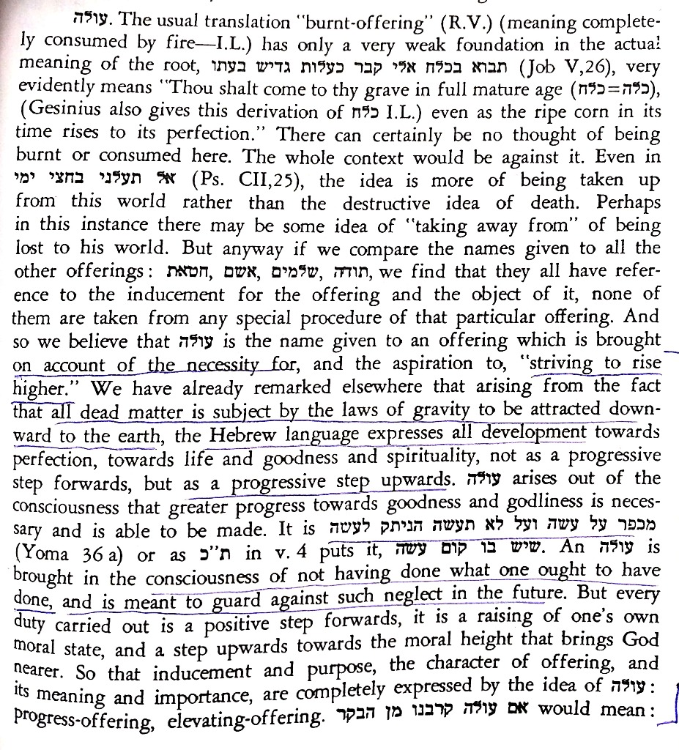 | 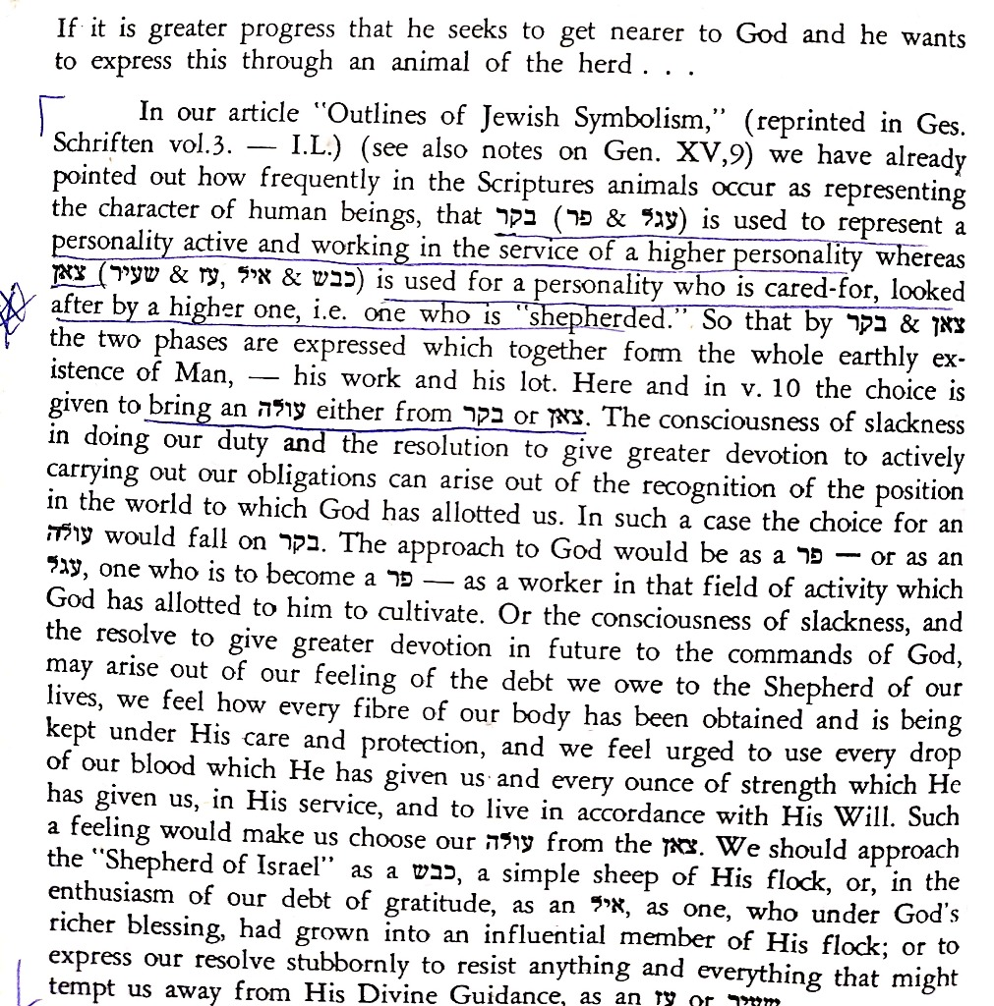

The Kabbalistic Approach
זוהר (ויקרא) פרשת ויקרא דף ד עמוד ב  רבי חזקיה הוה שכיח קמיה דר' שמעון אמר ליה האי דאקרי קרבן קירוב מבעי ליה או קריבות - מאי קרבן? א"ל הא ידיע הוא לגבי חברייא קרבן מאינון כתרין קדישין, דמתקרבי כלהו כחדא ומתקשרן דא בדא עד דאתעבידו כלהו חד ביחודא שלים לאתקנא שמא קדישא, כדקא חזי ההוא דכתיב קרבן ליי' קרבן דאינון כתרין קדישין ליי' הוא לאתתקנא שמא קדישא וליחדא ליה כדקא יאות בגין דישתכחו רחמין בכלהו עלמין, ושמא קדישא יתעטר בעטרוי לאתבסמא כלא... | טללי חיים, ויקרא  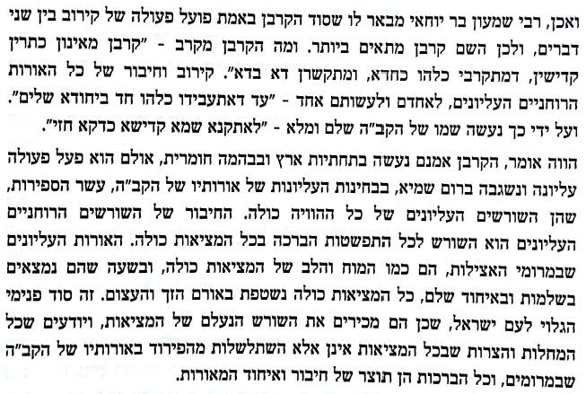

Modern Approaches
R. Shmuel Goldin,
https://www.ou.org/torah/parsha/rabbi-goldin-on-parsha/confronting_korbanot/
[T]he very first obligatory korban recorded in the Torah, the Korban Pesach of the Exodus, was, in its entirety, a family meal. No altar was present, no Temple service involved. The Israelites were, instead, commanded, on the eve of the Exodus, to physically consume the Paschal Lamb within the sanctity of their homes and to burn the remainder in the morning.
What then, defines the Paschal Lamb as a “korban”? How does this puzzling, seminal ritual set the stage for the entire sacrificial rite to follow? Why were portions of so many of the later korbanot designated as food? Shouldn’t each korban have been a true offering to God, consumed entirely in flames upon the altar?
We are forced, it would seem, to reexamine our understanding of korbanot. In contrast to classical “sacrifices,” consumed entirely on the altar, korbanot were, in large measure, shared meals with God. Faced with the naturally developing distance between man and his Creator, forced to address the separation from God that results from sin, the Torah proposes a path, astoundingly profound in its simplicity: invite God to your table.
A korban, deriving from the root word karov, “to draw near”, is the mechanism through which an individual can begin to repair and reestablish his relationship with a personal God. Just as, in the human realm, a shared meal is a powerful relational tool, so too, a meal consumed with God’s symbolic participation can begin to address His estrangement from our lives.

Amitah shel Torah, R. Yitzchak Twersky
Put in its crudest form,, the essence of korbanot is the act of “giving” food of ours to Hashem. This is, of course, a seemingly ridiculous idea...The act of “giving food to God” is the precise antithesis of the act of Adam and Chavah. Whereas Chavah took food that God withheld from man, a korban centers around giving “our” food to God. This is the symbolic dimension of the action; the act itself is a poetical reversal of the sin of the eitz hadaat.
The meaning of the symbol is that by bringing a korban we are doing the opposite of what Adam and Chavah did, in terms of substance as well as form. The substance of this is that the korban is essentially pure fulfillment of God’s will , just as the sin of the eitz hadaat was rebellion against it. The Torah specifices no inherent evil quality to the eitz hadaat; eating from it is wrong precisely because God prohibited it. The issue of the eitz hadaat is obedience to God’s will.
…”Bring a re’ach nichoach to Hashem” - satisfaction for Me that I commanded and my will was fulfilled (Sifrei, Bemidbar 107).

The Future
R. Shmuly Yanklowitz,
https://blogs.timesofisrael.com/please-g-d-i-dont-want-a-3rd-temple-a-radical-prayer-from-a-humble-servant/
Your holy servant Maimonides, considered the greatest Jewish philosopher in Jewish history, taught that animal sacrifices were only commanded to the Jewish people as a concession because it was the only type of Divine worship known in that era; it was progress from the pagan standard of human sacrifice. He also taught that prayer was evolution from animal sacrifice and a more silent meditative type of worship will eventually supersede prayer with words. Further, Rav Kook, the first Ashkenazi Chief Rabbi of pre-state Israel, taught us that in the Messianic era, we would all be vegetarians and only bring offerings of flour. To be sure, these great thinkers were complex with seemingly contradictory perspectives (some of which shine brighter than others). While livestock was once our primary resource and a meaningful sacrifice, today Your world operates in a different model of commerce. We would have new and more powerful contributions to sacrifice. Your people must be a light to the nations, not a source of darkness by returning to a practice once deemed honorable but now perceived by the global masses as barbaric. The Jewish people have transitioned in our own existential consciousness and our spiritual relationship to our animal’s slaughter has been altered irrevocably.

Rambam
Rambam, Hilchot Melachim 11:2
In the future, the Messianic king will arise and renew the Davidic dynasty, restoring it to its initial sovereignty. He will build the Temple and gather the dispersed of Israel. Then, in his days, the observance of all the statutes will return to their previous state. We will offer sacrifices, observe the Sabbatical and Jubilee years according to all their particulars as described by the Torah.

Rambam, Hilchot Meilah 8:8
Behold, the Torah says “And you shall guard all of my laws (hukkotai) and keep all of my rules (mishpatai) and you shall do them” (Vayikra 19:37). [The meaning of] “And you shall do them” is known—it means observing the hukkim. The guarding means that you shall not think [the hukkim] less than the mishpatim. The mishpatim are those laws whose reason and benefit of their observance is known, such as the prohibition of theft, murder and honoring one’s father and mother. The hukkim are those commandments whose reasons are not known. The Sages teach that hukkim are those laws [about which HaShem says] “I set for you and you have no permission to be skeptical of them,” even though a man may have some doubts in his heart about them, and the nations of the world attack them [in attempt to undermine their legitimacy]. . . All of the korbanot are hukkim, and consequently the sages have said that it is even on the service of the korbanot that the world depends…
Rambam, Temura 4:13
Despite the fact that all of the mitsvot are decrees of the King… it is [nonetheless] appropriate to ponder them, and, to the extent that you are able, attempt to prescribe some reason for them.”

מכתב מאליהו, חלק ד, דף 174
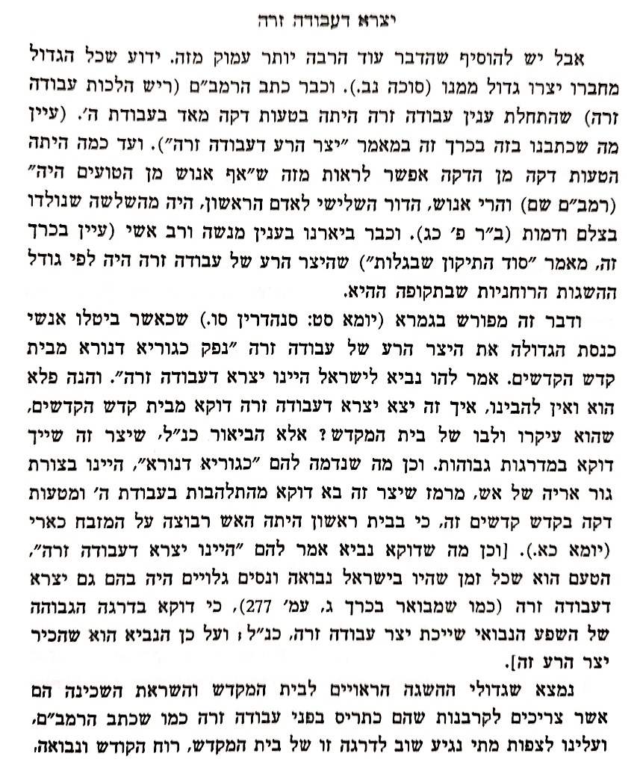

Rav Kook
Olat Re’iyah, vol. 1, p. 292
“v’arvah laHashem minchat Yehuda v’Yerushalayim kimei olam uch’shanim kadmoniyot—then shall the offering of Judah and Jerusalem be pleasant to the Lord as in the days of old and as in the ancient years” (Malachi 3:4; first line of the haftarah for Shabbat HaGadol) - In the future, the abundance of knowledge will spread to and penetrate even animals . . . and the sacrifices, which will then be from grain, will be as pleasing to God as in days of old in yesteryear [when there were animal sacrifices] . . .

Iggerot HaReiyah, vol. 4 [Jerusalem, 1984], 23-5, letter 994
And regarding sacrifices, it is more correct to believe that everything will return to its place, and God willing, be fulfilled when the redemption comes, and prophecy and the Divine spirit return to Israel

שו"ת משפט כהן (ענייני ארץ ישראל) סימן צד
וע"ד שאלתו אם מותר לנו לבנות בית המקדש ע"מ שלא להקריב קרבנות. לא ידעתי הציור, שאם מטעם טומאה הרי הותרה בצבור, כמש"כ בזה כבר בכפתור ופרח (פ"ו) ע"פ הרי"ח מפריש, וא"כ יהי' מותר להקריב ג"כ תמידין ומוספין וכל קרבנות ציבור. ובאמת אם נגיע למדה זו לבנות ביהמ"ק, הלא נוכל ג"כ לעשות פרה, כשנמצא פרה אדומה כשרה ונטהר מטו"מ ג"כ, ואז נקריב כל הקרבנות כולם. ואף על פי שאין לנו כהנים מיוחסים, אין זו כ"כ קפידא, דמה"ת סמכינן אחזקה, ולא אמרו מעלת יוחסין אלא בזמן שהיו להן יוחסין, ואלה שבקשו כתבם המתיחש הוי להו ריעותא כשלא נמצא בזמן קצר כזה, אבל באורך הזמן, שאין אבידת היוחסין ריעותא, י"ל דאין מעכב כלל ענין כתב היחש. גם אולי ישנם ג"כ יחידים מכהנים שי"ל כתבי יחס מסורים מדורות עתיקים. בכל אופן לע"ד אם יהי' רצון ד' שנבנה ביהמ"ק, גם קודם שיבא משיח ותתגלה הנבואה ויראו הנפלאות, לא יהי' כ"כ עכוב בדבר. אמנם המצוה היא לבנות הבית כדי להקריב שם, ולחוג הרגלים, שעיקרם הוא ג"כ קרבן ראי' וחגיגה. אבל לומר שאם אין מקריבים עוברים על לא תעשון אתי בית תבנית בית, לא מסתבר כלל, רק שעשה מצוה ולא גמרה אם עשה ביהמ"ק ולא הקריב כשיש בידו להקריב. ואם אין בידינו להקריב כלל ודאי י"ל שאין כאן מצוה, שזוהי צורת המצוה כלשון הרמב"ם בריש הל' ביה"ב ובסהמ"צ, אבל אם מקריבין אפי' קרבן אחד באיזה זמן בודאי הוי מצוה כצורתה, אלא שמחסרין שאר הקרבנות, ואין זה נוגע כלל לאיסור של בית תבנית בית.

The Midrash
ויקרא רבה (וילנא) פרשת צו פרשה ט סימן ז
ז רבי פנחס ורבי לוי ורבי יוחנן בשם ר' מנחם דגליא לעתיד לבא כל הקרבנות בטלין וקרבן תודה אינו בטל. כל התפלות בטלות ההודאה אינה בטלה. הה"ד (ירמיה לג) קול ששון וקול שמחה קול חתן וקול כלה קול אומרים הודו את ה' צבאות וגו' - זו הודאה ומביאין תודה בית ה' זה קרבן תודה' וכן דוד אומר (תהלים נו) עלי אלהים נדריך אשלם תודות לך תודה אין כתיב כאן אלא תודות ההודאה וקרבן תודה.

רד"ק תהלים פרק ק
(ד - ה) בֹּאוּ שעריו בתודה, בהודאה שתודו לו חסדו. ובדרש (שו"ט): רבי יוחנן בשם רבי מנחם דמן גליא...רצה לומר כי התפלות בטלות שלא יצטרכו לשאול צורכי העולם הזה, כי בטובה גדולה יהיו כל הימים, ואין להם אלא שבח והודאה לאל, וכן לא יהיו חוטאים שיצטרכו לקרבן חטאת ואשם. הודו לו, כי לעולם חסדו, כל ימי העולם יהיה חסדו עמנו, וכן אמונתו, היא ההבטחה שהבטיחנו בטובה לעתיד תהיה קיימת עד דור ודור, כלומר לכל הדורות לעולם:

ספר המנהיג הלכות הלל
ראשי חדשים לעמך נתת זמן כפרה לכל תולדות', ששעיר ראש חודש היה מכפר על ישרא' על טומאת מקדש וקדשיו כדאמ' בשבועות [ט' ע"א] מה נשתנה שעיר שלראש חודש שנ' בו לחטאת ליי', אמ' הקדוש ברוך הוא הביאו קרבן כפרה ליי' על שמעטתי את הירח, וזהו שכתו' בפרש' ביום השמיני ואת שעיר החטאת וגומ', ואותה נתן לכם לשאת את עון המקדש וגומ'. ושם נעשה לפניך, ואל תתמה לומ' מאין יספיקננו לנו בהמות להקרי' כל הקרבנות שנחסרו מחרבן הבית עד עמוד כהן לאורים ותומים שהרי הכתו' מבשרנו כל צאן קדר יקבצו לך וגומ', ובקרבנו' נדבה, אבל בקרבנות חובה עבר יומו בטל קורבנו, דכתי' עולת שבת בשבתו, ולא [עמוד רסד] עולת חול בשבת ולא עולת שבת זו בשבת אחרת.

