How to Pray and How Not to Pray
Shabbos 118b
Rab Judah said: May I be rewarded for drawing out prayer.

Berachos 55b
Rab Judah said further: There are three things the drawing out of which prolongs a man's days and years; the drawing out of prayer, the drawing out of a meal, and the drawing out of [easing in] a privy. But is the drawing out of prayer a merit? Has not R. Hiyya b. Abba said in the name of R. Johanan: If one draws out his prayer and expects therefore its fulfilment, he will in the end suffer vexation of heart, as it says, Hope deferred maketh the heart sick;1 and R. Isaac also said: Three things cause a man's sins to be remembered [on high], namely, [passing under] a shaky wall,2 expectation of [the fulfilment of] prayer, and calling on heaven to punish his neighbour?3 — There is no contradiction; one statement speaks of a man who expects the fulfilment of his prayer, the other of one who does not count upon it. What then does he do? — He simply utters many supplications.

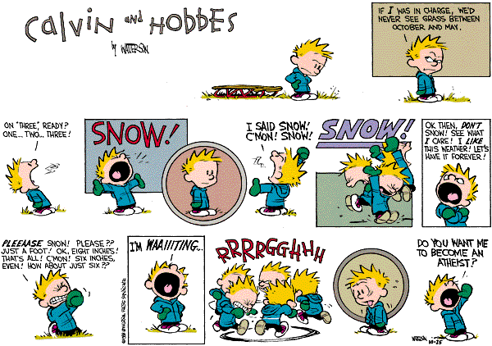

תוספות מסכת ברכות דף לב עמוד ב
כל המאריך בתפלתו ומעיין בה - פירוש שמצפה שתבא בקשתו לפי שכוון בתפלתו. תימה דהכא משמע דעיון תפלה לאו מעליותא הוא וכן משמע פ' הרואה (לקמן דף נה.) ג' דברים מזכירין עונותיו של אדם וקאמר עיון תפלה. ולא כן משמע בפ' מפנין (שבת דף קכז.) דקאמר אדם אוכל פירותיהן בעוה"ז וקא חשיב עיון תפלה אלמא מעליותא הוא וכן משמע בגט פשוט (ב"ב דף קסד:) דקאמר משלשה דברים אין אדם ניצול בכל יום וקאמר עיון תפלה פירוש שאין אדם מעיין בה אם כן משמע שהוא טוב? וי"ל דתרי עיון תפלה יש עיון תפלה דהכא המצפה שתבא בקשתו ועיון תפלה דהתם שמכוין את לבו לתפלה.
Stage I
R. Yosef Albo, Sefer Ikkarim, IV, chap. 18
The reason which leads men to doubt the efficacy of prayer is the same as that which leads them to deny God's knowledge. Their argument is as follows: Either God has determined that a given person shall receive a given benefit, or He has not so determined. If He has determined there is no need of prayer; and if He has not determined, how can prayer avail to change God's will that He should now determine to benefit the person, when He had not so determined before?
The influences from above come down upon the recipient when he is in a certain degree and state of preparation to receive them... Our idea, therefore, is that when a benefit is determined in favor of anyone, it is conditional upon a certain degree of right conduct...In the same way, when a certain evil is determined upon someone, it is also conditional upon his being wicked in a certain degree or of being predisposed to it. And if the degree of wickedness or predisposition thereto changes, the predetermined event or fate changes also necessarily for the better or the worse... In this way it is clear that prayer and right conduct help to prepare the person to receive the good influence or to nullify the evil that has been decreed concerning him, because he changes from the evil state in which he was... As for the objection that the divine will cannot be changed by prayer, the answer is that the divine will in the first place is that the decree should be realized if the person in question continues in the same state, and that the decree should be changed if the person's state changes.

George Meredith: Who rises from prayer a better man, his prayer is answered.

Stage II
Shimshon Raphael Hirsch
The word hitpalel (to pray) comes from the root palal, which in turn is related to the root balal…The root balal…denotes bringing a fresh element into a mass, incorporating this element into all parts of the mass, and thus forming a new material out of the mass. This is the Jewish concept of the judge’s task, [and it is for this reason that the verb palal means "to judge"]. The judge must bring justice and fairness, which are elements of Divine Truth, into the case. This must penetrate all elements of the dispute. Therefore, by bringing true justice into what was angry dissension, the judge transforms it into harmonious unity. When one does this to himself, he is said to hitpalel, that is, “to judge himself." Hitpalel means to take the element of God’s truth and make it penetrate all phases and conditions of our being and our lives. This allows our entire being to gain a degree of harmony in God. Jewish tefillah is hence very different from what is usually conceived of as prayer. It is not an outflowing from within, or an expression of that with which the heart is already filled. Rather, it is a renewal and penetration of truth which comes from the outside. If our prayers were not tefillah … there would be no sense in having fixed times and prescribed forms for them. For this assumes that periodically at fixed times the masses of a community are always filled with one and the same state of feelings...Such a prayer would be superfluous…But our prescribed prayers are not facts and truths of which we are already conscious; they are concepts which we wish to awaken and renew in ourselves. The less one may feel inclined to recite a prayer, the more necessary it may be to say it. (Commentary to Bereishit 20:7)

Stage III
R. Soloveitchik
Prayer in Judaism, unlike the prayer of classical mysticism, is bound up with human needs, wants, drives and urges, which make man suffer. Prayer is the doctrine of human needs. Prayer tells the individual, as well as the community, what his, or its, genuine needs are, what he should, or should not, petition God about....In short, through prayer man finds himself. Prayer enlightens man about his needs. It tells man the story of his hidden hopes and expectations. It teaches him how to behold the vision and how to strive in order to realize this vision. When to be satisfied with what one possesses, when to reach out for more. In a word, man finds his need-awareness, himself, in prayer.

