- Nuance and Balance

- Decision making in general
118
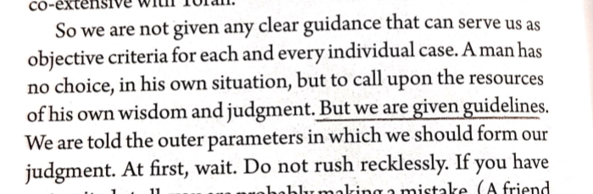

- Waiting vs. Activism
Nazi Germany
118
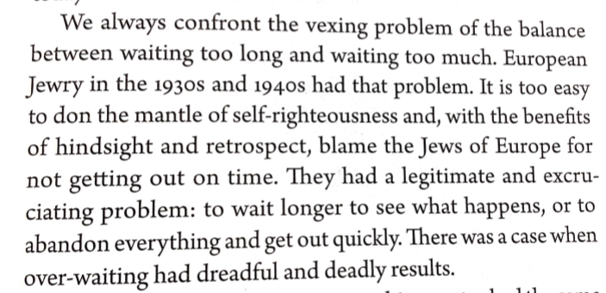

Messianism
119
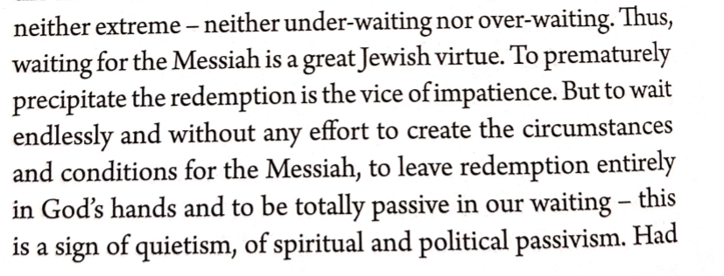

- Fundamentalism
77
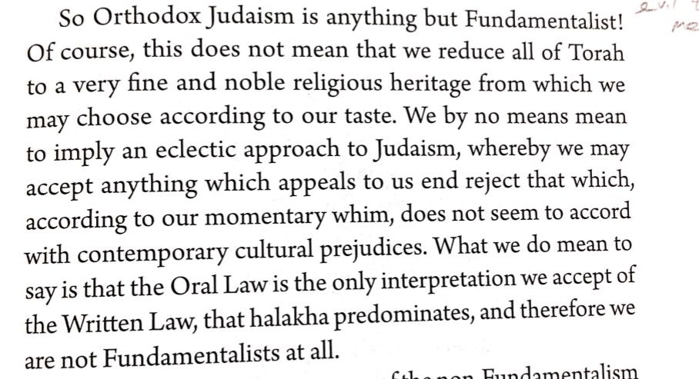

- Reverential vs Critical Study of Torah
11
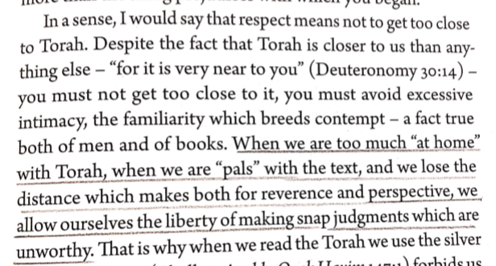
15
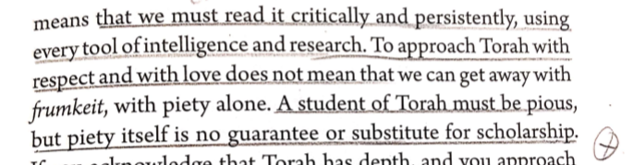
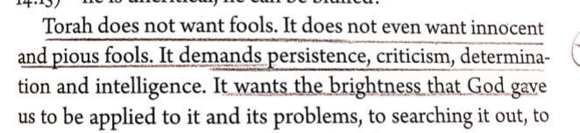

- Virtuous Traits Taken Too Far
45
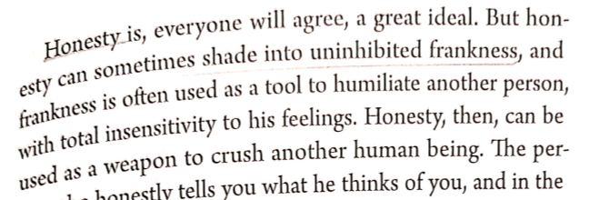

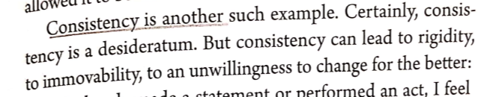

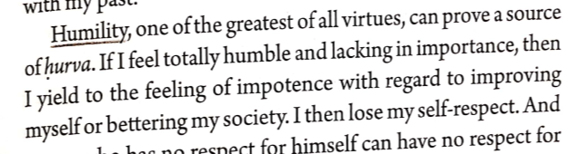

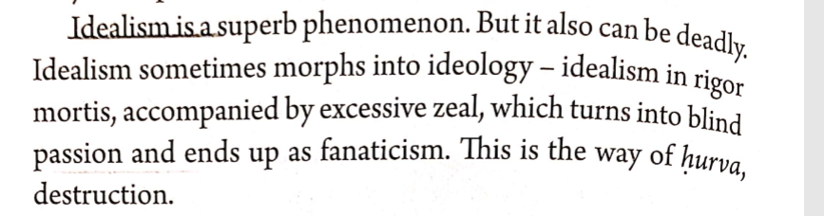

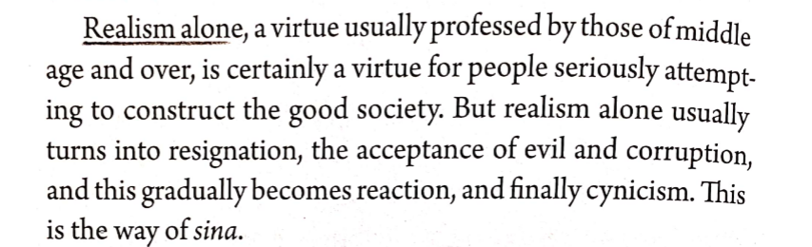

- Stringency or Flexibility in Rabbinic Policy Setting
61
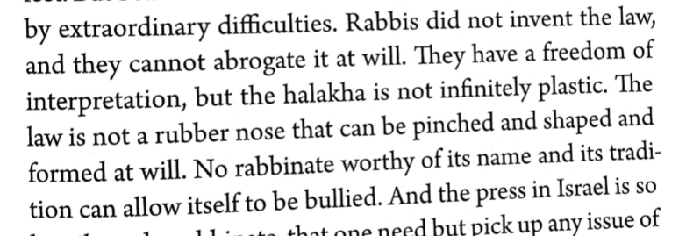

62
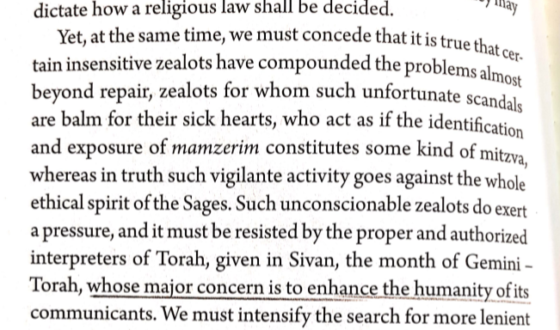

- The Kotzker “Saying”
48
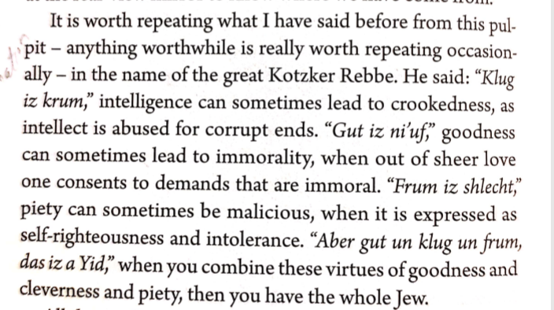

- Defending the Relevance and Timelessness of Judaism and Halacha

A Sense of Mission- 156

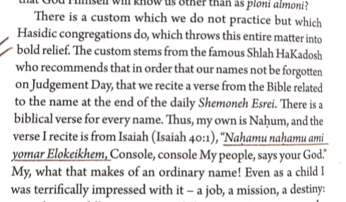

- Is It Relevant or too Detached

40
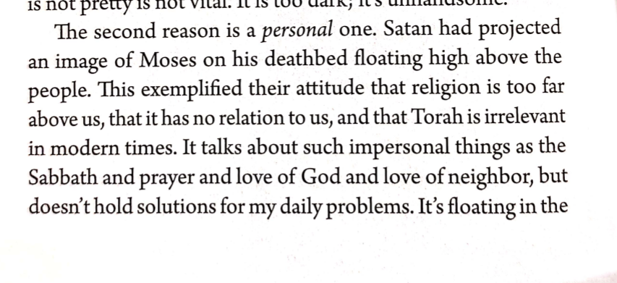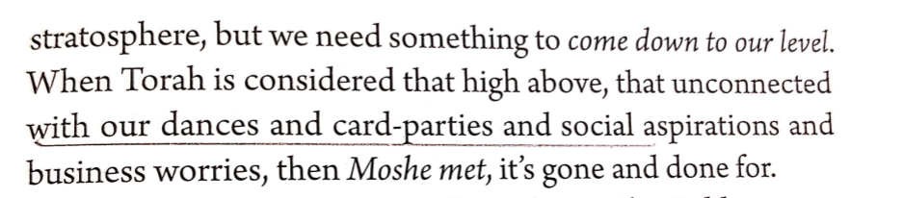

- Idealism in a Pragmatic World
100
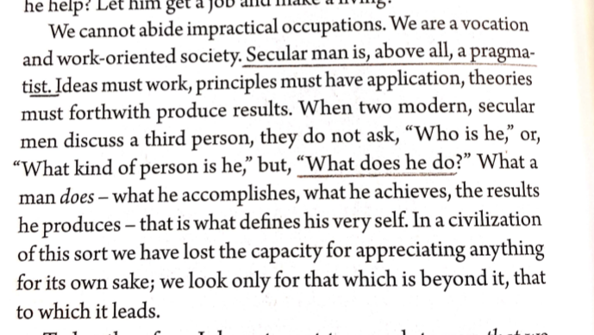

- Neutral Indifference
157
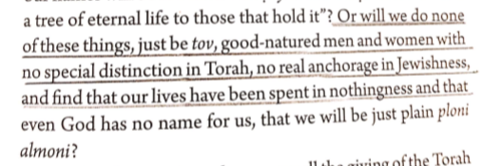
112
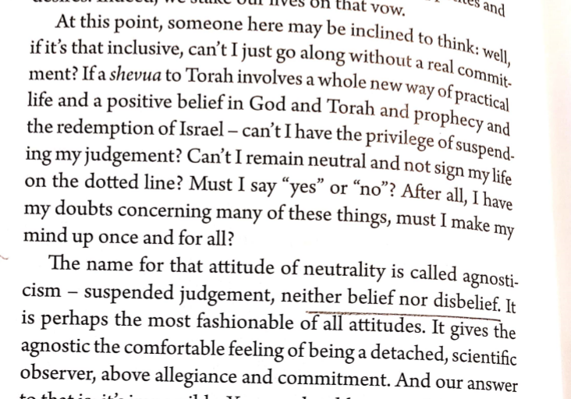
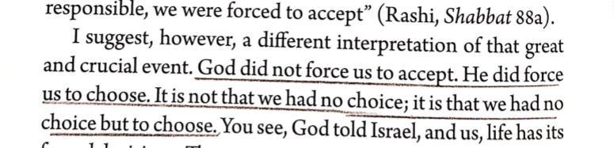
113
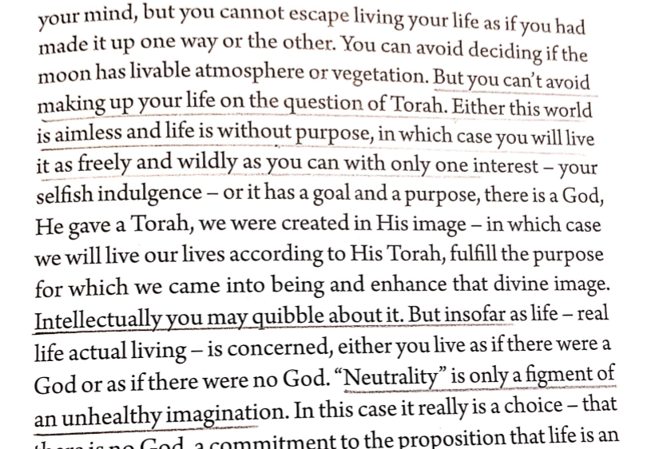

- Acknowledging the “Sickness”
28
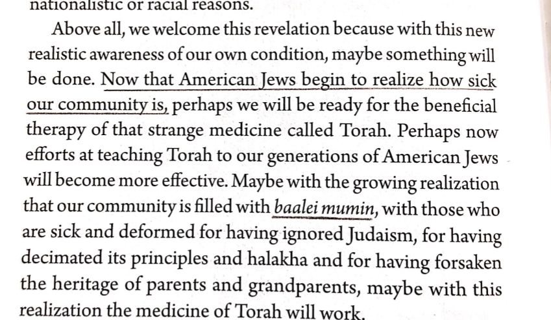

- Human Nature Hasn’t Changed
89
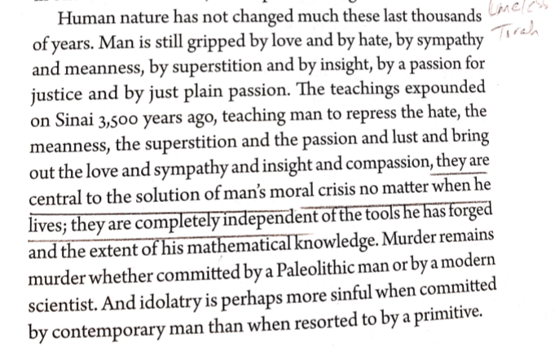
- Undiscovered Treasures

72
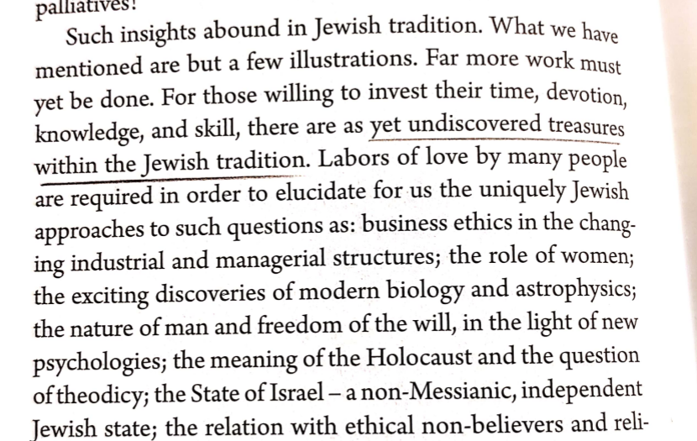

- Excess of Technology
86

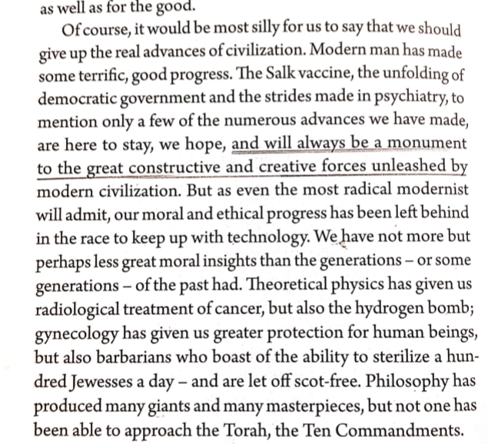

- Technological Advance but Moral Decline

36

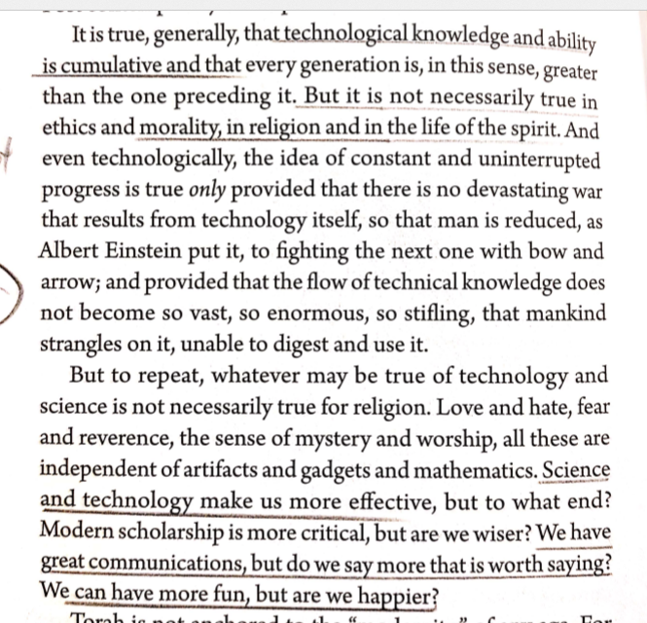

- Needless Technological Investment

53
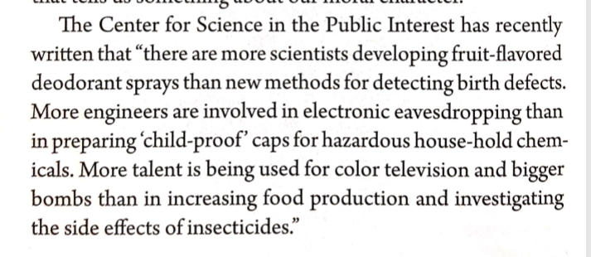

54
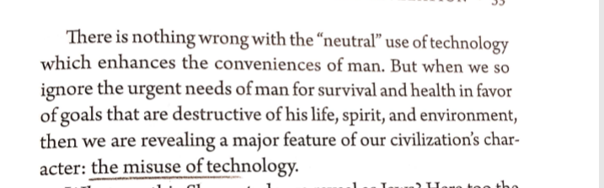

- Battling Imprisoning Terminology

90
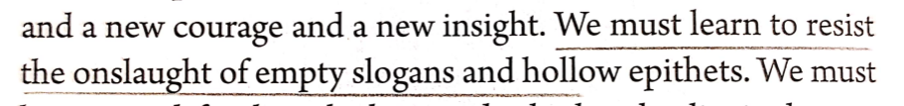
85
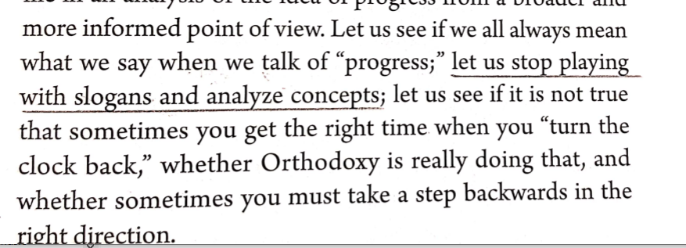

- Change vs. Progress
85
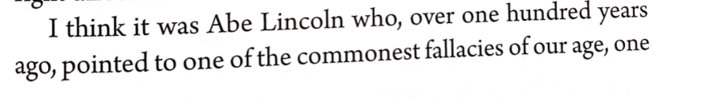
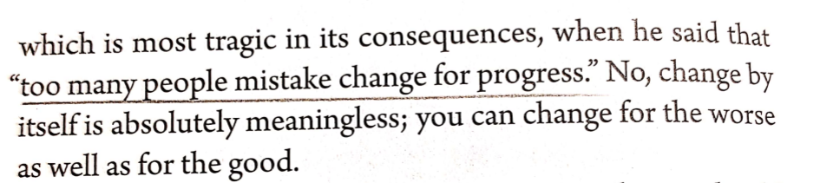

- Insulting the Fundamentalists
75
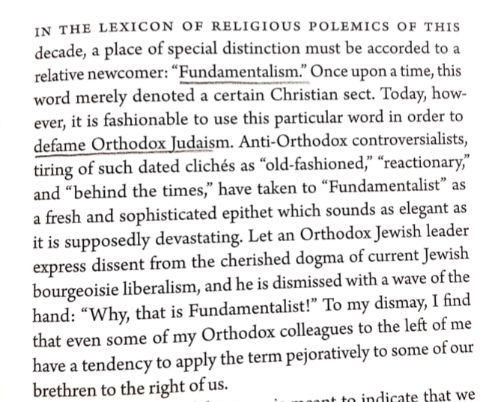

- I am Allergic to the Word Modern

33
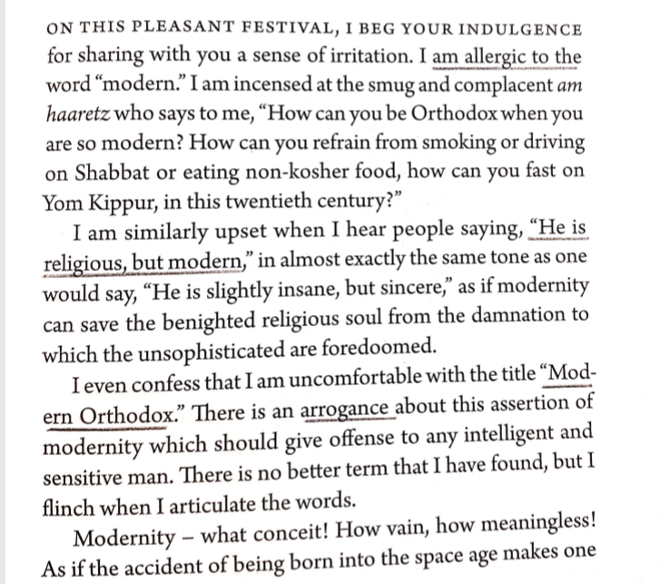

34
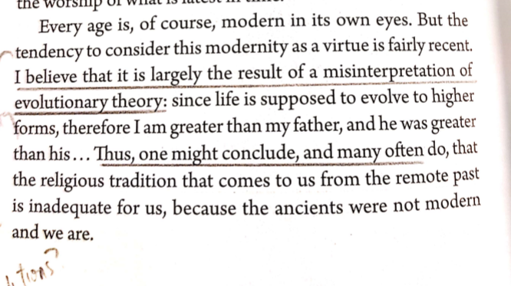
- We are guilty of chronolatry

34
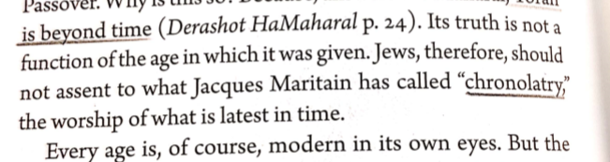

- The Advantage of Turning the “Clock Back”
85
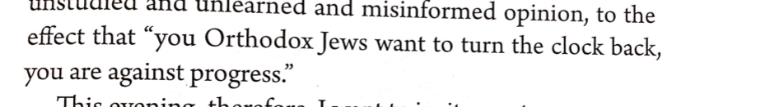

- Turn “On” or Turn

37
