Class # 15 – What is chosen about the chosen people?
Senior Fellowship Leadership Program –Rabbi Pinny Rosenthal

Review of last class:
- Is Zionism racist?
  - Racism is the belief that a person's essential good/ evil comes from their DNA rather than free choice. Typically the racist believes that goodness comes from the DNA of his/her group. Evil comes from the DNA of the "other" non-members of his/her group. The racist justifies his acts of discrimination expressions of hate by his ideology of racial superiority.
- Are the Beitar - Jerusalem fans – racist?

- Why would extreme nationalist groups be more vulnerable to racism?

3) What is the difference between nonracist countries such as England, Holland and Israel which nonetheless have some racist elements of society and Nazi Germany?
4] What surprised US Ambassador Nikki Haley about her first visit to the UN security council discussing the Middle East?
5) In what way does Judaism's view of mankind having a Tzelem Elokim heal our disposition to Racism?
II. Are Jews in general racists?
If not, how do you explain the derogatory term in Yiddish?
- Shaigetz 2. Shiksa 3. Shvartze 4. Goyishe Kup

The few.. the proud.. the Mamlechet Kohanim [kingdom of priests]

19:1 In the third month after the Israelites left Egypt, on the first of the month, they came to the desert of Sinai. 19:2 They had departed from Rephidim and had arrived in the Sinai Desert, camping in the wilderness. Israel camped opposite the mountain.

19:3 Moses went up to God. God called to him from the mountain and said, 'This is what you must say to the family of Jacob and tell the Israelites: 19:4 'You saw what I did in Egypt, carrying you on eagles' wings and bringing you to Me. 19:5 Now if you obey Me and keep My covenant, you shall be My special treasure among all nations, though all the world is Mine. 19:6 You will be a kingdom of priests and a holy nation to Me.' These are the words that you must relate to the Israelites.' 19:7 Moses came [back] and summoned the elders of the people, conveying to them all that God had said. 19:8 All the people answered as one and said, 'All that God has spoken, we will do.'

II Question: Factually, Nazis are the paradigmatic example of denying the humanity of the “other”.
Shouldn’t we be afraid that the idea of a superior “Mamlechet Kohanim” will promote denying the humanity of the “other”??

Rabbi at West Bank Pre-Military School Lauds Hitler - https://www.youtube.com/watch?v=ERUsjvVLwPc
III Shining example of Kohein:
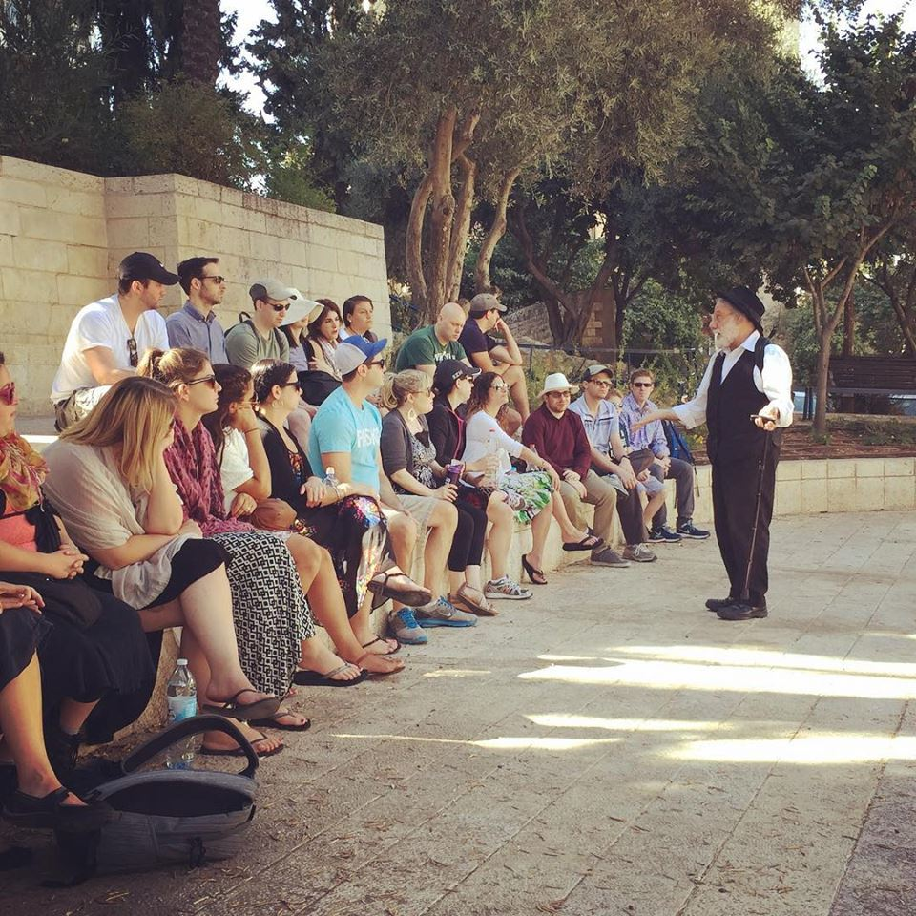
Rabbi Benji Levine [Gesher USA]. Addressing the MJE Heritage Trip 2015
https://www.youtube.com/watch?v=L9Fs3ketJnw
IV Mamlechet Kohanim defined: Malachi Ch. 2:6-9
ו תּוֹרַת אֱמֶת הָיְתָה בְּפִיהוּ וְעַוְלָה לֹא-נִמְצָא בִשְׂפָתָיו בְּשָׁלוֹם וּבְמִישׁוֹר הָלַךְ אִתִּי וְרַבִּים הֵשִׁיב מֵעָוֹן:
ז כִּי-שִׂפְתֵי כֹהֵן יִשְׁמְרוּ-דַעַת וְתוֹרָה יְבַקְשׁוּ מִפִּיהוּ כִּי מַלְאַךְ יְהֹוָה-צְבָאוֹת הוּא:
ח וְאַתֶּם סַרְתֶּם מִן-הַדֶּרֶךְ הִכְשַׁלְתֶּם רַבִּים בַּתּוֹרָה שִׁחַתֶּם בְּרִית הַלֵּוִי אָמַר יְהֹוָה צְבָאוֹת:
ט וְגַם-אֲנִי נָתַתִּי אֶתְכֶם נִבְזִים וּשְׁפָלִים לְכָל-הָעָם כְּפִי אֲשֶׁר אֵינְכֶם שֹׁמְרִים אֶת-דְּרָכַי וְנֹשְׂאִים פָּנִים בַּתּוֹרָה:
6 The law of truth was in his mouth, and unrighteousness was not found in his lips; he walked with Me in peace and uprightness, and did turn many away from iniquity. 7 For the priest's lips should keep knowledge, and they should seek the law at his mouth; for he is the messenger of the LORD of hosts. 8 But you turned aside out of the way; ye have caused many to stumble in the law; you have corrupted the covenant of Levi, says the LORD of hosts. 9 Therefore have I also made you contemptible and base before all the people, according as you have not kept My ways, but have had respect of persons in the law.
Seforno - Shemot 19:6 – A kingdom of priests. In this fashion you will be the treasure of them all by being a kingdom of priests to understand and teacher entire human race to call out in the name of Hashem and serve him in one accord, as it will be in the future.

V As a modern day Kohein, - What is our role?

VI Jewish Racism is an angry reaction to Anti Semitism

Sir Benjamin Disraeli (1804-1891), the British prime minister, was once insulted in the House of Commons because he was Jewish. He responded: “While your ancestors were painting themselves blue, my ancestors were worshipping one God.” (The Picts, early inhabitants of Scotland, for some strange reason did paint themselves blue.) But “The Little, Brown Book of Anecdotes,” with Clifton Fadiman as general editor, gives the following version, which is surely more accurate if not as much fun: “In 1835 Daniel O’Connell, the Irish Roman Catholic leader, attacked Disraeli in the House of Commons. In the course of his unrestrained invective, he referred to Disraeli’s Jewish ancestry. Disraeli replied, ‘Yes, I am a Jew, and while the ancestors of the right honorable gentleman were brutal savages in an unknown island, mine were priests in the temple of Solomon.’”

