Class # 3 - Transformational Yom Kippur
Senior Fellowship Leadership Program
Rabbi Pinny Rosenthal - prepared collaboratively with Rabbi Yoni Sacks

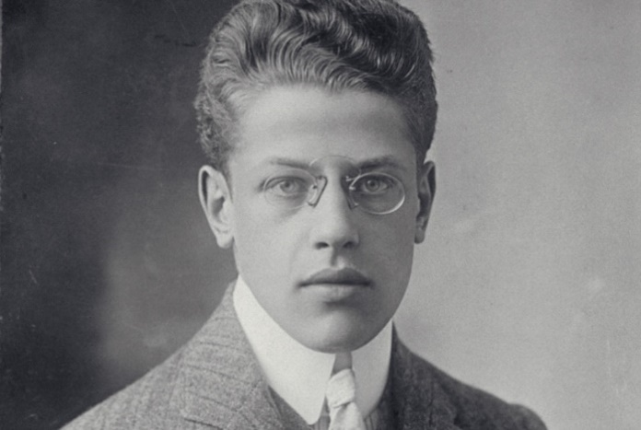
Franz Rosenzweig’s Yom Kippur: a life and death decision

In October 1913, 106 years ago these High Holidays, 26-year-old philosopher (and Jew) Franz Rosenzweig was preparing for a crucial conversion ceremony: his own, to Christianity.
However, because he insisted on converting “as a Jew, not as a ‘pagan,’ ” Rosenzweig dutifully attended services on the Day of Atonement 1913 at a small Orthodox synagogue in Berlin. In his mind, participation in the Day of Atonement was a necessary, preparatory step toward his Christian baptism. “Here was a Jew,” writes Nahum N. Glatzer in his biography of Rosenzweig, “who did not wish to ‘break off,’ but who deliberately aimed to ‘go through’ Judaism to Christianity.”

“Just as it is not possible to “unring” a bell, Rosenzweig clearly could not “unsound” the shofar he heard in 1913.
He was a master of return, a man who recognized that he, along with his entire generation, was lost, was born lost, and managed to reorient himself and find his way home.”

- What decision did Franz Rosenzweig face in the small Shul in Berlin on Yom Kippur?
- Why do you think he chose Yom Kippur as the day to make this decision? Was YK a proper choice of day for this decision?
- What factor stands out in Franz Rosenzweig’s decision not to be baptized?
- Nowadays, is it necessary to have an official conversion to live as fully accepted member of non-Jewish society?
- In what sense, does every Western Jew today, face a similar decision as Rosenzweig, every Yom Kippur?

Rambam, Laws of Teshuva, Ch. 2:6-7
Even though repentance and calling out [to God] are desirable at all times, during the ten days between Rosh HaShanah and Yom Kippur, they are even more desirable and will be accepted immediately as [Isaiah 55:6] states: "Seek God when He is to be found."
When does the above apply? To an individual. However, in regard to a community, whenever they repent and cry out wholeheartedly, they are answered immediately as [Deuteronomy 4:7] states: "[What nation is so great that they have God close to them,] as God, our Lord, is whenever we call Him."

7) Yom Kippur is the time of Teshuvah for all, both individuals and the community at large. It is the apex of forgiveness and pardon for Israel. Accordingly, everyone is obligated to repent and confess on Yom Kippur….

- In what sense is Hashem “near” us during the 10 days between Rosh Hashana and Yom Kippur? Why does that make our Teshuva more desirable?
- How did that “nearness” help Franz Rosenzweig?

Rambam, Laws of Teshuva, Ch. 7:4
A Baal-Teshuvah should not consider himself distant from the level of the righteous because of the sins and transgressions that he committed. This is not true. He is beloved and desirable before the Creator as if he never sinned.

Furthermore, he has a great reward for he has tasted sin and yet, separated himself from it, conquering his [evil] inclination. Our Sages declared: "In the place where Baalei Teshuvah stand, even the completely righteous are not able to stand." The level of Baalei Teshuvah transcends the level of those who never sinned at all, for they overcome their [evil] inclination more.

- What assumption do Baalai Teshuva have about their nearness/remoteness from Hashem?
- Why are Baalai teshuva actually on a higher level?

