Class # 2 Strangers in a strange land- the dangers of success
Senior Fellowship Leadership Program
Rabbi Pinny Rosenthal

10 Steps to Redemption

https://www.youtube.com/watch?v=7MsJYEIiIfs

In James Gray's THE IMMIGRANT, Ewa Cybulski (Marion Cotillard) and her sister sail to New York from their native Poland in search of a new start and the American dream. When they reach Ellis Island, doctors discover that Magda (Angela Sarafyan) is ill, and the two women are separated. Ewa is released onto the mean streets of Manhattan while her sister is quarantined. Alone, with nowhere to turn and desperate to reunite with Magda, Ewa quickly falls prey to Bruno (Joaquin Phoenix), a charming but wicked man who takes her in and forces her into prostitution. The arrival of Orlando (Jeremy Renner) - a dashing stage magician who is also Bruno's cousin - restores her self-belief and hopes for a brighter future, becoming her only chance to escape the nightmare in which she finds herself

- What crisis did the sisters face? In what way is this crisis characteristic of the vulnerability of immigrants?
- Who rescued them from this crisis?
- How did this “rescue” result in blackmail.
- What does this blackmail reveal about the underlying mentality of the “rescuer”?
- In what way is this underlying mentality of the “rescuer” characteristic of powerful people?
- Do all people share this issue? Do we the members of the class have this issue? Where and when?

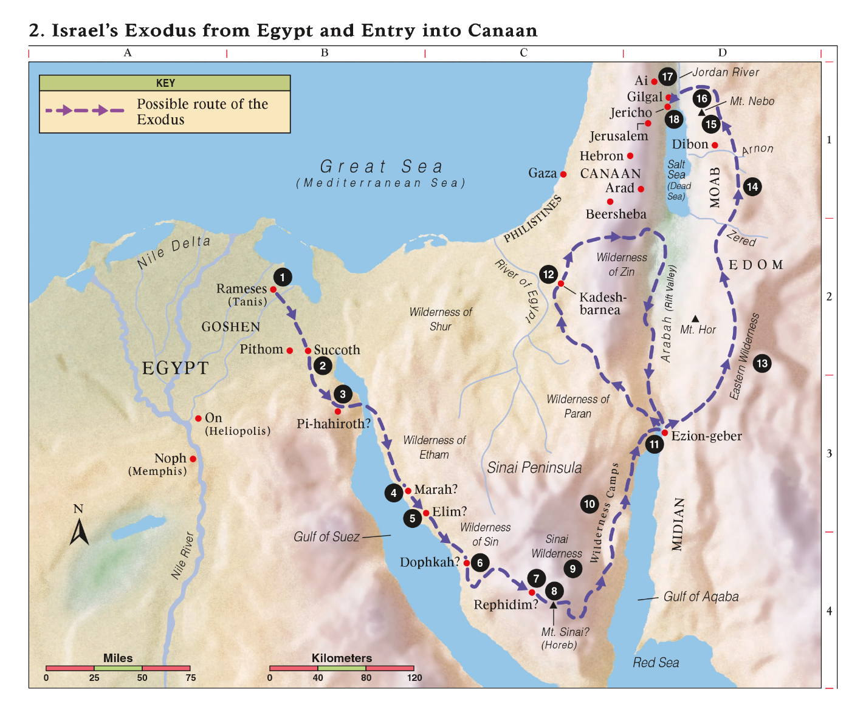

Jacob Arrives in Egypt
46:28 [Jacob] sent Judah ahead of him to make preparations in Goshen. They then arrived in the Goshen district. 46:29 Joseph [personally] harnessed his chariot, and he went to greet his father Israel in Goshen. He presented himself to [his father], and threw himself on his shoulders, weeping on his shoulders for a long time. 46:30 'Now I can die,' said Israel to Joseph. 'I have seen your face, and you are still alive.' 46:31 To his brothers and his father's family, Joseph said, 'I will go and tell Pharaoh. I will say the following to him: 'My brothers and my father's family have come to me from Canaan. 46:32 These men deal in livestock and are tenders of sheep. They have brought along their sheep, their cattle, and all their possessions.' 46:33 'When Pharaoh summons you and inquires as to your occupation, 46:34 you must say, 'We and our fathers have dealt in livestock all our lives'. You will then be able to settle in the Goshen district, since all shepherds are taboo in Egypt.'

47:1 Joseph went and told Pharaoh. He said, 'My father and brothers have come from Canaan, along with their sheep, their cattle, and all their belongings. They are now in the Goshen district.' 47:2 From among his brothers, he selected five men and presented them to Pharaoh. 47:3 Pharaoh asked [Joseph's] brothers, 'What is your occupation?'' We are shepherds,' they replied to Pharaoh, 'we and our fathers before us.'

47:4 'We have come to stay awhile in your land,' they explained to Pharaoh, 'because there is no grazing for our flocks, so severe is the famine in Canaan. If you allow us, we will settle in the Goshen district.' 47:5 Pharaoh said to Joseph, 'Your father and brothers have now come to you. 47:6 The land of Egypt is at your disposal. Settle your father and brothers in the best area. Let them settle in the Goshen District. If you have capable men among them, you can appoint them as livestock officers over my [cattle].' 47:7 Joseph brought his father Jacob and presented him to Pharaoh. Jacob blessed Pharaoh. 47:8 'How old are you?' asked Pharaoh of Jacob. 47:9 'My journey through life has lasted 130 years,' replied Jacob. 'The days of my life have been few and hard. I did not live as long as my fathers did during their pilgrimage through life.' 47:10 With that, Jacob blessed Pharaoh and left his presence. 47:11 Joseph found a place for his father and brothers to live. He gave them an estate in the Rameses region, in the best area, as Pharaoh had ordered.

- How are Bruno and Paroh the same? How are they different?
- Why did Yosef prep his brothers?
- What was his fear?
- Why did Jacob act in the manner he did?
- What was Pharaoh’s interest with Yosef’s brothers?
- Why is the enslavement of the Jews almost inevitable?

Shmaayah and Avtalyon received from them. Shmaayah would say: Love work, loath taking positions of leadership, and avoid intimacy with the government. Ethics of the Fathers 1:10

Rabbi Ovadeya Bartenura comments – Loath taking of positions of leadership – Distance yourself from taking leadership positions over the community for leadership buries its owners!

Rabbi Chanina the deputy High Priest said, "Pray for the welfare of the government, for without the fear of it, man would swallow his fellow alive." Ethics of the Fathers 3:2

