Tzedaka and Non-Jews

- The Gemarot in Bava Batra
  - This issue appears in 3 places in the first chapter of Bava Batra. While there are several halachic passages that are relevant in other masechtot, the passages in our Perek of Aggadic, so the legal implications must be teased out. In each story ask the following questions:
    - Does the story present the non-Jew as being obligated in charity? In each case charity can be looked at as an obligation, prohibition, or something else.
    - Is accepting their donation seen as positive, negative, or does it depend? What might it depend on?
  - See the following passages:
    - Bava Batra 3b-4a, from הורדוס (5th wide line on 3b) - לגובא דארייוותא, (two dots on 4a)
    - 8a-b: איפרא הורמיז (3 lines from the end) - מצוה רבה היא (1st line)
    - 10b-11a: איפר הורמיז (4 lines from the end) - סיימיה קמיה (1st line)

- The other Gemarot:
  - There are several other relevant passages, some that relate to the question of whether non-Jews are obligated, others to the appropriateness of accepting donations. These passages seem to be in tension.
    - In each, ask the questions from above- does it seem non-Jews are obligated, what is the stance of the passage with regards to accepting donations, etc.
  - Sanedrin 56-57.
    - 56a-b: This is the general discussion of the 7 mitzvot of Bnei Noach

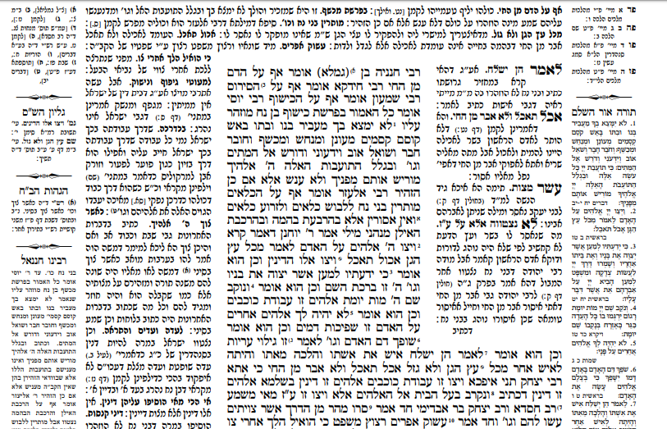

    - 57b: This passage deals with the obligation of non-Jewish women in the commandment of Dinim
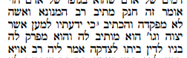
  - Sanhedrin 26a: This deals with the cases of people who are invalid for testimony.

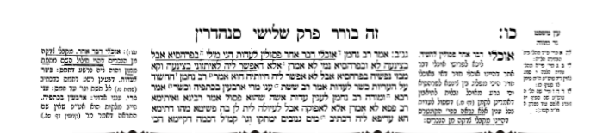

  - Shekalim and Arachin: This deals with donations of non-Jews to the Beit HaMikdash specifically

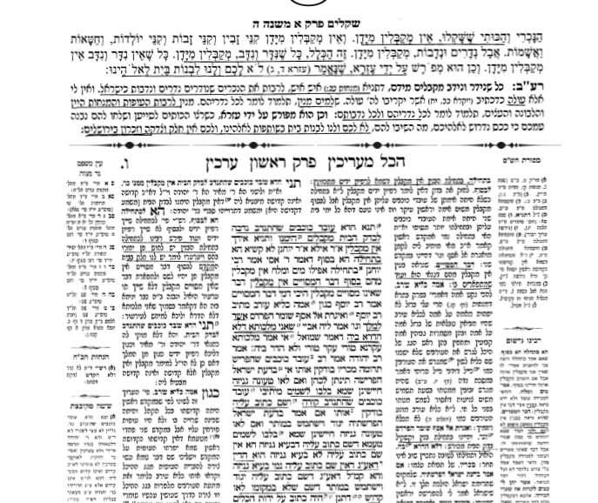
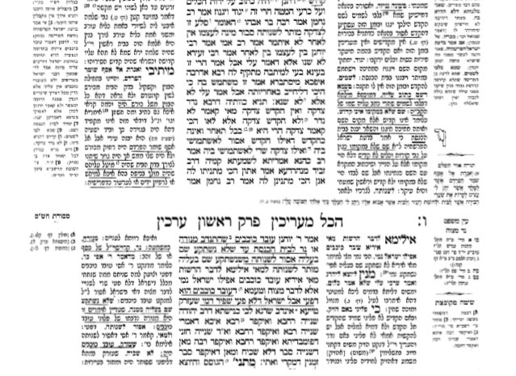

- The Obligation
  - Based on Sanhedrin 57b, does it seem that non-Jews are obligated in Tzedaka? It would seem to depend on the interpretation of the word צדקה in the passuk quoted in Bereishit 18:19, where Hashem explains why he chose Avraham. Look at the passuk - does it mean charity?
    - See Rashi to Sanhedrin 56b
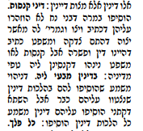
    - See this Gemara in Ketubot 8b. What does צדקה seem to mean here, and why might there be a dispute about whether the passuk should be quoted here?
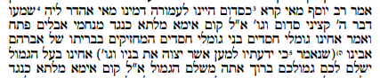
    - If you want, you can also look at Yevamot 79a regarding the three traits that Jews have as heirs of Avraham.
  - The Ran and R. Bechaye understand this differently than Rashi. Do they say the same thing?
    - Ran Sanhedrin 56b. I have included the footnotes from the Mossad HaRav Kook edition for a quick summary of some of the Achronim. I have them if you would like to look at them.
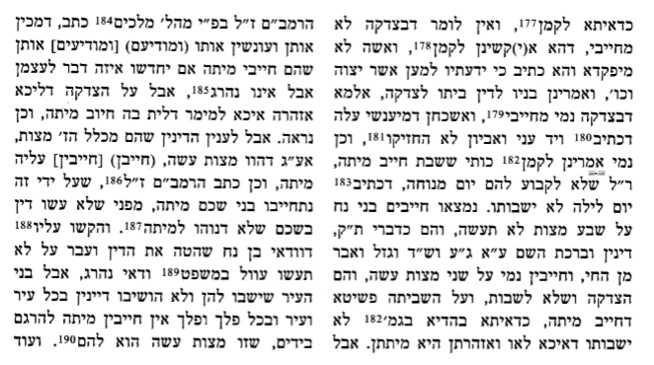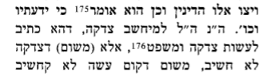

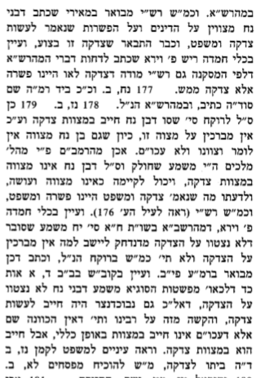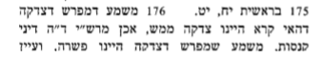

    - R. Bechaye on Bereishit 18:20, the following passuk that describes the sins of Sedom:
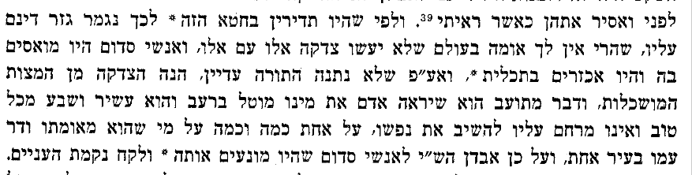
    - Netziv in his Haskama to Ahavat Chesed (by the Chafetz Chaim)
- 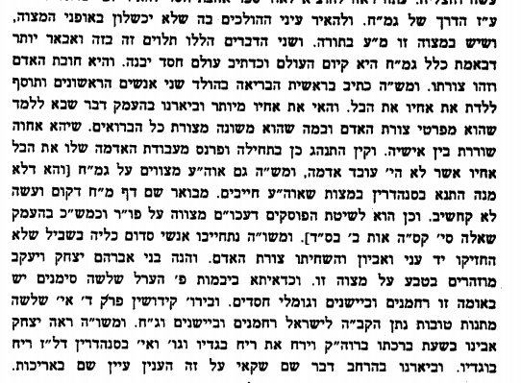
    - See the two opinions in the Yad Rama to Sanhedrin 57b
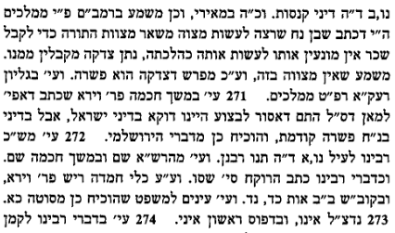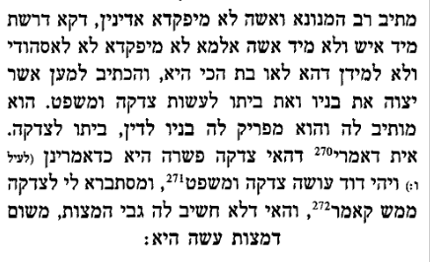
    - Rokeach
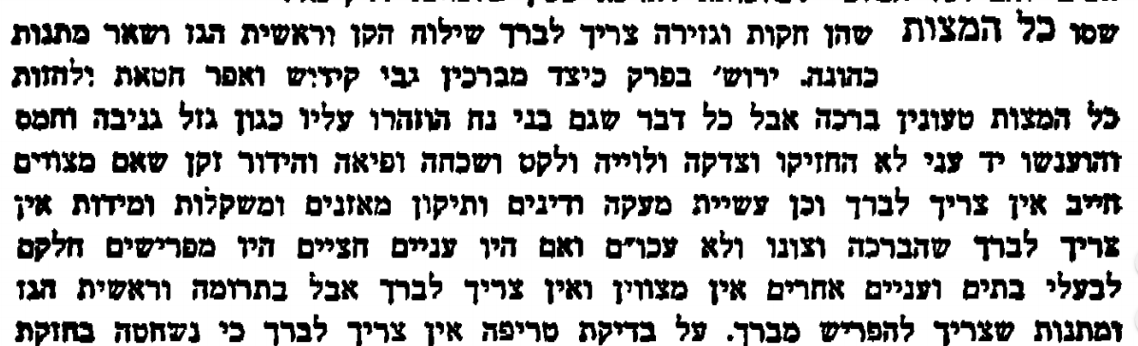
    - Rambam: See Hilchot Melachim 10:10.

    - Meshech Chochma to Bereishit 18:19
כי ידעתיו כו׳ אשר יצוה כו׳ צדקה ומשפט – זה דין ופשרה דגמרינן לקרא דויצו מזה (רש״י סנהדרין נ״ו ע״ב) אף ע״ג דאיכא תנא דאמר דאסור לבצוע זה דוקא בבית דין דישראל דדנין על פי דרכי התורה אסור לדיין לבצוע רק לדון בדיני תורה אם לא כשאינו יודע דין תורה אז מותר לבצע ולפשר אבל בבית דין של בני נח שמוזהרין על הדינים לדון דיני נמוסים כפי השכל האנושי בזה מותר ומצוה לפשר אפילו אם יודע הדין שלהם ולכן אמר בדוד ויהיה דוד עושה משפט וצדקה משפט שיש בו צדקה הוי אומר זה ביצוע כשאינו יודע או בדין מרומה שמשפט קודם ובאופנים שאין דין צדקה אבל באברהם כתוב צדקה ומשפט שקודם שנתנה, והיו בני נח תורה פשרה העיקר והדין הנמוסי טפל הי׳ משפט אחר הצדקה שהפשרה קודם ודו״ק וכן הביא רמב״ן בוישלח בדיני ישראל כל דין שאתה שלם ממנו (לא דין מרומה ויודע הדין) אי אתה רשאי לברוח ממנו (פירוש לבצע ולפשר) כו׳ אבל בדיניהם אעפ״י שאתה יודע שאתה שלם ממנו אתה רשאי לברוח ממנו (פי׳ מצוה לפשר כמו דפירשתי) ויעו״ש ברמב״ן שפירש בדרך אחר ובירושלמי שלפנינו אין זה המאמר. ולכן אמרו בניו לדין שאשה פסולה לדין וביתו לצדקה שפשרה כשר בנשים יעוי׳ דף נ״ז ע״ב ודו״ק.

  - Look back at the Gemarot in Bava Batra. What are the implications? If you want, you can look at the Kovetz Shiurim to Bava Batra 24 and 54.

- The Problems with Taking
  - In each of the sugyot above, what are the problems with taking donations, and when it is permitted? There are tensions between the sugyot. Can you explain the conceptual issues that drive the different factors? Can you understand how they work together?
  - Sanhedrin: The Psul Edut
    - See Rashi above and Rambam Hilchot Edut 11:5. What is the difference?
  - See Rambam Hilchot Rotzeach 12:15
  - There are many different ways of explain the issues. I include a summary of 5 directions, and then we will explore each approach and what the conceptual basis is for the approach. For each position, if you want to explore it more deeply, look it up in the original.
  - There are other distinctions that relate to what the money is being given for that emerge from the sugyot in Arachin. Make sure to see Tosafot in Bava Batra.
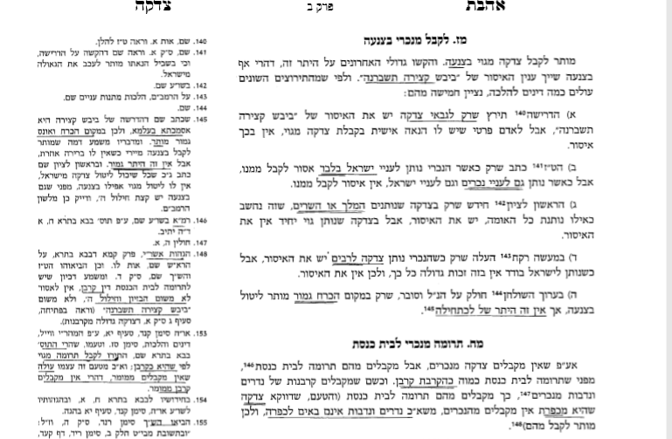

  - Shulchan Aruch: Carefully read Shulchan Aruch and see what is strange about his language.

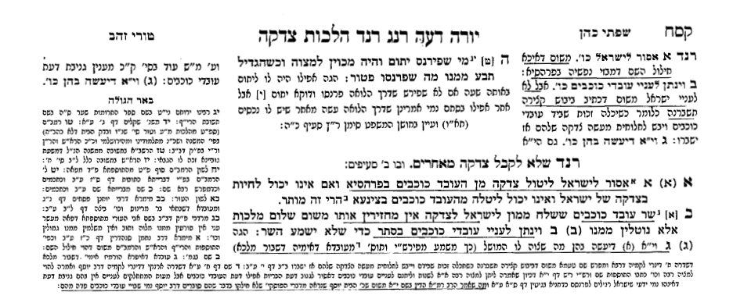
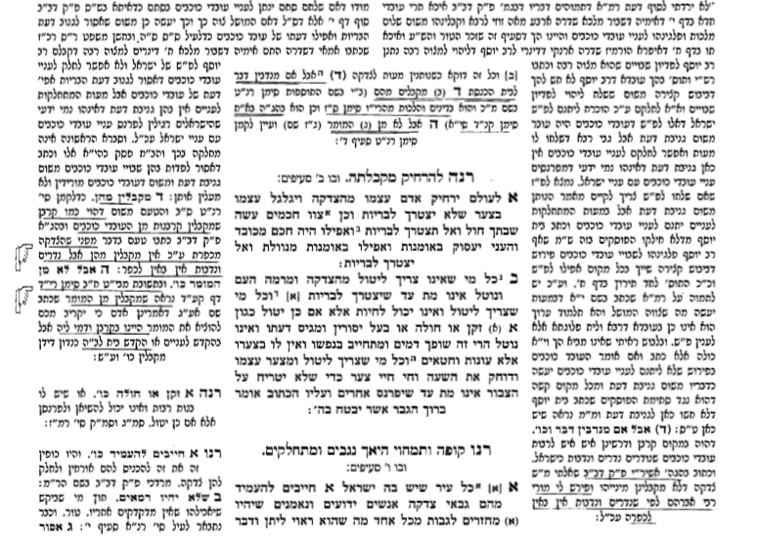
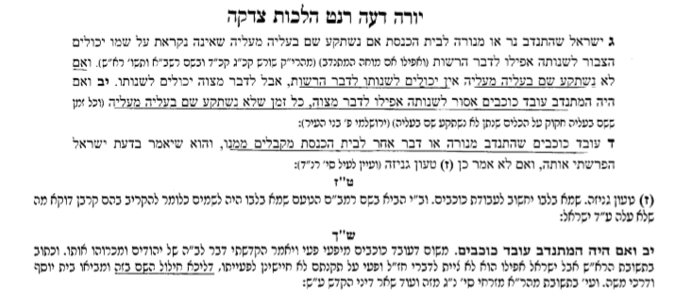

- Halacha:
  - There are many implications for this Halacha L’Maaseh. When we finish the conceptual issues, we will explore some of them.
  - This is particularly relevant to Christian groups who donate to Israel.

- Note that if you want to look at the Achronim inside, I have many of them collected.

