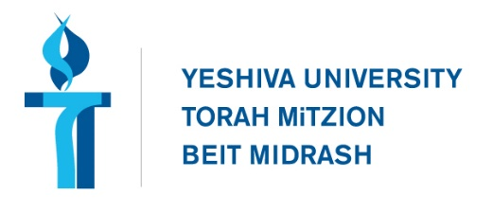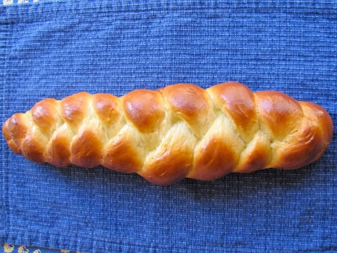**Why do we do That? Shlissel Challah**Adam Friedmann – afriedmann@torontotorah.comWhat is Shlissel Challah?

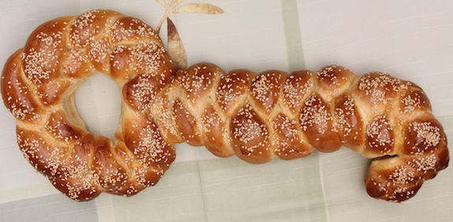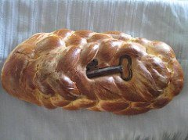  
Reasons for the Practice

1. **Mishnah, Rosh Hashanah, 1:2**

בארבעה פרקים העולם נידון בפסח על התבואה בעצרת על פירות האילן בראש השנה כל באי העולם עוברין לפניו כבני מרון שנאמר (תהלים ל"ג) היוצר יחד לבם המבין אל כל מעשיהם ובחג נידונין על המים:

The world is judged at four points during the year: On Pesach for grains, on Shavuot for fruits, on Rosh Hashanah all the people in the world pass before him like sheep in a flock as it says, “who creates their hearts together, who understands all of their actions”. On Sukkot they are judged for water.

1. **Tosfot Yom Tov, Ibid.**

וקשיא לי כיון שאדם נדון בר"ה. ודאי על כל המאורעות שלו דנין אותו. על תבואתו. ופירותיו. ושאר עסקיו. וכיון שכן הכל נדון בר"ה. וניחא לי שג' דברים נדונין לכל העולם. בשלשה זמנין אלו השנויין במשנתינו… אבל בר"ה כל באי עולם עוברין לפניו אחד אחד. וגוזרים עליו חלקו מדברים הללו.

It is difficult for me: If a person is judged on Rosh Hashanah, certainly he is judged for the all the events [for the coming year], on his grains, and his fruits, and the rest of his business. Since this is true [it seems] that everything is judged on Rosh Hashanah (and if so why do we need the other days?) I can answer this by saying that three things are judged for the whole world at the three times which are mentioned in our Mishnah…But on Rosh Hashanah all the people in the world pass before Him one by one, and they decree for them their portions of these (greater) things.

1. **Rabbi Pinchas of Koretz – 1728-1790 – Student of the Baal Shem Tov**

We poke holes into the Challah with a key, as a reminder that the gates are open until the second Pesach, etc. I heard this from (?) his son in his presence, but briefly without detailed explanation.

1. **Joshua, 5:9-11**

(ט) וַיֹּ֤אמֶר יְקֹוָק֙ אֶל־יְהוֹשֻׁ֔עַ הַיּ֗וֹם גַּלּ֛וֹתִי אֶת־חֶרְפַּ֥ת מִצְרַ֖יִם מֵעֲלֵיכֶ֑ם וַיִּקְרָ֞א שֵׁ֣ם הַמָּק֤וֹם הַהוּא֙ גִּלְגָּ֔ל עַ֖ד הַיּ֥וֹם הַזֶּֽה: (י) וַיַּחֲנ֥וּ בְנֵֽי־יִשְׂרָאֵ֖ל בַּגִּלְגָּ֑ל וַיַּעֲשׂ֣וּ אֶת־הַפֶּ֡סַח בְּאַרְבָּעָה֩ עָשָׂ֨ר י֥וֹם לַחֹ֛דֶשׁ בָּעֶ֖רֶב בְּעַֽרְב֥וֹת יְרִיחֽוֹ: (יא) וַיֹּ֨אכְל֜וּ מֵעֲב֥וּר הָאָ֛רֶץ מִמָּֽחֳרַ֥ת הַפֶּ֖סַח מַצּ֣וֹת וְקָל֑וּי בְּעֶ֖צֶם הַיּ֥וֹם הַזֶּֽה: (יב) וַיִּשְׁבֹּ֨ת הַמָּ֜ן מִֽמָּחֳרָ֗ת בְּאָכְלָם֙ מֵעֲב֣וּר הָאָ֔רֶץ וְלֹא־הָ֥יָה ע֛וֹד לִבְנֵ֥י יִשְׂרָאֵ֖ל מָ֑ן וַיֹּאכְל֗וּ מִתְּבוּאַת֙ אֶ֣רֶץ כְּנַ֔עַן בַּשָּׁנָ֖ה הַהִֽיא: ס

**9** And the LORD said to Joshua, “Today I have rolled away from you the disgrace of Egypt.” So that place was called Gilgal, as it still is. **10** Encamped at Gilgal, in the steppes of Jericho, the Israelites offered the Passover sacrifice on the fourteenth day of the month, toward evening. **11** On the day after the Passover offering, on that very day, they ate of the produce of the country, unleavened bread and parched grain. **12** On that same day, when they ate of the produce of the land, the manna ceased. The Israelites got no more manna; that year they ate of the yield of the land of Canaan.

1. **R. Abraham Joshua Heschel b"r Samuel of Apte – 1755-1825, Ohev Yisrael, New collected saying for the Shabbat after Pesach**

המנהג הוא מימים קדמונים לנקוב את החלות בשבת שלאחר פסח במפתחות. ונעשה על החלה צורת מפתח ומנהג ישראל תורה הוא וצריך טעם. כבר ביארנו טעמים על זה לעיל. והנה יש עוד לאלוה מילין טעם אחד על פי פשוטו כי הנה בעת הזאת כשאכלו ישראל מן המן, מהקרבת העומר ואילך לא אכלו עוד מן המן כמו שאמר הכתוב (יהושע ה, יא) ויאכלו ממחרת הפסח מעבור הארץ. ואמרינן בגמרא (קדושין לז ב) ממחרת הפסח אכול עד השתא לא אכול, ומאז התחילו לאכול מתבואת הארץ והיו ישראל צריכין לפרנסה כי עד עתה היה להם המן. וזאת ידוע שלכל דבר יש שער כמו שאנחנו מתפללין שיפתח לנו ה' יתברך שערי פרנסה. ומזה נשתרבב המנהג להיות עושין צורת מפתח על החלות לרמז שיפתח לנו ה' יתברך שערי פרנסה.

טעם הב' יש לומר, כי בעת ההוא סופרים אנו ספירה שבעה שבועות והם מ"ט יום על דרך סוד נ' שערי בינה. ואנחנו הולכים משער לשער ולכל שער יש מפתח וזהו שעושין צורת מפתח:

The practice from earlier days is to poke holes in the challot on the Shabbat after Pesach, with keys. And we make on the challah the figure of a key, and the minhag of Israel is Torah and requires a reason. We have already explained reasons for this above. And there is in addition to these another reason, according to the simple meaning, because at this time of the year when the Jews had been eating the *man* (i.e. in the desert), from the time of the offering of the Omer and onwards they stopped eating the *man*, as it is written “One the morrow of the Pesach they ate from the produce of the land”, and we say in the Gemara: The morrow of the Pesach is when they ate [implying that] until now they did not eat. From that point on the Jews ate from the produce of the grains of the land and they needed *parnassah*, but until this point they had received the *man*. And it is known that for everything there is a gate just like we pray that G-d should open for us the gates of *parnassah*. From this derives the practice of making the image of a key on the challot as an symbol that G-d should open for us the gates of *parnassah*.

A second reason: During this time we count the *Sefirah* for seven weeks, and they are 49 days, which, according to kabbalah, are associated with the 50 gates of wisdom. And we walk from gate to gate and each gate has a key, this is why they make the image of a key.

A Potential Issue: Idolatry

1. ***The Loaf of Idolatry?*, Shelomo Alfassa (Available at** [**www.mesora.org/Shlissel.html**](http://www.mesora.org/Shlissel.html)**)**

The baking of a key inside a bread is a non-Jewish custom which has its foundation in Christian, and possibly even earlier, pagan culture. At least one old Irish source tells how at times when a town was under attack, the men said, “let our women-folk be instructed in the art of baking cakes containing keys.”[7] Keys were traditionally manufactured in the form of a cross, the traditional symbol of Christianity,[8] a physical item all Christian commoners would posses in their home.[9] On Easter, the Christian holiday which celebrates the idea of Jesus ‘rising’ from the dead, they would bake the symbol of Jesus—the key shaped like a cross—into or onto a rising loaf.[10] This was not only a religious gesture, but the bread was a special holiday treat. Sometimes these breads were wholly formed in the shape of a cross; other times the shape of a cross was made out of dough and applied on top. In the context of historically baking a key into bread—the key itself, intrinsically, was a symbol of Christianity and by extension symbolized Jesus ‘rising’ in the dough.[11]

--------

[7] O'Brien, Flann. /The Best of Myles/. Normal, IL; Dalkey Archive Press, 1968. 393

[8] Small breads with the sign of the cross have been found as far back as 79 CE in the ancient Roman city of Herculaneum (see /The New York Times/ March 31, 1912). This was when Christianity emerged in Roman Judea as a Jewish religious sect which gradually spread out of Jerusalem.

[9] This was no different than the poor Jews of the ‘old world,’ who often would not have holy books but would certainly have a /mezuzah/ on their door which they considered a holy script in their own home.

[10] Another account mentions a key in a loaf: “In other parts of Esthonia [sic], again, the Christmas Boar [cake], as it is called, is baked of the first rye cut at harvest; it has a conical shape and a cross is impressed on it with a pig’s bone or a key, or three dints are made in it with a buckle or a piece of charcoal. It stands with a light beside it on the table all through the festival season.” See: Frazer, James George. /The Golden Bough/. London: Macmillan and Co., 1920. VII.

[11] Similar, there are modern non-Jewish customs, such as in Mexico, where a ‘baby Jesus’ figurine is baked into cupcakes; often, the child who finds it wins a prize.

1. **Shulchan Aruch, Yoreh Deah 178:1**

 אין הולכין בחוקות העובדי כוכבים .ולא ילבש מלבוש המיוחד להם. ולא יגדל ציצת ראשו כמו ציצת ראשם... הגה: אלא יהא מובדל מהם במלבושיו ובשאר מעשיו (שם). וכל זה אינו אסור אלא …או בדבר שנהגו למנהג ולחוק ואין טעם בדבר דאיכא למיחש ביה משום דרכי האמורי ושיש בו שמץ עבודת כוכבים מאבותיהם

We do not follow in the ways of Idol Worshippers. And one should not wear their special clothing, and one should not grow his hair like they grow their hair…Note: Rather one should be separate from them in his clothing and other activities. All of this is only forbidden…or regarding something which they do as a custom without any apparent reason **because are concerned that it might because of the “ways of Emory” and that there is some element of idol worship in the practice which they inherited from their forefathers.**

1. ***Handbook of Christian Feasts and Customs***

It was a universal custom (and still is in Catholic countries) to mark a new loaf of break with the sign of the cross before cutting it, in order to bless it and thank God for it. On special occasions the cross was imprinted on the loaf before baking, as on the Christmas loaves in southern France and in Greece, the Kreuzstollen (cross loaf) in Germany, the cross bread of Mid-Lent among the Slavs. On Good Friday, loaves bearing an imprinted cross (Karfreitaglaib) are eaten in Austria. In England, from the end of the fourteenth century, buns were baked with a cross marked on them. They are said to have originated at Saint Alban's Abbey in 1361, where the monks distributed them to the poor.

**Examples**

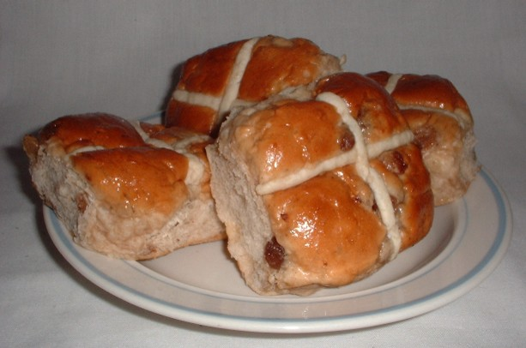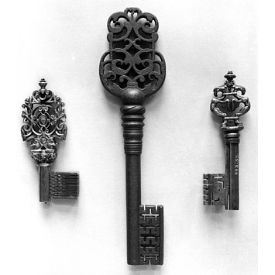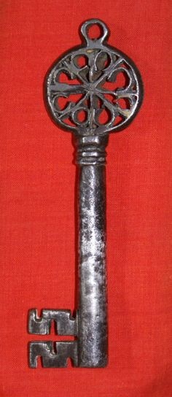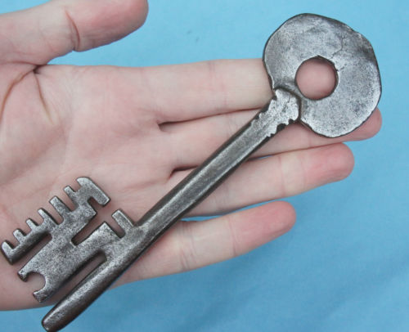

15th century key 16th century key 17th century key Hot Cross Buns