Why Not Uganda? Understanding the Holiness of the Land
Adam Friedmann – afriedmann@torontotorah.com
- Declaration of the British Government
allocating a “Jewish Territory” in East Africa (August 29, 1903)
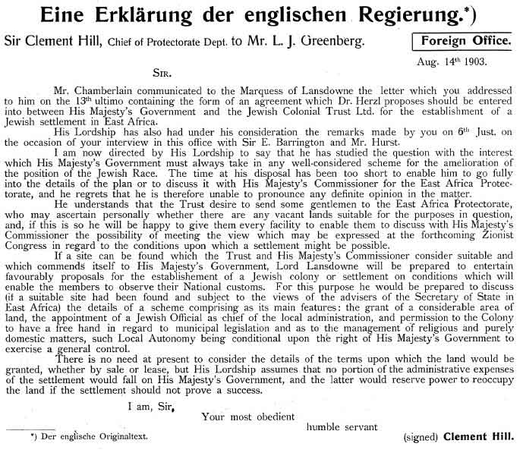

- Mizrachi Centre in Lida Responds to an Inquiring Member, In Sefer Tzionut haDatit, vol 1, p 479
(Dated 9th Nissan 5665)
We have a great deal to respond to his Honour’s words regarding the question of Uganda and the present settlement of the Land of Israel. However, the council has forbidden this office from to speak about this, either good or bad, therefore we are forced to pass over these matters in silence. However, we will ask his Honour one thing: Can he please explain to us why he considers the notion that Uganda will be only a temporary means to achieving the Land of Israel, “sophism”? We think that a Jewish autonomous region would, with its political strength, its economic might, its cultural reality, its various relations with other countries and states, its influence over the Hebrew Nation and its various institutions, be able to accomplish much in this matter. And not only do we believe this, but genius politicians like Chamberlain and Herzl have said similar things. We would be overjoyed if his Honour could prove the error of this perspective.

- The Kuzari, Rabbi Yehudah Halevi, pt 2
The Rabbi: Even so does the glory of God, which is only a ray of the divine light, benefit His people in His country.
Al Khazari: I understand what thou meanest by 'His people,' but less intelligible is what thou sayest about 'His country.'
The Rabbi: Thou wilt have no difficulty in perceiving that one country may have higher qualifications than others. There are places in which particular plants, metals, or animals are found, or where the inhabitants are distinguished by their form and character, since perfection or deficiency of the soul are produced by the mingling of the elements.
…
Whosoever prophesied did so either in the [Holy] Land, or concerning it, viz. Abraham in order to reach it, Ezekiel and Daniel on account of it. The two latter had lived during the time of the first Temple, had seen the Shekhinah, through the influence of which each one who was duly prepared became of the elect, and able to prophesy. Adam lived and died in the land. Tradition tells us that in the cave [of Machpelāh] were buried the four pairs: Adam and Eve, Abraham and Sarah, Isaac and Rebeccah, Jacob and Leah. This is the land which bore the name 'before the Lord,' and of which it is stated that 'the eyes of the Lord thy God are always upon it' (Deut. xi. 12).
…
It was appointed to guide the world, and apportioned to the tribes of Israel from the time of the confusion of languages, as it is said: 'When the Most High divided among the nations their inheritance' (Deut. xxxii. 8). Abraham was not fit to gain the divine influence, and to enter into a mutual compact, until he had, in Palestine, made the covenant with Him 'between the pieces' (Gen. xv. 17).

- The Emergence of Ethical Man, Rabbi Joseph B. Soloveitchik, pp 149-150
Why G-d could not enter into an ultimate relationship with Abraham in Mesopotamia and had to guide him into a new land is an old problem. Judah Halevu, in his Kuzari, explains it with the uniqueness of the Land of Israel as an ideal land for the meeting of God by man. He attributes metaphysical qualities to the land and endows it with a spiritual climate…Nahmanides, in his commentary to Lev. 18:25, followed in Halevi’s footsteps, as did the mystics. For them, the attribute of kedushah, holiness, ascribed to the Land of Israel is an objective metaphysical quality inherent in the land.

With all my respect for the Rishonim, I must disagree with such an opinion. I do not believe that it is halakhically cogent. Kedushah, under a halakhic aspect, is man-made; more accurately, it is a historical category. A soil is sanctified by historical deeds performed by a sacred people, never by any primordial superiority. The halakhic term kedushat ha-aretz, the sanctity of the land, denotes the consequence of a human act, either conquest (heroic deeds) or the mere presence of the people in that land (intimacy of man and nature). Kedushah is identical with man’s association with Mother Earth. Nothing should be attributed a priori to dead matter. Objective kedushah smacks of fetishism.
(For more on Rabbi Soloveitchik’s position about kedushat ha-aretz see http://bit.ly/2yRAbLu and http://bit.ly/2gE4mvw)

- Rambam, Laws of Terumah, 6:5 (Translation from Chabad.org)
כל שהחזיקו עולי מצרים ונתקדש קדושה ראשונה כיון שגלו בטלו קדושתן, שקדושה ראשונה לפי שהיתה מפני הכיבוש בלבד קדשה לשעתה ולא קדשה לעתיד לבוא, כיון שעלו בני הגולה והחזיקו במקצת הארץ קדשוה קדושה שנייה העומדת לעולם לשעתה ולעתיד לבוא, והניחו אותם המקומות שהחזיקו בהם עולי מצרים ולא החזיקו בהם עולי בבל כשהיו ולא פטרום מן התרומה והמעשרות כדי שיסמכו עליהם עניים בשביעית, ורבינו הקדוש התיר בית שאן מאותם המקומות שלא החזיקו בהם עולי בבל והוא נמנה על אשקלון ופטרה מן המעשרות.
All of the lands that [the Jews] who ascended from Egypt took possession of were sanctified in the first consecration [of the land]. When they were exiled, that sanctity was nullified. [The rationale is that] the initial consecration came about because of the conquest. [Hence,] its consecration was effective for the time [it was under their rule], but not for all time. When, by contrast, the descendants of the exiles ascended [from Babylon] and took possession of a portion of the land,24 they consecrated it a second time. [This consecration] is perpetuated forever, for that time and for all time.

- Ramban, Laws of the Sanhedrin, 4:6 (Translation from Chabad.org)
אין סומכין זקנים בחוצה לארץ ואף על פי שאלו הסומכין נסמכו בארץ ישראל, אפילו היו הסומכין בארץ והנסמך חוצה לארץ אין סומכין, ואין צריך לומר אם היו הסומכין בחוצה לארץ והנסמכין בארץ, היו שניהם בארץ סומכין אותו אף על פי שאינו עם הסמוכים במקום אחד, אלא שולחין לו או כותבין לו שהוא סמוך ונותנין לו רשות לדון דיני קנסות הואיל ושניהם בארץ, וכל ארץ ישראל שהחזיקו בה עולי מצרים ראויה לסמיכה.
Semichah may not be conveyed upon elders in the diaspora even if the judges conveying semichah received semichah in Eretz Yisrael. Even if the judges conveying semichah were in Eretz Yisrael and the elders to receive semichah were in the diaspora, they should not convey semichah. Needless to say, this applies if the judges conveying semichah were in the diaspora and the elders to receive semichah were in Eretz Yisrael. If both of them were in Eretz Yisrael, semichah may be conveyed even though the recipients are not in the same place as those conveying semichah. Instead, the judges conveying semichah send to the elder or write to him that he has been given semichah and that he has permission to adjudicate cases involving financial penalties. This is acceptable, because both of them are located in Eretz Yisrael. The entire area of Eretz Yisrael which the Jews who left Egypt took possession of is fit to have semichah conveyed within it.

