|  |  |
| --- | --- |
| Cantonists  Кантонисты  Tzar Nicholas I of Russia (1796-1855)  Reign: 1825-1855 |  |

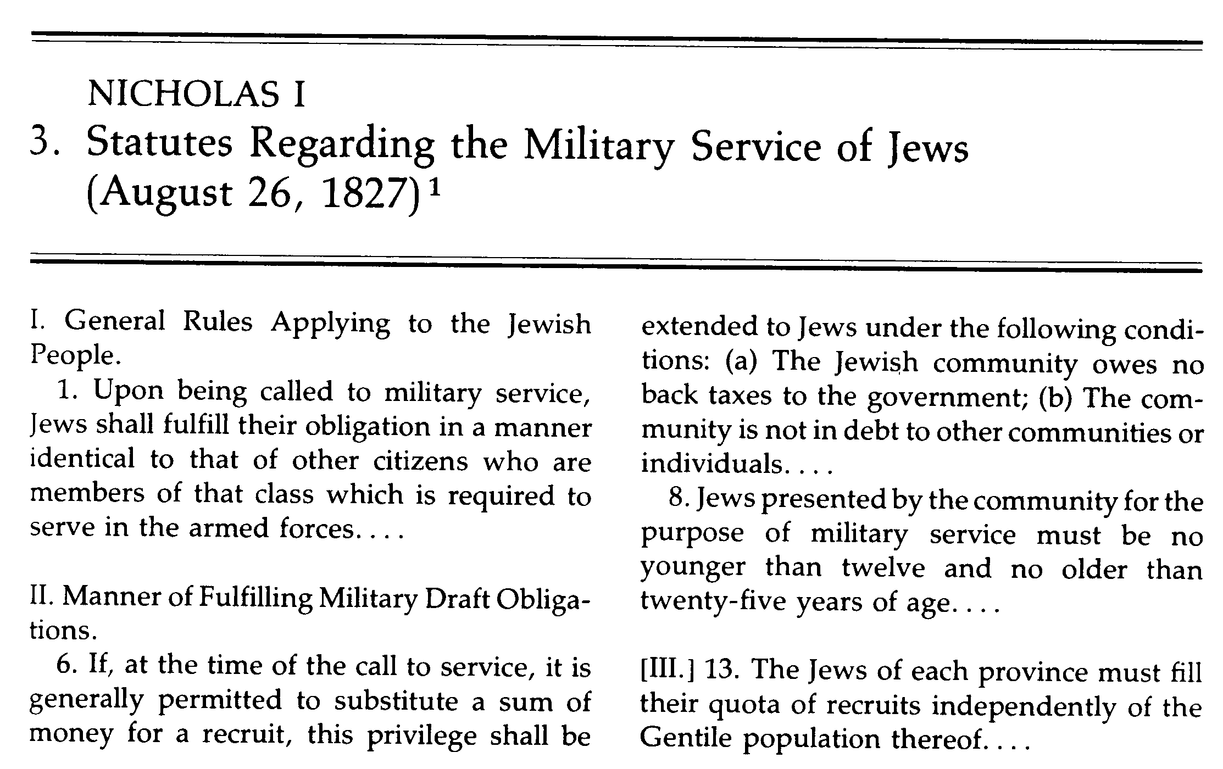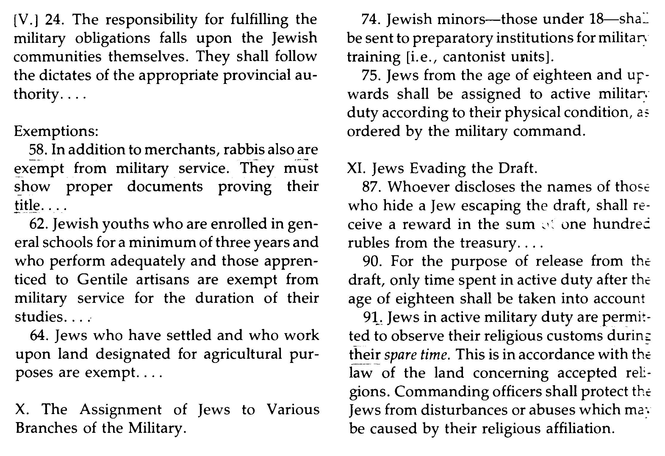

|  |  |
| --- | --- |
| Simon Dubnov*, History of the Jews of Russia and Poland*, vol II, pp 209:  How these unfortunate youngsters were driven to their places of destination we learn from the description of Alexander Hertzen [a famous Russian writer (1812-1870), was exiled to the government of Vyatka for propagating liberal doctrines], who chanced to meet a batch of Jewish cantonists on his involuntary journey through Vyatka, in 1835. At one of the post stations in some God-forsaken village of the Vyatka government he met the escorting officer. The following dialogue ensued between the two: | *Hertzen in 1860* |

"Whom do you carry and to what place?"

"Well, sir, you see, they got together a bunch of these accursed Jewish youngsters between the age of eight and nine. I suppose they are meant for the fleet, but how should I know? At first the command was to drive them to Perm. Now there is a change. We are told to drive them to Kazan. I have had them on my hands for a hundred versts or thereabouts. The officer that turned them over to me told me they were an awful nuisance. A third of them remained on the road (at this the officer pointed with his finger to the ground). Half of them will not get to their destination," he added.

"Epidemics, I suppose?", I inquired, stirred to the very core.

"No, not exactly epidemics; but they just fall like flies. Well, you know, these Jewish boys are so puny and delicate. They can't stand mixing dirt for ten hours, with dry biscuits to live on. Again everywhere strange folks, no father, no mother, no caresses. Well then, you just hear a cough and the youngster is dead. Hello, corporal, get out the small fry!"

The little ones were assembled and arrayed in a military line. It was one of the most terrible spectacles I have ever witnessed. Poor, poor children! The boys of twelve or thirteen managed somehow to stand up, but the little ones of eight and ten.... No brush, however black, could convey the terror of this scene on the canvas. Pale, worn out, with scared looks, this is the way they stood in their uncomfortable, rough soldier uniforms, with their starched, turned-up collars, fixing an inexpressibly helpless and pitiful gaze upon the garrisoned soldiers, who were handling them rudely. White lips, blue lines under the eyes betokened either fever or cold. And these poor children, without care, without a caress, exposed to the wind which blows unhindered from the Arctic Ocean, were marching to their death. I seized the officer's hand, and, with the words: "Take good care of them! ", threw myself into my carriage. I felt like sobbing, and I knew I could not master myself....