Out-Pharaohing the Pharaoh
jziring@torontorah.com

Was There an Exodus: Joshua Berman, http://mosaicmagazine.com/essay/2015/03/was-there-an-exodus/
Here a few words of background are in order. Like all great ancient empires, ancient Egypt waxed and waned. The zenith of its glory was reached during the New Kingdom, roughly 1500-1200 BCE. It was then that its borders reached their farthest limits and many of the massive monuments still visible today were built. We have already met the greatest pharaoh of this period: Ramesses II, also known fittingly as Ramesses the Great, who reigned from 1279 to 1213. Ramesses’ paramount achievement, which occurred early in his reign, was his 1274 victory over Egypt’s arch-rival, the Hittite empire, at the battle of Kadesh: a town located on the Orontes River on the modern-day border between Lebanon and Syria. Upon his return to Egypt, Ramesses inscribed accounts of this battle on monuments all across the empire. Ten copies of the inscriptions exist to this day. These multiple copies make the battle of Kadesh the most publicized event anywhere in the ancient world, the events of Greece and Rome not excepted. Moreover, the texts were accompanied by a new creation: bas reliefs depicting the battle, frame by frame, so that—much as with stained-glass windows in medieval churches—viewers illiterate in hieroglyphics could learn about the pharaoh’s exploits.
Enter now a longstanding biblical conundrum. Scholars had long searched for a model, a precursor, that could have inspired the design of the Tabernacle that served as the cultic center of the Israelites’ encampment in the wilderness, a design laid out in exquisite verbal detail in Exodus 25-29….In the throne tent, displayed in tighter focus below, the emblem bearing the pharaoh’s name and symbolizing his power is flanked by falcons symbolizing the god Horus, with their wings spread in protection over him…In Exodus (25:20), the ark of the Tabernacle is similarly flanked by two winged cherubim, whose wings hover protectively over it. To complete the parallel, Egypt’s four army divisions at Kadesh would have camped on the four sides of Ramesses’ battle compound; the book of Numbers (2) states that the tribes of Israel camped on the four sides of the Tabernacle compound. The resemblance of the military camp at Kadesh to the Tabernacle goes beyond architecture; it is conceptual as well. For Egyptians, Ramesses was both a military leader and a divinity. In the Torah, God is likewise a divinity, obviously, but also Israel’s leader in battle (see Numbers 10:35-36). The tent of God the divine warrior parallels the tent of the pharaoh, the living Egyptian god, poised for battle….
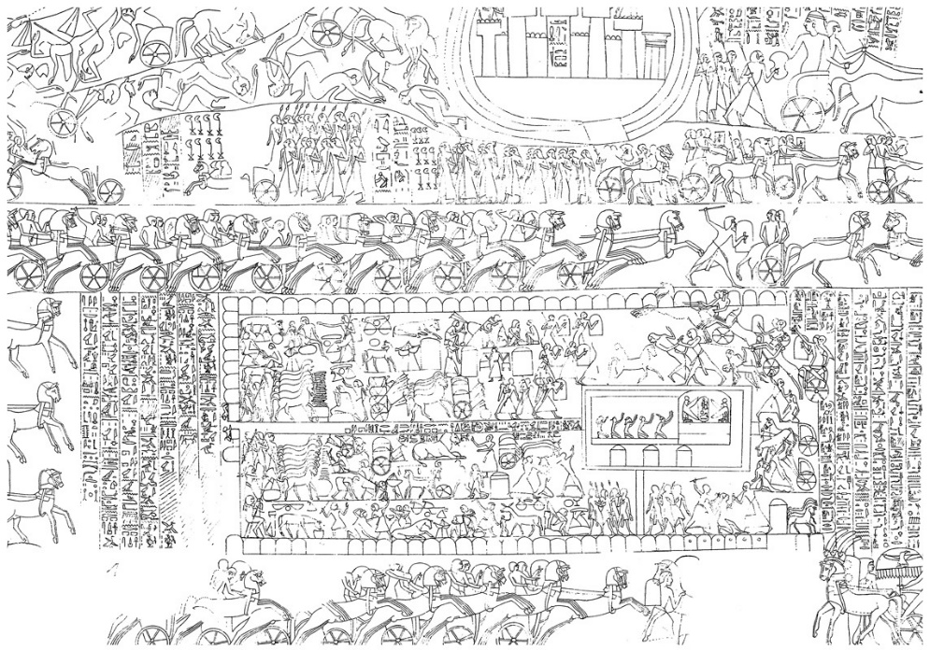
The camp is twice as long as it is wide. The entrance to it is in the middle of the eastern wall, on the left. (In Egyptian illustrations, east is left, west is right.) At the center of the camp, down a long corridor, lies the entrance to a 3:1 rectangular tent. This tent contains two sections: a 2:1 reception tent, with figures kneeling in adoration, and, leading westward (right) from it, a domed square space that is the throne tent of the pharaoh.
All of these proportions are reflected in the prescriptions for the Tabernacle and its surrounding camp in Exodus 25-27, as the two diagrams below make clear:

