Part One: Natural Faith

- Faith Implanted in Humanity

ספר צדקת הצדיק (אות רכט)
Tzidkat HaTzaddik (Reb Tzaddok Hakohen of Lublin)
And this is what the Torah says, “And I am Hashem your God,” which is not stated as a commandment, because it is based on the simple faith that is engrained in the heart of every person. | והיינו אנכי דלא אמר בלשון ציווי כמו שנתבאר במקום  אחר שהוא נגד אמונה פשוטה הקבועה בלב כל איש.
מאמרי הראי"ה – מאורות האמונה
Ma’marei Rav Kook
האמונה אינה לא שכל ולא רגש, אלא גילוי עצמי היותר יסודי של מהות הנשמה... וכשאין משחיתים את דרכה הטבעי לה, איננה צריכה לשום תוכן אחר לסעדה, אלא היא מוצאה בעצמה את הכל.
Faith is neither intellect nor emotion, rather it is the revelation of the most basic and essential self… And when nothing destroys its natural ways, it does not need anything else to establish it; it on its own finds everything.

- The Divine Encounter

My Bright Abyss, Christian Wiman
When I hear people say they have no religious impulse whatsoever ... I always want to respond: Really? You have never felt overwhelmed by, and in some way inadequate to, an experience in your life, have never felt something in yourself staking a claim beyond yourself, some wordless mystery straining through word to reach you? Never?

God and the Philosophers, Suspicions of Something More – Thomas V. Morris (page 16)
One professor I got to know well at Yale once told me that he was an atheist and that he did not accept the reality of anything like a soul or a spirit in the human domain, but that one thing worried him: Enter a room full of intelligent and sincere people, loosen them up a bit so that they’re comfortable talking about personal matters, and you’ll often hear some strange stories along these very lines, stories that it’s terribly hard to make sense of, apart from something like a religious view of the world… What do you do when people you respect, admire, and otherwise completely trust tell tales such as these? You begin to be suspicious, despite any inclinations you might have to the contrary, that there may indeed be a great deal more to life than meets the eye.

Alfred Tennyson, The Two Voices
Moreover, something is or seems
That touches me with mystic gleams,
Like glimpses of forgotten dreams –
Of something felt, like something here;
Of something done, I know not where;
Such as no language may declare.

- God in Nature

The World is Charged With The Grandeur of God
– G.M. Hopkins

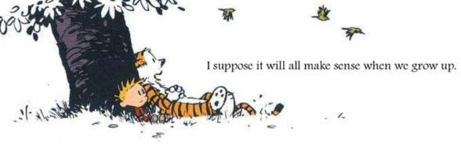
God and the Philosophers – Philosophy and Faith, Laura L. Garcia (page 174)
The second most powerful influence on my own acceptance of a spiritual realm was the natural beauty and grandeur of the Pacific Northwest, where I grew up. The rugged mountains of the Cascade range, with their unapproachable cliffs and wild, raging rivers, and the timeless thundering of the surf along the Oregon coast made a very deep impression on me. I still feel, with Wordsworth, that there are places where it is almost impossible to stand without coming to believe that one is fact to face with the divine.

רמב"ם משנה תורה, פ"ב מהל' יסודי התורה ה"ב
Maimonides, Laws of the Foundations of the Torah 2:2
והיאך היא הדרך לאהבתו ויראתו בשעה שיתבונן  האדם במעשיו וברואיו הנפלאים הגדולים ויראה  מהן חכמתו שאין לה ערך ולא קץ מיד הוא אוהב ומשבח ומפאר ומתאוה תאוה גדולה לידע השם  הגדול כמו שאמר דוד צמאה נפשי לאלהים לאל  חי וכשמחשב בדברים האלו עצמן מיד הוא נרתע  לאחוריו ויפחד ויודע שהוא בריה קטנה שפלה  עומדת בדעת קלה מעוטה לפני תמים דעות. | What is the path [to attain] love and fear of Him?  When a person contemplates His wondrous and great deeds and creations and appreciates His infinite wisdom that surpasses all comparison, he will immediately love, praise, and glorify [Him], yearning with tremendous desire to know [God's] great name, as David stated: "My soul thirsts for the Lord, for the living God" [Psalms 42:3]. When he [continues] to reflect on these same matters, he will immediately recoil in awe and fear, appreciating how he is a tiny, lowly, and dark creature, standing with his  flimsy, limited, wisdom before He who is of perfect knowledge.

- The Meaning-Seeking Being

Leo Tolstoy, A Confession (Page 28)
My question – that which at the age of fifty brought me to the verge of suicide – was the simplest of questions, lying in the soul of every man from the foolish child to the wisest elder: it was a question without an answer to which one cannot live, as I had found by experience. It was: “What will come of what I am doing today or shall do tomorrow? What will come of my whole life? ... Why should I live, why wish for anything, or do anything?” It can also be expressed thus: “Is there any meaning in my life that the inevitable death awaiting me does not destroy? … I was inevitably brought to acknowledge that all live humanity has another irrational knowledge – faith which makes it possible to live.

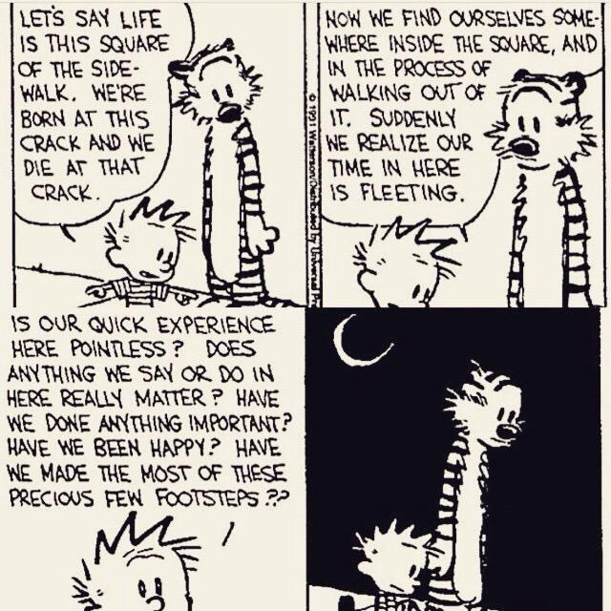

36 Arguments for the Existence of God, Rebecca Newberger Goldstein (Page 18)
At moments like this, could Cass altogether withstand the sense that—hard to put it into words—the sense that the universe is personal, that there is something personal that grounds existence and order and value and purpose and meaning – and that the grandeur of that personal universe has somehow infiltrated and is expanding his own small person, bringing his littleness more into line with its grandeur, that the personal universe has somehow infiltrated and is expanding his own small person, bringing his littleness more into line with its grandeur, that the person universe has been personally kind to him, gracious and forgiving, to Cass Seltzer, gratuitously, exorbitantly, divinely kind, and that despite Cass’s having, with callowness and shallowness aforethought, thrown spitballs at the whole idea of cosmic intentionality?

To know an answer to the question, ‘What is the meaning of human life?’ means to be religious. - Albert Einstein

The idea of life having a purpose stands and falls with the religious system. - Sigmund Freud

To believe in God means to understand the question about the meaning of life. To believe in God means to see that the facts of the world are not the end of the matter. To believe in God means to see that life has a meaning. - Ludwig Wittgenstein

