Part Two: **The Skeptical Inhibitor**

**God and the Philosophers, A Philosopher’s Way Back – William P. Alston, page 22**

I had been psyched into feeling that I was chickening out, was betraying my adult status, if I sought God… I was walking one afternoon in the country outside Oxford, wrestling with the problem, when I suddenly said to myself, “Why should I allow myself to be cribbed, cabined, and confined by these Freudian ghosts? Why should I be so afraid of not being adult? What am I trying to prove? Whom am I trying to impress? Whose approval am I trying to secure? ….Why should I hold back from opening myself to a transcendent dimension of reality, if such there be, just from fear of being branded as childish in some quarters?

1. **The Limits of Reason**

1. **The Problem of the Criterion - Chrisholm, Roderick M. *The Foundations of Knowing***

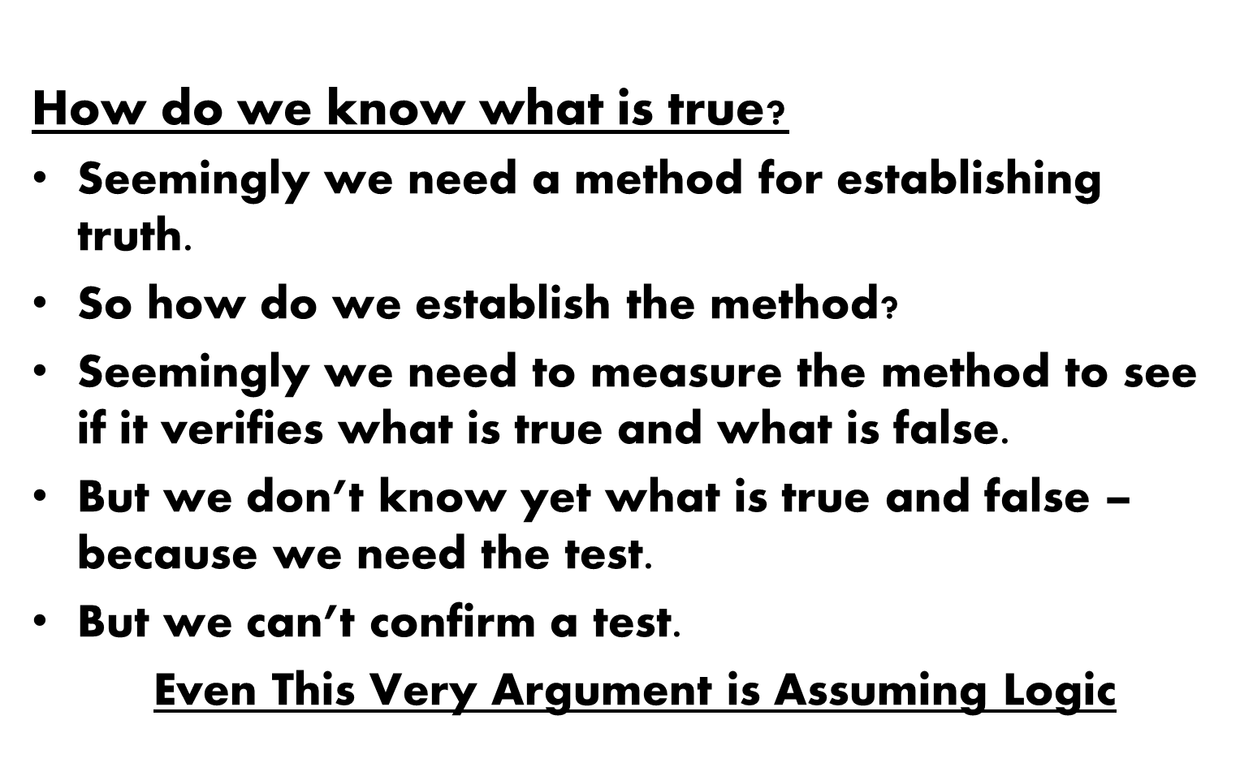

1. **James – The Will to Believe (The Right to Believe)**



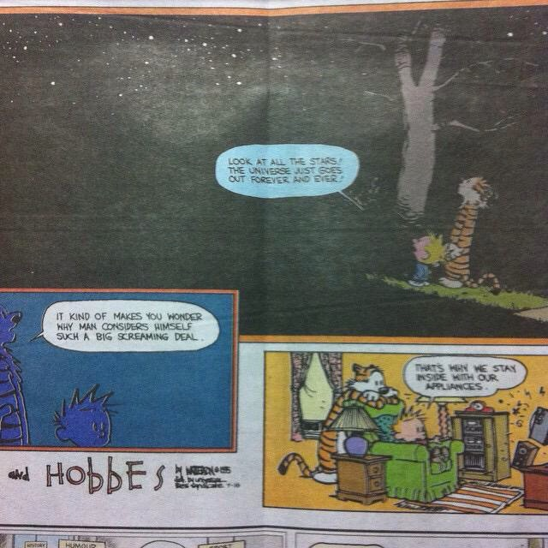

1. **There is More To Us Than Our Minds**

**God and the Philosophers, The Over-Examined Life is Not Worth Living - David Shatz**

Hume was fascinated by the divorce between philosophy and practical life. In my study, he said, I come to appreciate that I lack adequate grounds for all sorts of things I take for granted in my life—the regularity of nature, the reality of the physical world; yet when I exit, those intellectual infirmities have not the slightest influence on my belief system. A philosophical skeptic, someone who casts doubt on our grounds for these and other common beliefs, cannot *live* his skepticism, Hume holds. Even in his study, in fact, Hume isn’t really a skeptic. He doesn’t doubt he’s putting pen to paper, and doesn’t wonder whether the paper will abruptly pop out of existence. That nobody is *really* a skeptic—*even* while philosophizing—becomes clear if you watch what we philosophers do, not what we say. When a philosopher publishes an article called “Why There Are No People” (an actual title!), he invites a joke: Whom does he think he’s writing for? Whom will he blame if he gets turned down for tenure?

Hume’s point, however, was probably normative as well as descriptive. Hume taught us, in effect, that it is a vice to be too rational, to hold out for rigorous arguments in all walks of life. Only a mad person would want to conduct his or her life with complete, Spock-like logicality. **We are possessed not of minds alone, but of hearts, emotions, needs, instincts, and habits; and we inhabit social contexts.**

1. **Our Challenge, Modern Orthodoxy**

**Elli Fischer, Modern Orthodoxy Has Its Costs – Not Just Financial, Jewish Week, February 2015**

The pressure to produce high earners discourages and marginalizes those members of the community whose calling is in music, literature, the visual arts, or the performing arts. The problem is not only that creative types will likely be unable to afford the Modern Orthodox lifestyle; the community itself tends to marginalize those who pursue artistic careers, viewing them as irresponsible.

1. **From Thought To Experience:**

***Faith as an Encounter and Relationship***

**God and the Philosophers – Philosophy and Faith, Laura L. Garcia (pages 174-5)**

Some will see in this nothing more than a short and unconvincing version of the design argument for God’s existence, but that is not how I would describe it. Rather, it seemed to me as though I felt God’s presence in the beauty of these natural wonders, that I was standing before Him, their maker and their life… From the perspective of the believer, coming to God often seems more like an encounter than like solving a math problem.

**The Lonely Man of Faith, Rabbi Joseph B. Soloveitchik (**Footnote I, page 51)

The trouble with all rational demonstrations of the existence of God, with which the history of philosophy abounds, consists in their being exactly what they were meant to be by those who formulated them: abstract logical demonstrations divorced from the living primal experiences in which these demonstrations are rooted. For instance, the cosmic experience was transformed into a cosmological proof… Does the loving bride in the embrace of her beloved ask for proof that he is alive and real? Must the prayerful soul clinging in passionate love and ecstasy to her Beloved demonstrate the He exists?

**Faith and Doubt, Rabbi Norman Lamm**

Martin Buber speaks of *Two Types of Faith* – the name of one of his books. One is a state of *acknowledgment*, in which I accept, with my whole being and not only my reason, certain propositions as true. The other is a relationship of *trust* where, again not necessarily with sufficient reason, I commit my confidence in another. For our purposes, let us sharpen that distinction. The first, that of acknowledgement, is a *cognitive* type of faith, in which I intellectually accept certain propositions as true – such as the existence and unity of God… This is a “belief-that” type of faith; *that* God exists, *that* He is One, *that* He is incorporeal. The content of this faith is noetic, its mode is intellectual. The second type, that of *trust*, is not “belief-that” but “belief-in.” Regardless of the thoughts I entertain *about* God, regardless of my theology and dogmas I affirm, I believe *in* Him: I trust and esteem Him. **This is the area not of propositions but of relationship;** it is not existential in the logician’s sense, but existential in the existentialist’s sense.

**Faith and Doubt, Rabbi Norman Lamm**

Perhaps the most radical exponent of *emunah temimah* in fairly modern times was the Hasidic Zaddik, R. Nahman Bratzlaver; yet one need but read his writings, and the writings about him by his leading disciple and biographer, to realize that he was an extraordinarily complicated man who had suffered the worst torments of doubt, who had studied Maiomonides’ *Guide*, and who had struggled valiantly in order to achieve the blessed *temimut* which he recommended over the theological sophistication for which he had such contempt. Simple faith is not the same as simplemindedness.