Rav Kook, The Rav and The Rebbe #21 – The Rav on the Haggadah
Festival of Freedom, “Slavery and Freedom”
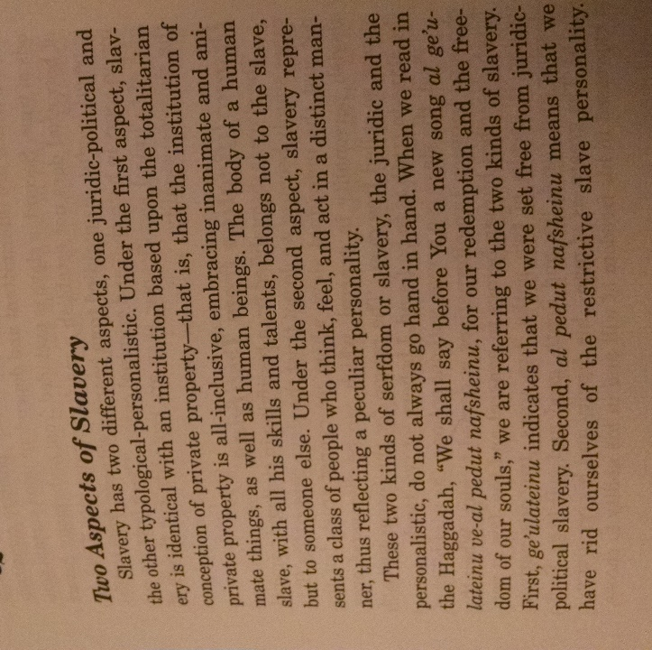
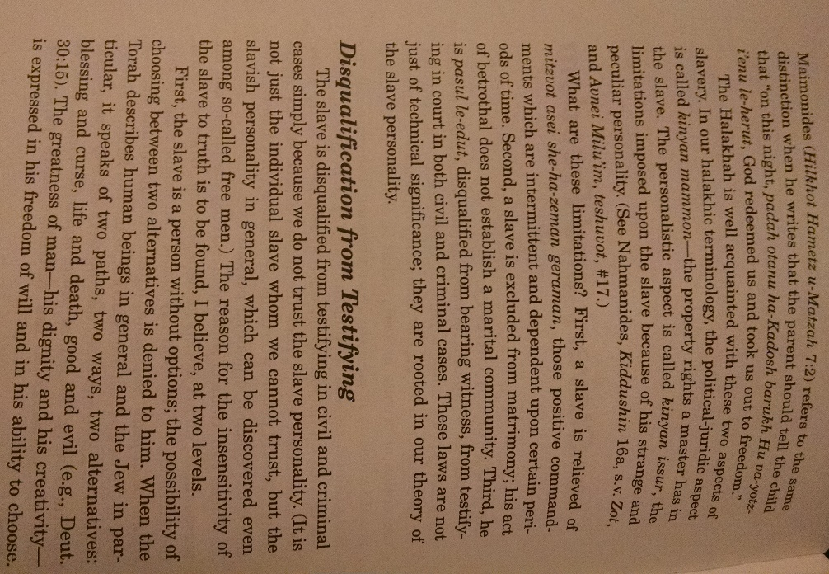

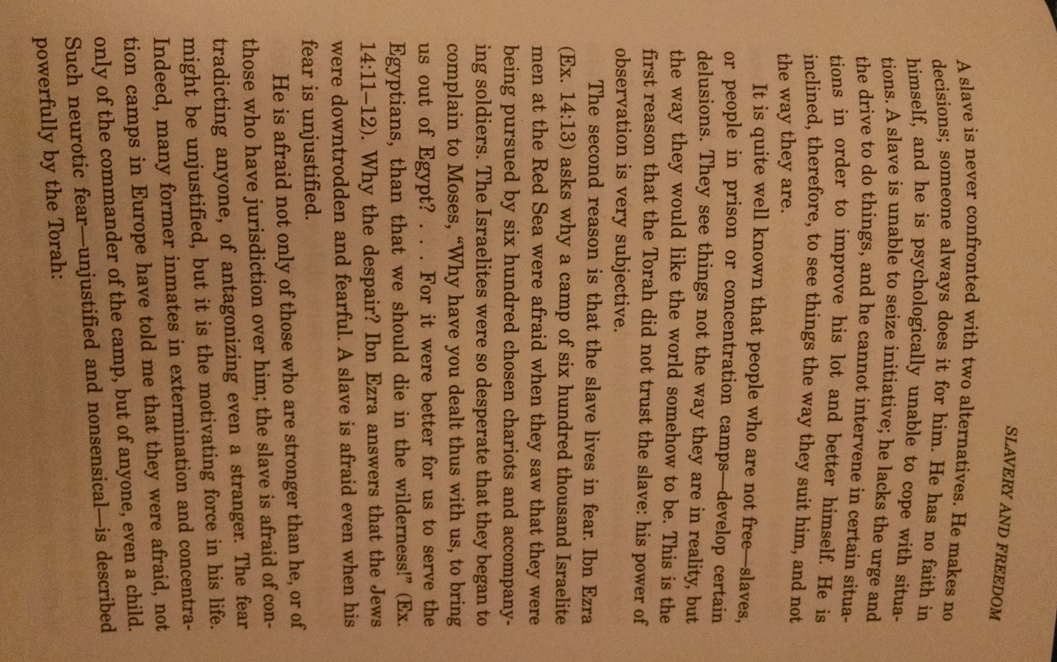

Halakhic Man, page 109
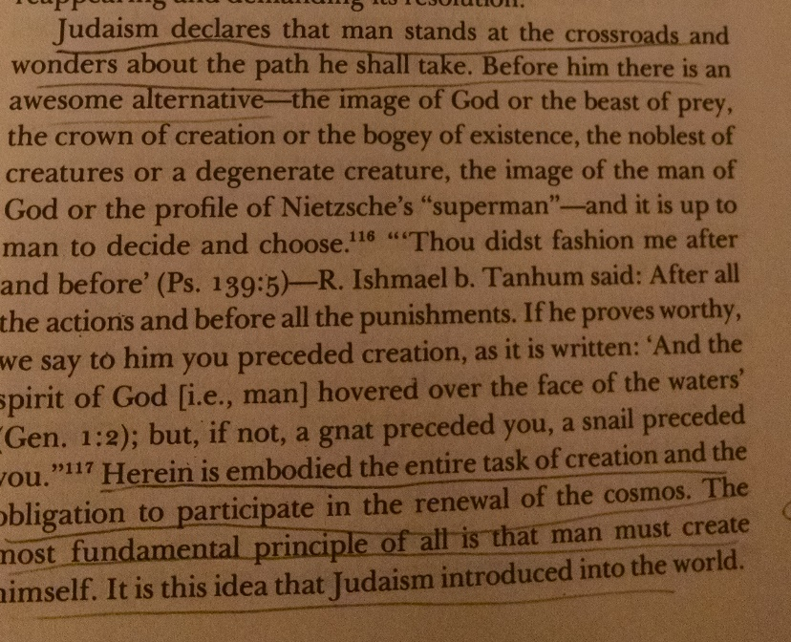

מפניני הרב עמוד קיב
אנוס על פי הדיבור דאילו היה יעקב אבינו עוזב את ארץ ישראל על דעת עצמו היה מאבד את זכותו בארץ כמו עשו וכדכתיב בפרשת וישלח לו ו ויקח עשו את נשיו ואת בניו ואת בנותיו וכו' וילך אל ארץ מפני יעקב אחיו ועיי"ש ברש"י שהביא שם מדרש אגדה מפני שטר חוב וכו' אמר אלך לי מכאן אין לי חלק במתנה שניתנה לו הארץ הזאת וכו'
והוסיף עוד רבנו בזה דיוסף היה משנה למלך במצרים ולא היה יכול לחזור לארץ ישראל ובפני יעקב אבינו היו שתי אפשרויות או שירד למצרים עם שאר כל השבטים בכדי לאחד את כלל ישראל או להשאר בארץ ישראל להחזיק ביישוב הארץ למרות הפירוד שבכלל ישראל והחלטתו היתה שאחדות כלל ישראל עדיפא וחשובה יותר מאשר ענין הדירה בארץ ישראל

Rabbi Aton Holtzer, file:///C:/Users/yzbro/Downloads/rav-soloveitchik-on-the-pesach-haggadah.pdf
In the seventh Perek of Rambam’s laws of chametz and matzah, The Rambam writes: אפילוּ Even - "חכמים גדוֹלים חייבים לספר ביציאת מצרים וכל המאריך בדברים שׁאירעוּ ושׁהיוּ הרי זה משׁוּבח great sages are required to tell of Yetzias Mitzrayim, and all who lengthen their discussion of what happened and took place is praiseworthy." The Rambam was always extremely careful in his wording. At first glance, ושׁהיוּ שׁאירעוּwould appear to mean the exact same thing - "that happened." The Rambam was never prone to redundancy, and each word that he uses has meaning. In Hebrew, if one describes a situation such as his falling from a tree, he uses the word שׁאירע .If he describes a circumstance as one in which he climbed up a tree, he uses the word שׁהיה .שׁאירעmeans that something happened to an object that was passive; the gravitational pull caused the person to fall from the tree - the force overwhelmed him. שׁהיה ,however, denotes that the object was active, that he executed a conscious decision, that he utilized his energy to accomplish an objective that he had set for himself. By climbing up the tree, the man implemented his decision to climb it. In Mitzrayim, was the Ge'ulah שׁאירע ,where an outside force imposed itself upon B'nei Yisrael, or שׁהיה ,that we acted as human beings endowed with freedom and consciously implemented our choice? According to the Rambam, these both were present in Yetzias Mitzrayim. The question whether the Ge'ulah merely 'happened' to the Jew, or whether he was a participant who caused the Ge'ulah, is the debate that we find in the Gemara about the meaning of גנוּת and שׁבח .According to Shmuel, the ושׁבח גנוּת is היינוּ עבדים ,the physical Ge'ulah, the שׁאירעוּ - the Jew was merely pulled by force; he was enslaved against his will and redeemed without his participation.
According to Rav, who says that the ושׁבח גנוּת is אבוֹתינוּ היוּ זרה עבוֹדה עוֹבדי מתחילה" ,from the beginning our ancestors were idol worshippers," that our redemption was from being idol worshippers to worshippers of Hashem, how did the Ge'ulah take place? Was Avraham forced to choose G-d? Spiritual redemption from idolatry, paganism and primitive religions and cults can happen only with חפשׁית בחירה ,freedom of choice; it does not just "happen" to a Jew. Avraham realized that idolatry was wrong and saw the mistakes of paganism, so he chose G-d. No spirituality is decreed upon man by G-d unless man agrees to commit himself to the idea. מתחילה is not שׁאירעוּ ;it is שׁהיוּ . Certain events in Mitzrayim were שׁאירעוּ .Though Moshe told the Jews far in advance of the Ge'ulah, they still were not prepared. Matzah is the symbol of their unpreparedness, of שׁאירעוּ . However, התוֹרה קבלתwas שׁהיוּ ;the Torah was not imposed upon the Jew involuntarily. There is no involuntary גירוּת ;Matan Torah was only a possibility once there was ויאמרוּ יחדו העם כל ויענוּ נעשׂה' ה דבר אשׁר כל .At סיני הר ,the Jew was an active participant in events. This is שׁהיוּ

Festival of Freed, “In the Inner Transformation of Seder Night”
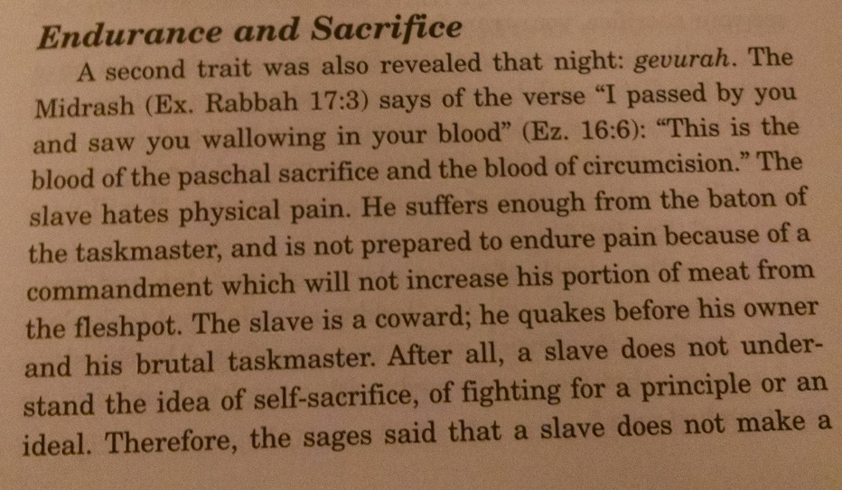

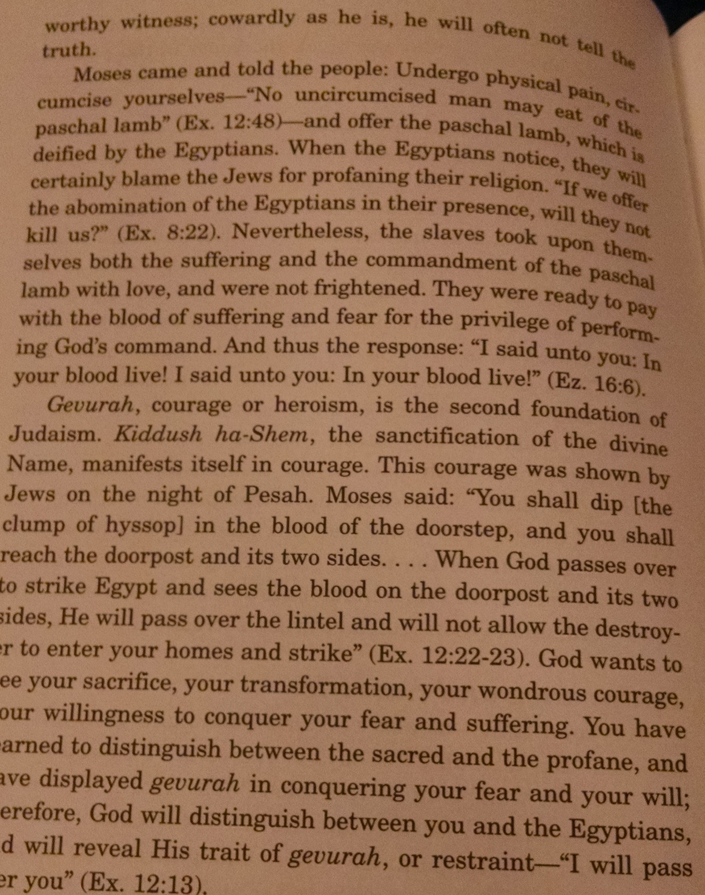

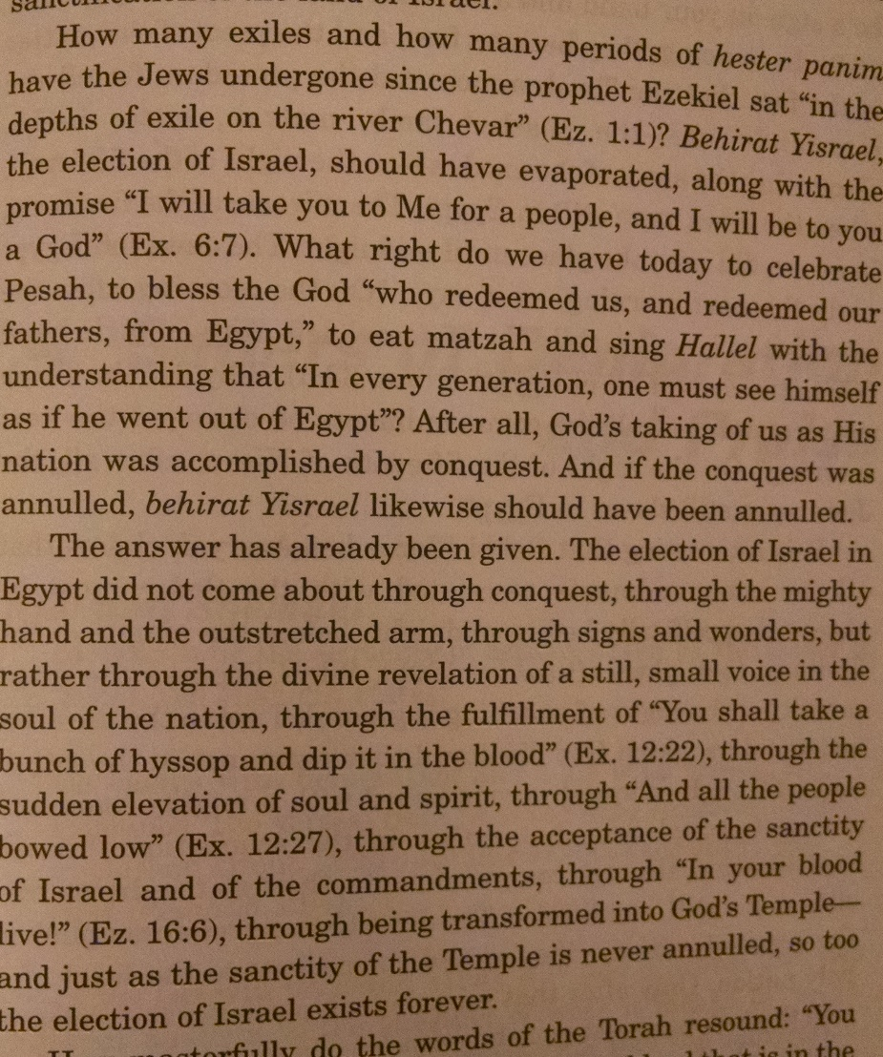

Festival of Freedom, 61-62
We have a story of personal freedom, the adventure of man in his attempt to raise himself from a natural, determined and mechanical existence to a state of autonomy and freedom. Everyone is in bondage to the unalterable order of things and events, to Pharoah. One is born into a slave world, into an environment of rigid causation and regularity. One is thrust into an alien, indifferent, alas cruel world, where he is not master but slave to events not of his making. Only through an act of sheer heroism can one free himself from this order and mold a new inner experience.

In a word, free will is not a grant given to man, but a challenge he confronts, which he can and must meet. It is an objective he is summoned to realize, and the exodus narrative is the dramatic presentation of his encounter, of his combat with and victory over his antagonist, namely, the slave order and slave existence.

