Ancient Texts Modern Dilemmas
A Prayer for the Welfare of the Government?
Rabbi Sammy Bergman- sbergman@torontotorah.com

Fiddler on the Roof
Leibesh: Is there a proper blessing... for the Tzar?
Rabbi: A blessing for the Tzar…of course! May God bless and keep the Czar…far away from us!
Modern Opposition
- Rabbi Jonathan Muskat (Facebook, December 2016)
I don't think I fully processed the impact of President Obama's betrayal of the State of Israel by not vetoing the anti-Israel UN resolution until last Saturday night. Upon reflection and after being utterly disgusted by Secretary of State John Kerry's rebuke of Israel yesterday, I don't see how I can recite a prayer that explicitly blesses President Obama anymore in shul. At the same time, I am aware of the danger of not reciting a prayer for the government when you don't like the government's policies. Where do you draw the line? Honest and vigorous political debate is good, but not when it is time to pray. We all pray together, Republicans and Democrats alike, in a spirit of unity. It is important that we have a fixed prayer expressing our gratitude that we live in a medina shel chesed like the United States…
- Rabbi Shmuly Yanklowitz (facebook, January 2017)
Because of my commitment to the integrity of prayer, starting this week, I can no longer recite or say amen to the Shabbat prayer for the success of the US President.
So I have drafted a new prayer that I will plan to recite each Shabbat morning. If you also feel it's important to pray for the US government but also feel you cannot pray for the success of this President, feel free to adapt it as you please. I felt that it is not enough to simply avoid the US President in the prayer for the government but to remind myself of the billions of vulnerable people who are at risk under his rule, and challenge myself each Shabbat to build up the strength for another week of spiritual resistance.
History of Praying for the King
- Jeremiah 29:4-7 (JPS Tanakh 1985 translation)
(ד) כֹּ֥ה אָמַ֛ר ה' צְבָקוֹת אֱלֹק֣י יִשְׂרָאֵ֑ל לְכָל־הַ֨גּוֹלָ֔ה אֲשֶׁר־הִגְלֵ֥יתִי מִירוּשָׁלִַ֖ם בָּבֶֽלָה׃ (ה) בְּנ֥וּ בָתִּ֖ים וְשֵׁ֑בוּ וְנִטְע֣וּ גַנּ֔וֹת וְאִכְל֖וּ אֶת־פִּרְיָֽן׃ (ו) קְח֣וּ נָשִׁ֗ים וְהוֹלִידוּ֮ בָּנִ֣ים וּבָנוֹת֒ וּקְח֨וּ לִבְנֵיכֶ֜ם נָשִׁ֗ים וְאֶת־בְּנֽוֹתֵיכֶם֙ תְּנ֣וּ לַֽאֲנָשִׁ֔ים וְתֵלַ֖דְנָה בָּנִ֣ים וּבָנ֑וֹת וּרְבוּ־שָׁ֖ם וְאַל־תִּמְעָֽטוּ׃ (ז) וְדִרְשׁ֞וּ אֶת־שְׁל֣וֹם הָעִ֗יר אֲשֶׁ֨ר הִגְלֵ֤יתִי אֶתְכֶם֙ שָׁ֔מָּה וְהִתְפַּֽלְל֥וּ בַעֲדָ֖הּ אֶל ה' כִּ֣י בִשְׁלוֹמָ֔הּ יִהְיֶ֥ה לָכֶ֖ם שָׁלֽוֹם׃
(4)Thus said the LORD of Hosts, the G-d of Israel, to the whole community which I exiled from Jerusalem to Babylon: (5) Build houses and live in them, plant gardens and eat their fruit. (6) Take wives and beget sons and daughters; and take wives for your sons, and give your daughters to husbands, that they may bear sons and daughters. Multiply there, do not decrease. (7) And seek the welfare of the city to which I have exiled you and pray to the LORD in its behalf; for in its prosperity you shall prosper.
- Baruch Chapter 1-11-12
And pray for the life of Nabuchodonosor king of Babylon, and for the life of Balthasar his son, that their days may be upon earth as the days of heaven: And the Lord will give us strength, and lighten our eyes, and we shall live under the shadow of Nabuchodonosor king of Babylon, and under the shadow of Balthasar his son, and we shall serve them many days, and find favour in their sight.
- Pirkei Avot 1:10 (translation from Dr. Joshua Kulp)
שְׁמַעְיָה וְאַבְטַלְיוֹן קִבְּלוּ מֵהֶם. שְׁמַעְיָה אוֹמֵר, אֱהֹב אֶת הַמְּלָאכָה, וּשְׂנָא אֶת הָרַבָּנוּת, וְאַל תִּתְוַדַּע לָרָשׁוּת:
Shemaiah and Abtalion received [the oral tradition] from them. Shemaiah used to say: love work, hate acting the superior, and do not attempt to draw near to the ruling authority.

- Pirkei Avot 2:3 (translation from Dr. Joshua Kulp)
הֱווּ זְהִירִין בָּרָשׁוּת, שֶׁאֵין מְקָרְבִין לוֹ לָאָדָם אֶלָּא לְצֹרֶךְ עַצְמָן. נִרְאִין כְּאוֹהֲבִין בִּשְׁעַת הֲנָאָתָן, וְאֵין עוֹמְדִין לוֹ לָאָדָם בִּשְׁעַת דָּחְקוֹ
Be careful [in your dealings] with the ruling authorities for they do not befriend a person except for their own needs; they seem like friends when it is to their own interest, but they do not stand by a man in the hour of his distress.
- Pirkei Avot 3:2 (translation from Dr. Joshua Kulp)
רַבִּי חֲנִינָא סְגַן הַכֹּהֲנִים אוֹמֵר, הֱוֵי מִתְפַּלֵּל בִּשְׁלוֹמָהּ שֶׁל מַלְכוּת, שֶׁאִלְמָלֵא מוֹרָאָהּ, אִישׁ אֶת רֵעֵהוּ חַיִּים בְּלָעוֹ.
Rabbi Hanina, the vice-high priest said: pray for the welfare of the government, for were it not for the fear it inspires, every man would swallow his neighbor alive.
- Rabbi David Abudarham, Sefer Abudarham (14th century Spain), translation from Jay Jubas
נהגו לברך את המלך ולהתפלל לשם שיעזרהו ויאמצהו על אויביו שכן כתוב (ירמיה כט, ט) ודרשו את שלום העיר אשר הגליתי אתכם שמה והתפללו בעדה אל ה' כי בשלומה יהיה לכם שלום. ושלום העיר הוא שיתפלל לשם שינצח המלך את אויביו
And they were accustomed to blessing the king and to praying to G-d that He should aid him and strengthen him over his enemies, as it says: And seek the peace of the city where I have caused you to be carried away captives, and pray to the Lord for it; for in its peace shall you have peace. And the peace of the city is that he shall pray to G-d that the king shall defeat his enemies.
Who are we praying for?
- Rabbi Yonah of Gerundi (13th century Spain), commentary on Avot 3:2
זה הענין ר"ל שיש לאדם להתפלל על שלום כל העולם ולהצטער על צער של אחרים. וכן דרכן של צדיקים …שאין לאדם לעשות תחנוניו ובקשתו לצרכיו לבד. אך להתפלל על כל בני אדם שיעמדו בשלום ובשלומה של מלכות יש שלום לעולם:
The idea is that a person should pay for peace in the whole world and empathize with the pain of others. This is the way of the righteous…that a person should not merely pray for their own needs, but should pray for all of humanity that they should stand in peace. If there is peace for the kingdom there is peace for the whole world.
- Rabbi Yisrael Lipschitz (19th century Poland), Tiferet Yisrael on Avot 3:2
ז) בשלומה של מלכות. אפילו של אומות העולם [כירמיה כ"ט פ"ז],… ולכן הזהיר על זה, משום שבשלום המנהיג תלוי הצלחת כל אדם, כמו שיעץ ריב"ז בזמן החורבן [כגיטין נ"ו א'], ולא לבד מלכות, אלא גם כל מנהיג בעירו ועדתו נקרא בשם מלך והוה מתפלל בשלומם כדי שיהיה להם מנוח לפקח על טובת הכלל, ומה"ט עושין מי שברך בכל שבת לפריץ ומלך ונאמר יה"ר בכל יום קריאת התורה בעד לומדי התורה לבעבור כי הם נושאי הנרות לפני בני דורם להנהיגם בדרך ישרה:
For the peace of the kingdom- even of secular nations… therefore he warned about this, because each person’s success is contingent upon welfare of the leader. As Rabbi Yochanan the son of Zakkai advised during the time of the destruction.
- Rabbi Obadiah Seforno (15th century Italy), Avot 3:2
אף על פי שהמלך לפעמים בלתי כשר כמו שקרה ברוב מלכי בית שני והוא אולי גוזל וחומס מכל מקום ראוי להתפלל בשלומו כי אז יטיל מוראו ולא יסכים שיגזלו העם זה את זה ובזה מסיר החמס מבין המון העם.
Even though the king is sometimes improper, as was the case with most of the Kings during the 2nd temple period, and he may even steal and extort, nevertheless it’s appropriate to daven for his welfare so that he will impart his awe and won’t allow the nation to steal from each other. This way he will rid the multitudes of extortion.
Subversive Allusions
תפילה לשלום המדינה | A Prayer for the Welare of the State
הנותן תשועה למלכים וממשלה לנסיכים. מלכותו מלכות כל עולמים, הפוצה את דוד עבדו מחרב רעה, הנותן בים דרך ובמים עזים נתיבה, הוא יברך את הנשיא ואת משניהו ואת כל שרי הארץ הזאת.  מלך מלכי המלכים ברחמיו יתן בלבם ובלב כל יועציהם ושריהם לעשות טובה עמנו ועם כל ישראל. בימיהם ובימינו תושע יהודה וישראל ישכון לבטח, ובא לציון גואל. וכן יהי רצון, ונאמר אמן: | May He who gives salvation to kings and dominion to princes, whose kingdom is an everlasting kingdom, who delivers His servant David from the evil sword, who makes a way in the sea and a path through the mighty waters, bless the President, Vice President and all officials of this land.  May the supreme King of Kings in His mercy put into their hearts and the hearts of all their counselors and officials, to deal kindly with us and all of Israel. In their days and in ours, may Judah be saved and Israel dwell in safety, and may the Redeemer come to Zion. May this be His will, and let us say: Amen

- Psalms 144:9-11 (JPS Tanakh 1985 translation)
(ט) אֱ‍ֽלֹקים שִׁ֣יר חָ֭דָשׁ אָשִׁ֣ירָה לָּ֑ךְ בְּנֵ֥בֶל עָ֝שׂ֗וֹר אֲזַמְּרָה־לָּֽךְ׃ (י) הַנּוֹתֵ֥ן תְּשׁוּעָ֗ה לַמְּלָ֫כִ֥ים הַ֭פּוֹצֶה אֶת־דָּוִ֥ד עַבְדּ֗וֹ מֵחֶ֥רֶב רָעָֽה׃ (יא) פְּצֵ֥נִי וְהַצִּילֵנִי֮ מִיַּ֪ד בְּֽנֵי־נֵ֫כָ֥ר אֲשֶׁ֣ר פִּ֭יהֶם דִּבֶּר־שָׁ֑וְא וִֽ֝ימִינָ֗ם יְמִ֣ין שָֽׁקֶר׃
(9) O G-d, I will sing You a new song, sing a hymn to You with a ten-stringed harp, (10) to You who give victory to kings, who rescue His servant David from the deadly sword. (11) Rescue me, save me from the hands of foreigners, whose mouths speak lies, and whose oaths are false.
- Isaiah 43:16-17 (JPS Tanakh 1985 translation)
(טז) כֹּ֚ה אָמַ֣ר ה' הַנּוֹתֵ֥ן בַּיָּ֖ם דָּ֑רֶךְ וּבְמַ֥יִם עַזִּ֖ים נְתִיבָֽה׃ (יז) הַמּוֹצִ֥יא רֶֽכֶב־וָס֖וּס חַ֣יִל וְעִזּ֑וּז יַחְדָּ֤ו יִשְׁכְּבוּ֙ בַּל־יָק֔וּמוּ דָּעֲכ֖וּ כַּפִּשְׁתָּ֥ה כָבֽוּ׃
(16) Thus said the LORD, Who made a road through the sea And a path through mighty waters, (17) Who destroyed chariots and horses, And all the mighty host— They lay down to rise no more, They were extinguished, quenched like a wick:
- Gary Rosenblatt, Pray For The President? A Divine Dilemma, The New York Jewish Week
Whether you are inclined to curse or pray for Donald Trump and his new administration, the new president could surely benefit from Divine guidance. And it might be a good idea for each of us to take a deep breath and focus on what we have in common — a love of our country and its freedoms — and do our best to ensure that America moves forward with both strength and compassion.

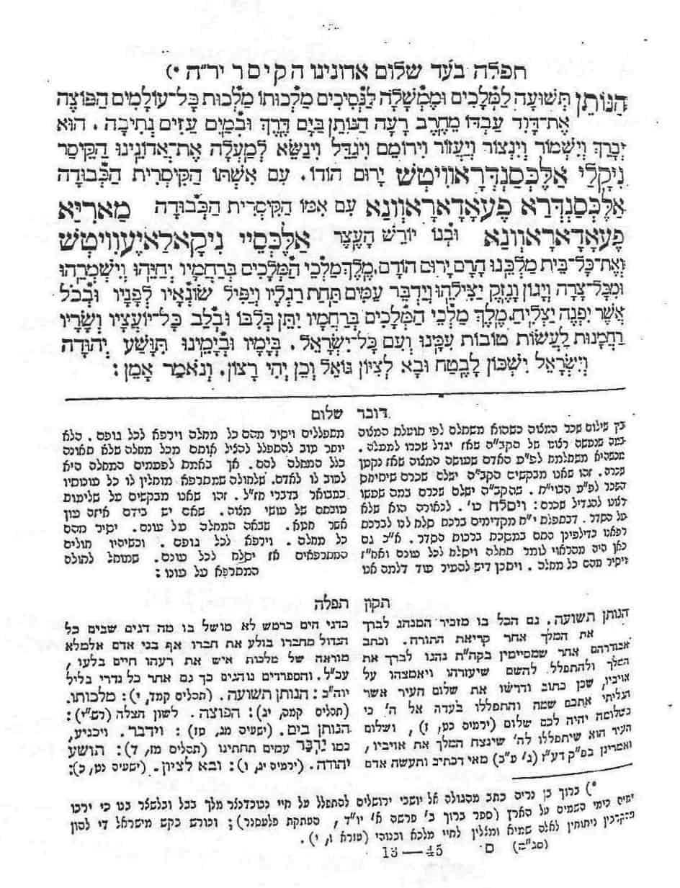

Picture obtained from https://thelehrhaus.com/scholarship/praying-for-governments-we-dislike/

