Humour or Humiliation?
Adath Israel Congregation
Rabbi Sammy Bergman- sbergman@torontotorah.com

- JongEun Yim, Therapeutic Benefits of Laughter in Mental Health: A Theoretical Review
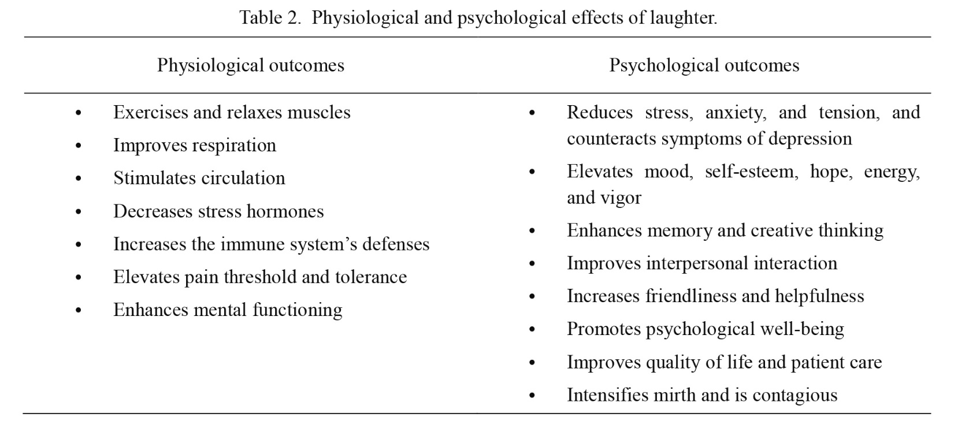
Humor in the Torah and Rabbinic Literature
- Shemot 14:11 (JPS Tanakh 1985 translation)
As Pharaoh drew near, the Israelites caught sight of the Egyptians advancing upon them. Greatly frightened, the Israelites cried out to the LORD. And they said to Moses, “Was it for want of graves in Egypt that you brought us to die in the wilderness? What have you done to us, taking us out of Egypt?

- Talmud, Nidda 50b-51 (Davidson Edition Translation)
On a day when Rabbi Yehuda HaNasi would laugh, calamity would befall the world, as Rabbi Yehuda HaNasi’s sufferings would atone for the sins of the Jewish people. He therefore said to bar Kappara: Do not cause me to laugh, and I will give you forty se’a of wheat in return. Bar Kappara said to him: The Master will see that any se’a I wish I will take. He took a large palm basket, smeared it with tar, and overturned it upon his head, and went, and said to Rabbi Yehuda HaNasi: Let the Master measure for me the forty se’a of wheat that I am owed by you. Rabbi Yehuda HaNasi laughed at this and said to him: Did I not warn you not to make me laugh? He said to him: What I am taking from you is simply the wheat that I am owed by you.

- Talmud, Pesachim 9b (Davidson Edition Translation)
אמר רבא וכי חולדה נביאה היא
Rava said in surprise: And is the marten a prophetess that knows that now is the fourteenth of Nisan and no one will bake until the evening, and it leaves over bread and conceals it in its hole?
- Talmud, Bava Kama 37a (Davidson Edition Translation)
The Gemara relates: Ḥanan the wicked slapped a certain man. He then came before Rav Huna for judgment. Rav Huna said to him: Go give him a half-dinar, which is the fine imposed for such an act. Ḥanan the wicked had a clipped dinar, and wanted to give him a half-dinar from it, but there was no one who wanted to take it from him to give him smaller coins for it. Ḥanan the wicked then gave him another slap, rendering himself liable to pay an additional fine of half a dinar, and gave him the clipped dinar as payment.

A prohibition to be merry?
- Isaiah 28:25 (JPS Tanakh 1985 translation)
Therefore, refrain from mockery, Lest your bonds be tightened. For I have heard a decree of destruction from my Lord GOD of Hosts Against all the land.
- Talmud, Sanhendrin 63b (Davidson Edition Translation)
Rav Naḥman says: All types of mockery are forbidden, except for mockery of idol worship, which is permitted
- Rabbi Yeshayah son of Rabbi Eliyah Ditrani (Italy, 12 - 13th century), Talmud, Sanhebdrin (ibid.)
All mockery is forbidden, as it writes: (Isaiah 28:25) “Therefore refrain from mockery, lest your bonds be tightened”, except for mockery of idol worship.
- Chapters of the Fathers 3:13 (Translation by Dr. Joshua Kulp)
Rabbi Akiva said: Merriment and frivolity accustom one to sexual licentiousness;
- Talmud, Berachot 30b-31a (Davidson Edition Translation)
Mar, son of Ravina, made a wedding feast for his son and he saw the Sages, who were excessively joyous. He brought a valuable cup worth four hundred zuz and broke it before them and they became sad. The Gemara also relates: Rav Ashi made a wedding feast for his son and he saw the Sages, who were excessively joyous. He brought a cup of extremely valuable white glass and broke it before them, and they became sad. Similarly, the Gemara relates: The Sages said to Rav Hamnuna Zuti at the wedding feast of Mar, son of Ravina: Let the Master sing for us. Since he believed that the merriment had become excessive, he said to them, singing: Woe unto us, for we shall die, woe unto us, for we shall die. They said to him: What shall we respond after you? What is the chorus of the song? He said to them, you should respond: Where is Torah and where is mitzva that protect us? In a similar vein, Rabbi Yoḥanan said in the name of Rabbi Shimon ben Yoḥai: One is forbidden to fill his mouth with mirth in this world, as long as we are in exile (ge’onim), as it is stated: “When the Lord returns the captivity of Zion we will be as dreamers” (Psalms 126:1). Only “then will our mouths fill with laughter and our lips with song” (Psalms 126:2). When will that joyous era arrive? When “they will say among nations, the Lord has done great things with these” (Psalms 126:2). They said about Reish Lakish that throughout his life he did not fill his mouth with laughter in this world once he heard this statement from his teacher, Rabbi Yoḥanan.
- Rabbi Yosef Caro, (16th Century, Israel) Code of Jewish Law Orach Chaim 560:5
It is forbidden for a person to fill their mouth with mirth in this world.
Reasons for Caution
- Responsa of Geonim Question 100
A parable can be drawn to a student who sits before her teacher, if she sees her teacher in pain she will feel the pain with him. From the time the sanctuary was destroyed, there is no joy before Him. Therefore, it’s forbidden for a person to fill their mouth with mirth in this world.

- Rabbi Moshe Chaim Luzzato (18th century Amsterdam), Path of the Just Ch. 4 (Translation by R’ Yosef Sebag)
The second detrimental factor, laughter and levity, is very severe. For one who is immersed in these is like one immersed in the great sea, from which it is extremely difficult to escape. For behold, laughter destroys a man's heart until reason and knowledge no longer rule in him. He becomes like a drunkard or a madman whereby it is impossible to give counsel or guide them for they are incapable of accepting any direction…
Why is this so? Because just like the essence of "watchfulness" involves putting matters to mind, so the essence of laughter is to remove from one's mind straight, rational thinking so that thoughts of fearing G-d do not enter his heart at all. Consider the severity of levity and its destructive power. For just like a shield smeared with oil deflects and drops arrows from him, causing them to fall to the ground, preventing them from reaching the body of the man, so too is levity before rebuke and reprimand. For with one act of levity or a little laughter, a man casts from himself a great many rousings and impressions that the heart was made to feel due to stimulation in seeing or hearing matters that awakened him to an accounting of his deeds.
Rule 1: Don’t overdo it
- Rabbi Moshe Maimonides (12th century Egypt), Mishneh Torah: Human Dispositions Ch. 2 (tr. Simon Glazer)
Man shall not be frivolous and sarcastic, nor sad and pessimistic, but of good cheer. Thus said the wise men: "Frivolity and light-headedness train man for prostitution" (Pir. Ab. 3.13). And they have commanded: Man shall not be boisterous in laughter, nor sad and forlorn, but receive every person with a kind expression upon his face.
Rule 2: Content Control- No Slander or Vulgar Content
- Rabbi Yosef Zvi Rimon, Purim Pranks in Halakha, Yeshivat Har Etzion Virtual Beit Midrash (Tr. David Strauss)
People sometimes think that stinging comments uttered in jest are not governed by the prohibition, but truth be told, great caution must be displayed in the matter. The person who makes the comment may view it as a joke, but the person about whom the comment is made may see it differently, even if he does not object. Even if the injured party tries to ignore the comment and be forgiving, he often suffers if only slightly, and this too involves a violation of the Torah prohibition of verbal wrongdoing.
- Talmud, Shabbat 33a (Davidson Edition Translation)
Due to the sin of vulgar speech, troubles abound, and harsh decrees are renewed, and the youth among the enemies of Israel, a euphemistic reference to Israel, die, and orphans and widows cry out for help and are not answered, as it is stated: “Therefore the Lord shall have no joy in their young men, neither shall He have compassion on their fatherless and widows; for everyone is ungodly and an evildoer, and every mouth speaks wantonness. For all this His anger is not turned away, but His hand is stretched out still” (Isaiah 9:16).
Rule 3: What is your motivation?
- Kohelet Chapter 3 (JPS Tanakh Translation)
A season is set for everything, a time for every experience under heaven: A time for being born and a time for dying, A time for planting and a time for uprooting the planted; A time for slaying and a time for healing, A time for tearing down and a time for building up; A time for weeping and a time for laughing, A time for wailing and a time for dancing;

- Talmud, Shabbat 30b (Davidson Edition Translation)
That explanation is like that which Rabba did. Before he began teaching halakha to the Sages, he would say something humorous and the Sages would be cheered. Ultimately, he sat in trepidation and began teaching the halakha.

- Talmud, Taanit 22a (Davidson Edition Translation)
In the meantime, two brothers came to the marketplace. Elijah said to Rabbi Beroka: These two also have a share in the World-to-Come. Rabbi Beroka went over to the men and said to them: What is your occupation? They said to him: We are jesters, and we cheer up the depressed. Alternatively, when we see two people who have a quarrel between them, we strive to make peace
- Rav Tzadok Ha-Kohen Rabinowitz of Lublin (19th century Poland), Tzidkat Hatzaddik 260
The Sages stated “it’s forbidden for a person to fill there mouth with mirth in this world”. “Filling the mouth” means when one has no other motivation and one is steeped in it.

Purim: The Last Laugh
- Rabbi Yitzchak Hutner (20th century New York) Pachad Yitzchak on Purim Essay 9
The Nation of Israel feels on Purim Day that the good fortune Amalek currently experiences is nothing but a bitter mockery. The nation of Israel perceives on Purim day that the today’s joy is nothing but eternal mockery and then she opens her mouth and fills it with laughter, and she then understands her laughter- the flame of the sound of that joy of: “then or mouths will be filled with joy”, hence is the custom of Israel to make all kinds of revelry on Purim.

- Mishlei Chapter 31
She adorns strength and valor and is gleeful on the last day.

- Bereshit Rabah, 59:2
When is she gleeful? When she enjoys her reward at the end of days.

