Snapshots: Maimonides and the travails of Sephardic Jewry

- Jewish Communities in Exotic Places [2000], Ken Blady, pgs. 6-7
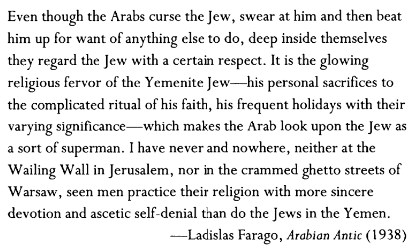
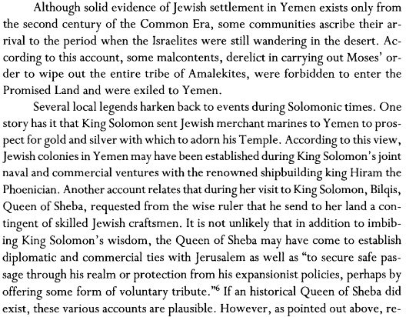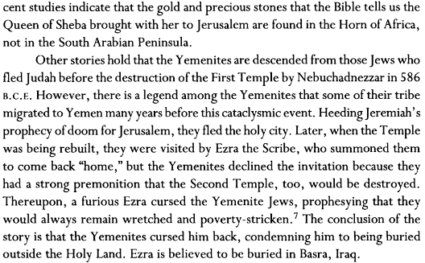
- Introduction to Epistle to Yemen [1172], Wikipedia
THE EPISTLE TO YEMEN, probably a compilation of several shorter responsa, was written by Maimonides about 1172 in reply to an inquiry (or inquiries) by Jacob ben Netan'el al-Fayyūmi, the then head of the Jewish community in Yemen. The exchange of letters was occasioned by a crisis through which the Jews of that country were passing. A forced conversion to Islam, inaugurated about 1165 by 'Abd-al-Nabī ibn Mahdi, who had gained control over most of Yemen, threw the Jews into panic. The campaign conducted by a recent convert to win them to his new faith, coupled with a Messianic movement started by a native of the country who claimed he was the Messiah, increased the confusion within the Jewish community. Rabbi Jacob evidently sought guidance and encouragement, and Maimonides attempted to supply both.
- Siddur, 12th Principle of Faith
אֲנִי מַאֲמִין בֶּאֱמוּנָה שְׁלֵמָה, בְּבִיאַת הַמָּשִׁיחַ, וְאַף עַל פִּי שֶׁיִּתְמַהְמֵהַּ, עִם כָּל זֶה אֲחַכֶּה לּו בְּכָל יום שֶׁיָּבוא.
I believe with perfect faith in the coming of the Messiah, and, though he tarry, I will wait daily for his coming.
- Mishneh Torah (Maimonides), Laws of Kings Ch. 11
1 Do not presume that in the Messianic age any facet of the world's nature will change or there will be innovations in the work of creation. Rather, the world will continue according to its pattern. Although Isaiah 11:6 states: 'The wolf will dwell with the lamb, the leopard will lie down with the young goat,' these words are a metaphor and a parable. The interpretation of the prophecy is as follows: Israel will dwell securely together with the wicked gentiles who are likened to a wolf and a leopard… Similarly, other Messianic prophecies of this nature are metaphors...
2 Our Sages taught: "There will be no difference between the current age and the Messianic era except the emancipation from our subjugation to the gentile kingdoms."
- Iggeret Teiman [1172], Moses Maimonides, Egypt, 1135-1204
- Empathy and recognition of Messianic travails
...You write that the rebel leader in Yemen decreed compulsory apostasy for the Jews by forcing the Jewish inhabitants of all the places he had subdued to desert the Jewish religion just as the Berbers had compelled them to do in Maghreb… Indeed, this is a subject which no religious man dare take lightly, nor any one who believes in Moses put aside. There can be no doubt that these are the Messianic travails concerning which the sages invoked God that they be spared seeing and experiencing them.
- Rejoinder to have faith in God and not be swayed by other religions
...Remember, that ours is the true and authentic Divine religion, revealed to us through Moses, the master of the former as well as the later prophets, by means of which God has distinguished us from the rest of mankind… This did not happen because of our merits, but rather as an act of Divine grace, and on account of our forefathers who were cognizant of God and submitted to Him as we read, "The Lord did not set His love upon you, nor choose you, because ye were more in number than any people ... but because the Lord loved you, and because He would keep the oath which He swore unto your fathers." (Deuteronomy 7:7). God has made us unique by His laws and precepts, and our pre-eminence is manifested in His rules and statutes... Therefore all the nations instigated by envy and impiety rose up against us, and all the kings of the earth motivated by injustice and enmity applied themselves to persecute us. They wanted to thwart God, but He cannot be thwarted.
- The falsification of Islam and the truth of Judaism (Argument from Design)
After him arose the Madman who emulated his precursor since he paved the way for him. But he added the further objective of procuring rule and submission, and he invented his well known religion. All of these men purposed to place their teachings on the same level with our divine religion. But only a simpleton who lacks knowledge of both would liken divine institutions to human practices. Our religion differs as much from other religions for which there are alleged resemblances as a living man endowed with the faculty of reason is unlike a statue which is ever so well carved out of marble, wood, bronze or silver. When a person ignorant of divine wisdom or of God's works sees the statue that superficially resembles a man in its contours, form, features, and color, he believes that the structure of the parts of a statue is like the constitution of a man, because he is deficient in understanding concerning the inner organization of both. But the informed person who knows the interior of both, is cognizant of the fact that the internal structure of the statue betrays no skillful workmanship at all, whereas the inward parts of man are truly marvelously made, a testimony to the wisdom of the Creator, such as the prolongation of the nerves in the muscles and their ramifications...
- Words of Chizuk and Divine promise of protection
Though they shall appear to be triumphant for a while, and be in the ascendancy for a longer or shorter period of time, they shall not last nor endure. We have a divine assurance from time immemorial that whenever a decree of apostasy is passed against us, God will ultimately terminate it. When King David… reflected... how many trials and tribulations they had undergone from the beginning of their history, and nevertheless were not exterminated, he was moved to exclaim, "Much have they afflicted me from my youth up; but they have not prevailed against me." (Psalms 129:2).. My brethren, you all know that in the time of Nebuchadnezzar the Wicked, the Jews were compelled to worship idols… Ultimately God destroyed Nebuchadnezzar… Similarly during the Second Commonwealth when the wicked Greek rulers gained control of Palestine, they instituted severe persecutions against Israel in order to abolish the Torah… Finally, God brought to an end simultaneously their empire and their laws… We are in possession of the divine assurance that Israel is indestructible and imperishable, and will always continue to be a pre-eminent community. As it is impossible for God to cease to exist, so is Israel's destruction and disappearance from the world unthinkable… Put your trust in the true promises of Scripture, brethren, and be not dismayed at the series of persecutions or the enemy's ascendency over us, or the weakness of our people. These trials are designed to test and purify us...
- Introduction: Maimonides Letter on Apostasy, Leon D. Stitskin
The “Letter on Apostasy,” Iggeret ha-Shemad, was the first public document written by Maimonides. It was written in 1160 or 1161, at least seven years before the completion of his first major work, “The Commentary on the Mishna”... He was approximately twenty-six years old when he wrote this famous letter in Arabic… The letter originated in the period between 1146-1165--a time of religious persecution in Morocco and Spain, provoked by a new sect of Mohammedans, the Almohades. The founder… conceived an Islam dedicated to the Koran and the Sword… stressing the superiority of Islam, he promulgated a unitarian confession of Faith… which everyone was obligated to articulate… his ambition of initiating a spiritual reformation and political conquests came to fruition upon his demise when his disciple became the… “Prince of the Faithful.” The dynasty of the Almoravides was uprooted after a prolonged siege in 1146 when Morocco fell into Abdulmumen’s hands. To Jews and Christians the only alternatives were: death or apostasy.
...Now, many of the Christians were able to find an asylum in Northern Spain among their correligionists… but the Jews had no refuge open to them. Many suffered martyrdom, and the majority agreed outwardly and uttered the Islamic formula of conversion, “There is no God but Allah and Mohammed is His Prophet.” ...they found encouragement in a “Letter of Consolation” written by Maimonides’ father, Maimon, who exhorted them not to despair, for God had not forsaken them…
there was, however, a Maghrib pietist residing in Fez who was not pleased with the lenient tone of Maimon’s letter and decided to inquire of a foreign Rabbi… the reply… was quick, uncompromisingly harsh and diametrically opposed to Maimon’s “Letter of Consolation.” He declared that any Jew who publically uttered the Moslem confession, although secretly performing all of Jewish precepts, could no longer be regarded as a Jew. The Moslems were idolaters and the only course for a steadfast Jew was not to submit… but accept martyrdom… this responsum was widely circulated… it was as if they were cast forth once again into the desert of despair… Maimonides was outraged by the intolerance and harsh judgment of the armchair critic. And, as if associating himself personally in the charge, he proceeded in the Iggeret ha-Shemad to combat the zealot with his own weapons.
- Iggeret ha-Shemad, Moses Maimonides, 1135-1204
- Historical perspective
Moses, Elijah and Isaiah were punished for inveighing against the apostasy of Israel… Rabbi Meir and Rabbi Eliezer feigned heathenism at a similar period of religious persecution to save their lives… Jewish history records that three wicked evildoers like Ahab, Eglon- King of Moab, and Nebuchadnezzar were rewarded for one single good deed despite their lives of wickedness. Should we not then conclude, says Maimonides, that good works performed in secret by our own forced pseudo-apostates will be rewarded (Stitskin, 105).
- Halakhic perspective
- Kiddush ha-Shem: Mishneh Torah, Laws of Yesodei HaTorah, Ch. 5
1 The entire house of Israel are commanded regarding the sanctification of [God's] great name, as [Leviticus 22:32] states: "And I shall be sanctified amidst the children of Israel." Also, they are warned against desecrating [His holy name], as [the above verse] states: "And they shall not desecrate My holy name."
What is implied? Should a gentile arise and force a Jew to violate one of the Torah's commandments at the pain of death, he should violate the commandment rather than be killed, because [Leviticus 18:5] states concerning the mitzvot: "which a man will perform and live by them." [They were given so that] one may live by them and not die because of them. If a person dies rather than transgress, he is held accountable for his life.
2 When does the above apply? With regard to other mitzvot, with the exception of the worship of other gods, forbidden sexual relations, and murder. However, with regard to these three sins, if one is ordered: "Transgress one of them or be killed," one should sacrifice his life rather than transgress.
3 All the above [distinctions] apply [only in times] other than times of a decree. However, in times of a decree - i.e., when a wicked king like Nebuchadnezzar or his like will arise and issue a decree against the Jews to nullify their faith or one of the mitzvot - one should sacrifice one's life rather than transgress any of the other mitzvot, whether one is compelled [to transgress] amidst ten [Jews] or one is compelled [to transgress merely] amidst gentiles.
4 When anyone about whom it is said: "Sacrifice your life and do not transgress," transgresses instead of sacrificing his life, he desecrates [God's] name. If he does so in the presence of ten Jews, he desecrates [God's] name in public, nullifies [the fulfillment of] the positive commandment of the sanctification of [God's] name, and violates the negative commandment against the desecration of God's name.
Nevertheless, since he was forced to transgress, he is not [punished by] lashing, and, needless to say, is not executed by the court even if he was forced to slay [a person]. The [punishments of] lashes and execution are administered only to one who transgresses voluntarily, [when the transgression is observed by] witnesses, and [when] a warning [was given], as [Leviticus 20:5] states concerning one who gives his children to [the worship of] Molech: "I will turn My face against that person."
- Religious Coercion of Islam
You should know that the previous persecutions in the days of the sages, our people were called upon to transgress the Law in action as the Talmud relates: “They were forbidden to engage in the study of the Torah; the laws of circumcision were proscribed and they were coerced into unclean cohabitation.” But during this period of religious persecution we are not forced to perform any acts of apostasy but just to recite an empty formula. And if one wishes to practice the six hundred and thirteen precepts in secret, he can do so without punishment. For this form of compulsion requires no action but the recital of a simple formula which the Moslems themselves know were uttered insincerely.
Veribly, one preferred to suffer martyrdom in order not to pronounce the Mohammedan confession, has done nobly and well and his reward is great before the Lord… Should one, however, inquire of me: “Shall I be slain or pronounce the Mohammedan confession,” my answer would be: “Utter the formula and live!”
...propose several modes of behavior incumbent upon us. It is first of all important to focus our attention upon any of the precepts we are still capable of observing. Notwithstanding the fact that we may be forced to commit many serious transgressions such as the desecration of some crucial laws of the Sabbath, this should not preclude the possibility of observing less significant laws...
However, the crucial advice I wish to give myself and to those I admire and to those who seek my opinion is to leave those places of hostility and go to a location where one could fulfill the Law without compulsion and fear… similarly our patriarch Abraham rejected his family and birthplace and escaped to save his soul from the influence of disbelievers.
Should we, however be compelled to physically violate any of the precepts, we are actually forbidden to remain in that place even to the point of leaving all of our possessions behind and search by day and night for a more suitable environment...
It is imperative that one who continues to live in a hostile environment… has to consider himself as close to being willfully guilty of desecrating God’s name… Nevertheless, he should keep in mind that by performing even one of the mitzvot in this state of pseudo-apostasy, God will double his reward as he did not do it for self-glory or out of fear but for the sake of God.
By the same token we should never alienate or despise Sabbath violators, but, on the contrary, draw them nigh and inspire them to perform mitzvot… The Talmud states “a decree is likely to cease”. It is thus our hope that the Almighty will abolish religious persecution… (Stitskin, pgs. 107-111)

https://en.wikisource.org/wiki/Epistle_to_Yemen/Complete
Translated by Boaz Cohen
Tradition, Fall 1973
Translation and notes of Leon D. Stitskin in Tradition, Fall 1973

