השכלה
Enlightenment – Aufklärung
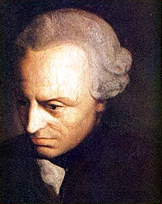  Immnuel Kant (1724-1804) | 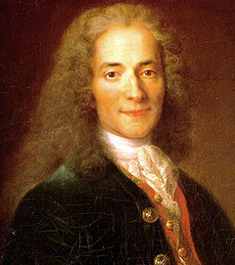  Voltaire (1694-1778)
“What Is Enlightenment?" (German: Was ist Aufklärung?) [1784]
Enlightenment is man's emergence from his self-imposed immaturity. Immaturity is the inability to use one's understanding without guidance from another. This immaturity is self-imposed when its cause lies not in lack of understanding, but in lack of resolve and courage to use it without guidance from another. Sapere Aude! [dare to know] "Have courage to use your own understanding!" – that is the motto of enlightenment.
http://www.english.upenn.edu/~mgamer/Etexts/kant.html

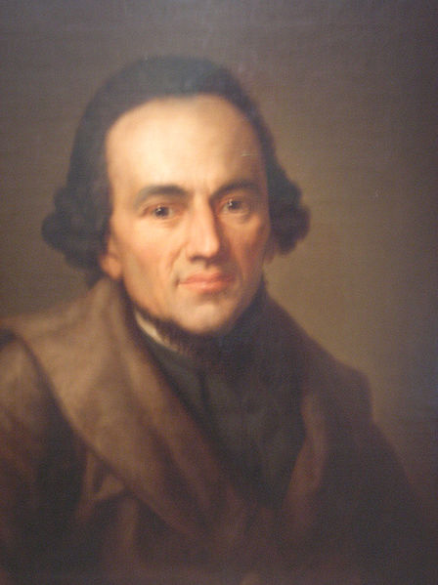
Moses Mendessohn (1729-1786)
ETERNAL TRUTHS TEMPORAL TRUTHS

Ideologies and Characteristics of Haskalah:
- Negate Jewish alienation in Exile > Emancipation
- Promote Jewish productivity
- Anti-Messianic
- 3 + Nationalism = Zionism
- Identification as Citizins first
- > Reform Judaism
- Judaism as Culture

