Class # 18 – Singing Hallel while living through a Plague
Advanced Fellowship Parsha Class - Sponsored in memory of Alice Toby Barbanel z”l
Rabbi Pinny Rosenthal - prepared collaboratively with Rabbi Yoni Sacks

What is the goal of the seder?

- Which of these familiar feasts is most similar in purpose to the Seder: A. 4th of July BBQ B. Thanksgiving dinner C. Superbowl party

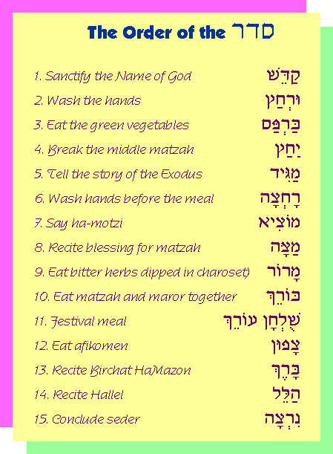
Rambam, Laws of Chametz and Matzah, Ch. 7:4
One must begin [the narrative describing our ancestors'] base [roots] and conclude with [their] praise. What does this imply? One begins relating how originally, in the age of Terach, our ancestors denied [God's existence] and strayed after vanity, pursuing idol worship. One concludes with the true faith: how the Omnipresent has drawn us close to Him, separated us from the gentiles, and drawn us near to His Oneness.
Similarly, one begins by stating that we were slaves to Pharaoh in Egypt and [describing] all the evil done to us, and concludes with the miracles and wonders that were wrought upon us, and our freedom.
2) What are the two “beginnings” and two “endings” of the story of the exodus that we are obligated to present?
3) How can you have two beginnings to a story?
4) What is the goal of our story telling? {the story of Rav Oshry}

Magid, First Half of Hallel
He holds the cup in his hand, and he covers the matzah and says:

Therefore we are obligated to thank, praise, laud, glorify, exalt, lavish, bless, raise high, and acclaim He who made all these miracles for our ancestors and for us: He brought us out from slavery to freedom, from sorrow to joy, from mourning to [celebration of] a festival, from darkness to great light, and from servitude to redemption. And let us say a new song before Him, Halleluyah!

- Why are we singing Hallel?
- How can we sing anything when the situation is so bad?
- Why is the Hallel divided into two parts?

Halleluyah! Praise, servants of the Lord, praise the name of the Lord. May the Name of the Lord be blessed from now and forever. From the rising of the sun in the East to its setting, the name of the Lord is praised. Above all nations is the Lord, His honor is above the heavens. Who is like the Lord, our God, Who sits on high; Who looks down upon the heavens and the earth? He brings up the poor out of the dirt; from the refuse piles, He raises the destitute. To seat him with the nobles, with the nobles of his people. He seats a barren woman in a home, a happy mother of children. Halleluyah! (Psalms 113)
In Israel's going out from Egypt, the house of Ya'akov from a people of foreign speech. Judah became His -holy one, Israel, His dominion. The Sea saw and fled, the Jordan turned to the rear. The mountains danced like rams, the hills like young sheep. What is happening to you, O Sea, that you are fleeing, O Jordan that you turn to the rear; O mountains that you dance like rams, O hills like young sheep? From before the Master, tremble O earth, from before the Lord of Ya'akov. He who turns the boulder into a pond of water, the flint into a spring of water. (Psalms 114)
Magid, Second Cup of Wine
We raise the cup until we reach "who redeemed Israel"

Blessed are You, Lord our God, King of the universe, who redeemed us and redeemed our ancestors from Egypt, and brought us on this night to eat matsa and marror; so too, Lord our God, and God of our ancestors, bring us to other appointed times and holidays that will come to greet us in peace, joyful in the building of Your city and happy in Your worship; that we shall eat there from the offerings and from the Pesach sacrifices, the blood of which shall reach the wall of Your altar for favor, and we shall thank You with a new song upon our redemption and upon the restoration of our souls. Blessed are you, Lord, who redeemed Israel.

We say the blessing below and drink the cup while reclining to the left

Blessed are You, Lord our God, who creates the fruit of the vine.

- Why are we thank Hashem that arrived at the time to eat Matzah and Maror and ask that we be able to offer the Pesach offering? Why is that the focus?

