Class # 33- Shelach - The Anatomy of a breakup - from Angel to devil
Advanced Fellowship Parsha Class - Sponsored in memory of Alice Toby Barbanel Z”l
Rabbi Pinny Rosenthal - prepared collaboratively with Rabbi Yoni Sacks

https://www.youtube.com/watch?v=YOEBmD6LiEU
- Why does Carrie’s still love her “ex” even after he broke her heart?
- Is this love for an “ex” a common occurrence?
- Why would her love for her “ex” also cause Carrie to hate herself?

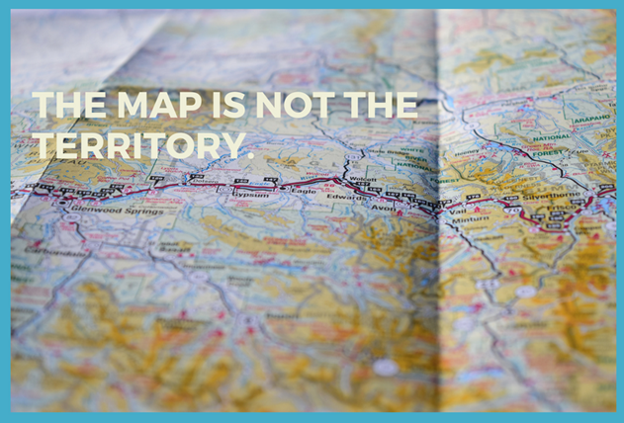

The Map is Not the Territory by Bob Hoffmeyer
“A beam of white light goes out and is received by three people. Through the filter of one it appears red, for another, blue, and for the third, it is dull grey. This is not unlike what happens as we take in our experiences of life. Each new experience we have is filtered through an internal map of reality that is already there. It is what is stored on our map that determines our experience of what happens in life. And, as we shall see, it is our map that enables or limits us as we go forward in life. It is the content of their individual maps that makes something so incredibly easy for one person and so seemingly impossible for another…”

4) What would you call the part of Carrie that judges whether her map of Sebastian is real?

Parshat Shelach - The Spies’ Mission
13:18 See what kind of land it is. Are the people who live there strong or weak, few or many? 13:19 Is the inhabited area good or bad? Are the cities where they live open or fortified? 13:20 Is the soil rich or weak? Does [the land] have trees or not? Make a special effort to bring [back] some of the land's fruits.'It was the season when the first grapes begin to ripen.

The Spies report
13:27 They gave the following report: 'We came to the land where you sent us, and it is indeed flowing with milk and honey, as you can see from its fruit. 13:28 However, the people living in the land are aggressive, and the cities are large and well fortified. We also saw the giant's descendants there. 13:29 Amalek lives in the Negev area, the Hittites, Yebusites and Amorites live in the hills, and the Canaanites live near the sea and on the banks of the Jordan.' 13:30 Caleb tried to quiet the people for Moses. 'We must go forth and occupy the land,' he said. 'We can do it!' 13:31 'We cannot go forward against those people!' replied the men who had gone with him. 'They are too strong for us!' 13:32 They began to speak badly about the land that they had explored. They told the Israelites, 'The land that we crossed to explore is a land that consumes its inhabitants. All the men we saw there were huge! 13:33 While we were there, we saw the titans. They were sons of the giant, who descended from the [original] titans. We felt like tiny grasshoppers! That's all that we were in their eyes.
The people react
14:1 The entire community raised a hubbub and began to shout. That night, the people wept. 14:2 All the Israelites complained to Moses and Aaron. The entire community was saying, 'We wish we had died in Egypt! We should have died in this desert! 14:3 Why is God bringing us to this land to die by the sword? Our wives and children will be captives! It would be best to go back to Egypt!' 14:4 The people started saying to one another, 'Let's appoint a [new] leader and go back to Egypt.'

Joshua and Caleb respond
14:5 Moses and Aaron feel on their faces before the whole assembled Israelite community. 14:6 Among the men who had explored the land, Joshua son of Nun and Caleb son of Yefuneh tore their clothes in grief. 14:7 They said to the whole Israelite community, 'The land through which we passed in our explorations is a very, very good land! 14:8 If God is satisfied with us and brings us to this land, He can give it to us - a land flowing with milk and honey. 14:9 But don't rebel against God! Don't be afraid of the people in the land! They have lost their protection and shall be our prey! God is with us, so don't be afraid!' 14:10 The whole community was threatening to stone them to death, when God's glory suddenly appeared at the Communion Tent before all the Israelites.

Rashi - FOR THEY ARE STRONGER - They said this, — if this were at all possible (i.e. if one may be permitted to say so of God) — with reference to the Omnipresent (ממנו, stronger than "He", they thus uttered blasphemy) (Sotah 35a; Arakhin 15a).

Seforno - It is a land that eats its inhabitants - even though the people living there are strong, this is not a compliment to the land; rather it means that it is only due to their exceptionally hardy constitution that they were able to survive in that land. Ordinary people would die there because the climate is so hard to take.

Seforno - like grasshoppers, or even less significant. They did not bother to harm us as they did not think we represented a threat to them.

The Mishna in Sanhedrin 10:3
The spies have no share in the World to Come, as it says, (Numbers 14:37) "Even those men that did bring up an evil report of the land, died by the plague before the Lord." "Died," in this world; "in the plague," in the World to Come.

Rambam, Laws of Character Traits - 7:3
Our Sages said: "There are three sins for which retribution is exacted from a person in this world and, [for which] he is [nonetheless,] denied a portion in the world to come: idol worship, forbidden sexual relations, and murder. Lashon horah is equivalent to all of them. Our Sages also said: "Anyone who speaks lashon horah is like one who denies God as [implied by Psalms 12:5]: 'Those who said: With our tongues we will prevail; our lips are our own. Who is Lord over us!!”
In addition, they said: "Lashon horah kills three [people], the one who speaks it, the one who listens to it, and the one about whom it is spoken. The one who listens to it [suffers] more than.

