2004-2018: God’s Country
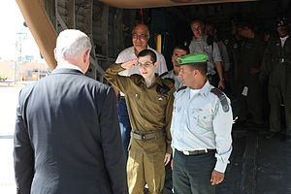  Gilad Shalit freed after 5 years with Hamas (2011) | 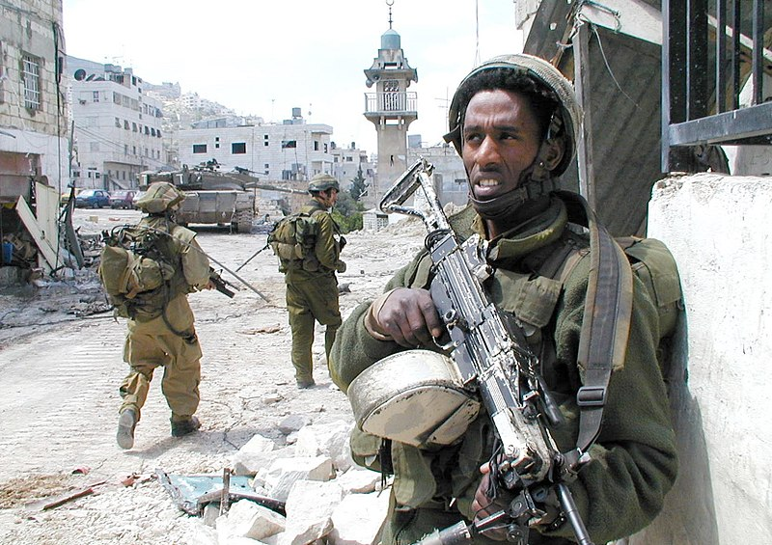  Operation Defensive Shield (2014)

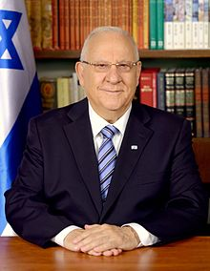  Reuven Rivlin, 10th President (2014) | 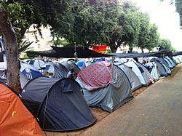  Social Justice Protests (2011) | 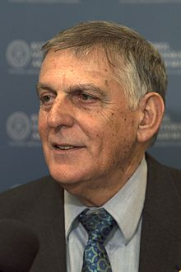  Dan Shechtman, Nobel Prize Chemistry (2011)

Ofek-8 Satellite in Space (2008) | Israel- The “Start-Up” Nation
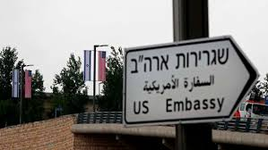
70 Years of Indepence, Opening of US Embassy in Jerusalem (2018)

Orthodox Jews in Israel Oppose Withdrawal, but Differ on Protest
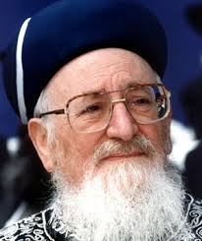
TEL AVIV (Mar. 20, 2005)
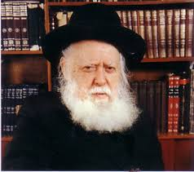
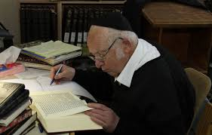
At Orthodox synagogues across Israel and the territories, a short prayer is being recited against the planned Israeli withdrawal from the Gaza Strip and a portion of the northern West Bank. The prayer asks for divine blessing for those “sons who are living selflessly and with perseverance in all parts of Judea, Samaria and Gaza,” asking to “uplift their spirits and strengthen their heart” as they stand up against those who would wish them harm. Rabbi Mordechai Eliahu, a former Sephardi chief rabbi in Israel, has asked congregations to recite the prayer as a protest against Prime Minister Ariel Sharon’s plan to withdraw Israel from the Gaza Strip and a section of the northern West Bank unilaterally, evacuating some 8,000 Jewish settlers from their homes. Across Israel’s Orthodox spectrum, the majority of voices are solidly against the withdrawal plan. What varies is the degree of resistance that leading Orthodox figures are supporting. Eliahu and another former chief rabbi, Avraham Shapira, have been among the most high-profile voices to call on soldiers and police to refuse orders to evacuate settlers, a tactic that is gaining popularity in national religious circles.
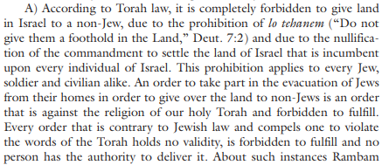  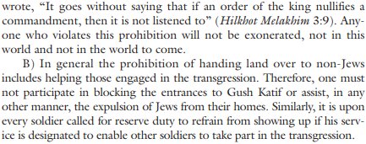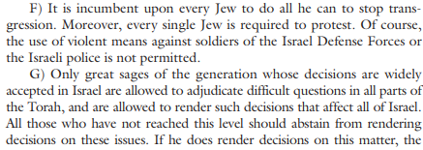  ~ excerpts from Tradition 40:1/2007 | 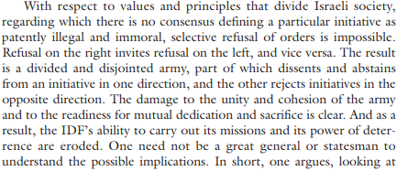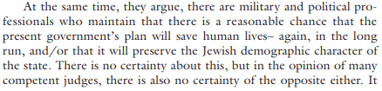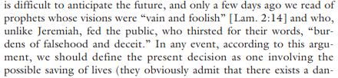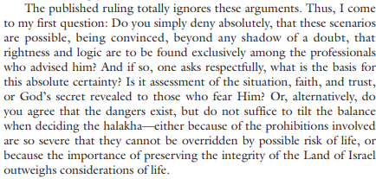

Ariel Sharon: Hero of Israel
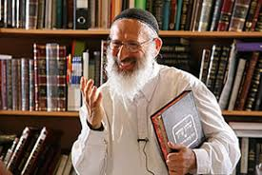
Arik Sharon has ascended on high and many are left with mixed emotions. As are all human beings, he was a complex creature, light and darkness intermingled within him. We must remember, however, that we stand before one who can be defined as a hero of Israel.
A hero of Israel: who fought with courage and strength, wisdom and ingenuity, especially during the Yom Kippur War. We are all indebted to him for his decisive role during this period.
A hero of Israel: who had a major part in the settlement of Yehudah and Shomron.
A hero of Israel: who faltered in the destruction of Gush Katif, but surely believed that he was acting in the Nation's best interest. His failures do not nullify his merits, just as the positive acts performed by Yochanan Cohain Gadol, who served for 80 years as the Cohain Gadol, were not nullified by the fact that he became a Tzeduki (a heretic, see Berachot 29a).
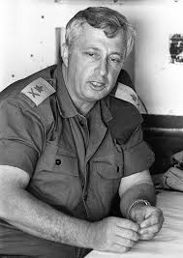
This hero of Israel purchased a home in the Old City of Yerushalayim - "The Sharon House" - in the so-called "Muslim Quarter". In doing so he informed us, and the entire world, that this is Jewish land, the eternal property of our forefathers, upon which others came and built without our permission and presence.
This hero of Israel, man of the military, man of settlement and man of leadership has ascended on high, and we are all indebted to him. A man of opposites has ascended on high, and we pray that he finds comfort there.
All these contradictions made him a fascinating man to watch and to deal with. Yet he really was, I think, a simple man at root. He saw himself as a Jew whose job it was to protect the Jewish state. In early 2003, President George W. Bush sent deputy national security advisor Steve Hadley and me (I was the senior Mideast official on the NSC) to meet with him, hear him out, and see what he thought of the various peace plans. Was he open to compromises? What he told us, according to my notes of the meeting, was this:
I took risks personally but never took any risks with the security of the State of Israel. I appreciate Arab promises but will take seriously only tangible performance. For tangible performance I will take tangible steps. Israel is a tiny small country. From the Jordan River to Jerusalem is only 17.5 miles. Before 1967, the Knesset was in range of machine guns south of Jerusalem. From the Green Line to Tel Aviv is 11 miles. From the sea at Netanya to Tulkarm is 9 miles. Two-thirds of the Jewish population lives is a narrow strip on the coastal plain. Between Haifa and Ashdod, which is 80 miles, is two-thirds of the Jewish population, our only international airport, and most of our infrastructure. All of that is overlooked by the hills of Judea and Samaria.
I am a Jew above all and feel the responsibility to the future of the Jewish people on my shoulders. After what happened in the past, I will not let the future of the Jewish people depend on anyone, even our closest friends. Especially when you saw the crowds cheering Saddam who killed even members of his own family and government. With the deepest friendship and appreciation, we do not choose to be the lamb, but not the lion either. I will not sacrifice the nation.
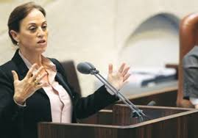
‘The Heritage Of All Israel’ Ruth Calderon (02/14/2013)
Mr. Chairman, honorable Knesset, the book I am holding changed my life, and to a large extent it is the reason that I have reached this day with the opportunity to speak to the Knesset of Israel as a new member… I was not acquainted with the Mishna, the Talmud, Kabbala or Hasidism… but when I first encountered the Talmud and became completely enamored with it, its language, its humor, its profound thinking, its modes of discussion, and the practicality, humanity, and maturity that emerge from its lines, I sensed that I had found the love of my life, what I had been lacking...
I am convinced that studying the great works of Hebrew and Jewish culture are crucial to construct a new Hebrew culture for Israel. It is impossible to stride toward the future without knowing where we came from and who we are, without knowing, intimately and in every particular, the sublime as well as the outrageous and the ridiculous. The Torah is not the property of one movement or another. It is a gift that every one of us received, and we have all been granted the opportunity to meditate upon it a we create the realities of our lives. Nobody took the Talmud and rabbinic literature from us. We gave it away, with our own hands, when it seemed that another task was more important and urgent: building a state, raising an army, developing agriculture and industry, etc. The time has come to reappropriate what is ours, to delight in the cultural riches that wait for us, for our eyes, our imaginations, our creativity.

Instead of telling you about this book’s beauty, I wish to tell you a story from Talmud, one small story, the story of Rabbi Rechumei, which appears in Ketubot 62b, and through it to say some words about this moment and about the tasks I will set for myself in the Knesset. Rabbi Rechumei was constantly before Rava in Mechoza. He would habitually come home every Yom Kippur eve. One day the topic drew him in. His wife anticipated him: “Here he comes. Here he comes.” He didn’t come. She became upset. She shed a tear from her eye. He was sitting on a roof. The roof collapsed under him, and he died.

You are probably thinking: what kind of date is that to choose to come home? Yom Kippur eve? It is not exactly a day of intimacy. It is generally a day of prayer, and not even at home. One day, one time, one year, the topic drew him in. The study in the beit midrash so fascinated him that he forgot. He did not leave in time. He could not abandon his studies and he did not go home. His wife anticipated him: “Here he comes. Here he comes.” One can hear the aspirant tone of her words in Aramaic: “Hhhashta atei; hhhere he comes.” This expectation, that every text message, every phone call, every footfall, every knock at the door, you are certain is him. Here he comes. Here he comes. He didn’t come. At some point, she realizes that he is not coming this year. Perhaps the shofar blast announcing the onset of Yom Kippur was sounded, after which nobody would arrive, due to the sanctity of the holiday. She becomes upset. This woman, who waited all year, who for many years has waited all year for one day, cannot stand it anymore. She becomes upset. She is disappointed; she is sorrowful; she loses control. She sheds a tear from her eye – this is an active verb, not a passive one. She allows one tear to leak out of her eye onto her cheek, after years of not crying… He sat on the roof, and as the tear falls from the woman’s eye, the roof caves in under him and he falls to the ground and dies.

What can I learn about this place and my work here from Rabbi Rechumei and his wife? First, I learn that one who forgets that he is sitting on another’s shoulders – will fall… I learn that righteousness is not adherence to the Torah at the expense of sensitivity to human beings. I learn that often, in a dispute, both sides are right, Sometimes we feel like the woman, waiting, serving in the army, doing all the work while others sit on the roof and study Torah; sometimes those others feel that they bear the entire weight of tradition, Torah, and our culture while we go to the beach and have a blast. Both I and my disputant feel solely responsible for the home. Until I understand this, I will not perceive the problem properly and will not be able to find a solution. I invite all of us to years of action rooted in thought and dispute rooted in mutual respect and understanding.
“My special challenge is not just to ensure the existence of the state, but also to ensure that it will include an effective legacy of Jewish identities – including those that do not require keeping commandments – as a precondition for interest in Jewish history or Jewish sources. Only such a legacy will enable the continued willingness of most of the public that lives in the state to continue to support a state that is both Jewish and democratic” ~ Ruth Gavison
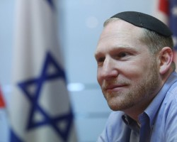
Jewish Link: ... Can you tell our readers one of your most favorite Nefesh B’Nefesh aliyah stories? Rabbi Fass: ...One of my most emotional aliyah moments was an experience I witnessed on a charter aliyah flight. An Auschwitz survivor was seated next to a 9-year-old girl, and throughout the course of the flight they got to know each other. It was amazing to see someone who had survived the atrocities of the Holocaust connecting with such a young, strong symbol of the future of the Jewish people. Together they experienced this historic moment of the Jewish people returning to their homeland. I will never forget the sight of the two of them disembarking in Israel, holding hands, as they took their first steps together as Israeli citizens. For me, the experience was an essential reminder of the eternal nature of the Jewish people and the miracle of our return to Eretz Israel.

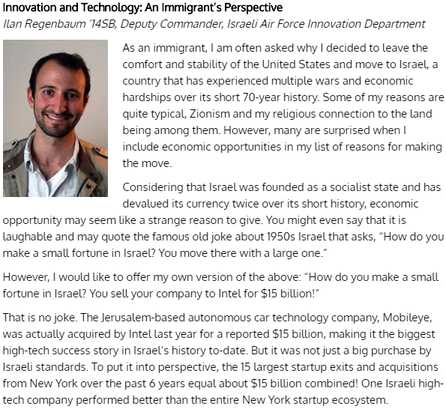  https://blogs.yu.edu/news/israel-at-70/#Regenbaum | 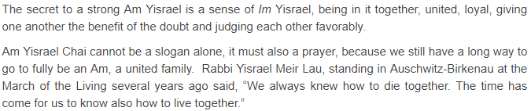  https://rabbisblog.brsonline.org/am-yisrael-chai-a-slogan-or-a-prayer/  Plant a Jewish people in a country that comes to a standstill on Yom Kippur; speaks the language of the Bible; moves to the rhythms of the Hebrew (lunar) calendar; builds cities with the stones of its ancestors; produces Hebrew poetry and literature, Jewish scholarship and learning unmatched anywhere in the world—and you have continuity.  http://www.jidaily.com/2b070

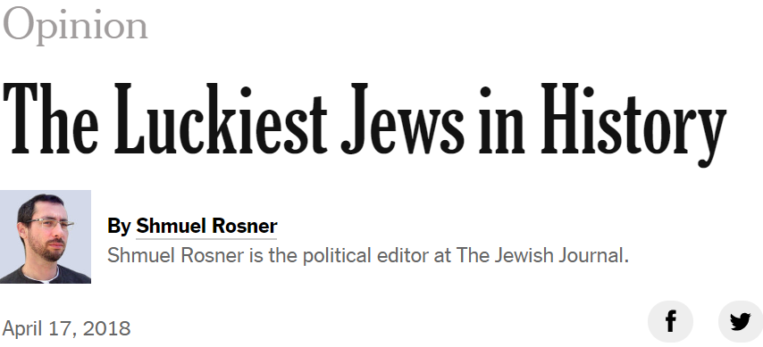
Thus, when celebrating 70 years of statehood, we Jews must engage in a kind of balancing act. On one hand, we need to appreciate the great achievement of building this Jewish homeland in such a short time in such a hostile environment. On the other hand, we need to grasp the smallness of this achievement in the scheme of Jewish history.
The prophet Jeremiah described the Babylonian exile as a 70-year affair. We consider that short. In the second century BCE, the Hasmonean kingdom, widely viewed as the last period of Jewish political autonomy before the founding of Israel, lasted for about eight decades before it became client of the Romans. This kingdom is still today a source of Jewish pride, but it is also a cautionary tale: Most Israelis plan for a future that extends much further than merely another decade of statehood.
So being the luckiest Jew ever is a blessing and a burden. The more we have, the more obligated we are to guard it and the more afraid we are to lose it. We’re afraid for psychological reasons: Jews thought they were lucky in the past, and it often ended badly for them (remember Germany in the early 20th century). But we are also afraid because of indisputably dangerous circumstances: There are people out there who want to harm us, deny us what we have and destroy us, from Iranian leaders to Palestinian extremists to anti-Semites around the world.
And Israel faces other challenges, some of which are familiar to many countries: economic inequality, populism, homegrown radicalism and illegal immigration. Not even the lucky Jew can ignore these and other challenges that hover like clouds over the future of Jewish sovereignty and success.
Still, Israelis tend to be hopeful. In a survey taken a year ago, 73 percent of Israeli
Jews said they were optimistic “about Israel’s future.” They must see something beyond the challenges that makes them so confident. One of them, I believe, is this sense of being lucky, of being born at such a good time.
The number 70 has a special place in the Jewish tradition. The people of Israel make up one of 70 nations; Moses had 70 elders at his side as he wandered the desert; a well-known commentary suggests that God has 70 names, as does the city of Jerusalem. Celebrating 70 years of independence instinctively feels more special than 60 or 80. It instinctively connects the mind of a modern Israeli to the long, complicated and treacherous Jewish past. And it instinctively makes him aware that what feels like a long and sometimes exhausting journey is barely one lucky step on the dusty Jewish road.
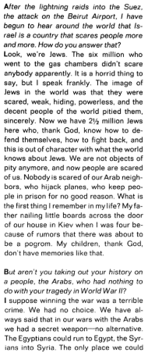  ~ An interview with Golda Meir in Life, October 1969 | Tourists by Yehuda Amichai  Visits of condolence is all we get from them.  They squat at the Holocaust Memorial,  They put on grave faces at the Wailing Wall  And they laugh behind heavy curtains  In their hotels.  They have their pictures taken  Together with our famous dead  At Rachel's Tomb and Herzl's Tomb  And on Ammunition Hill.  They weep over our sweet boys  And lust after our tough girls  And hang up their underwear  To dry quickly  In cool, blue bathrooms.  Once I sat on the steps by agate at David's Tower,  I placed my two heavy baskets at my side. A group of tourists  was standing around their guide and I became their target marker. "You see  that man with the baskets? Just right of his head there's an arch  from the Roman period. Just right of his head." "But he's moving, he's moving!"  I said to myself: redemption will come only if their guide tells them,  "You see that arch from the Roman period? It's not important: but next to it,  left and down a bit, there sits a man who's bought fruit and vegetables for his family."

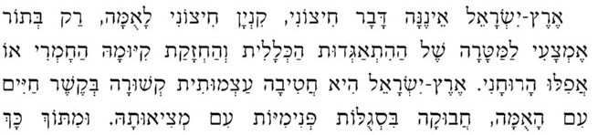 | 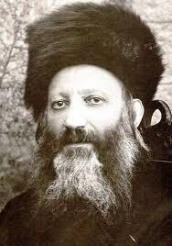

פירושו של הרב אבינר לספר אורות (ארץ ישראל פרק א) של הרב קוק
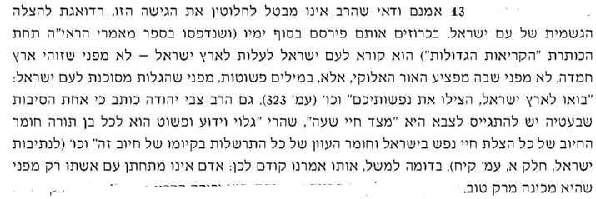
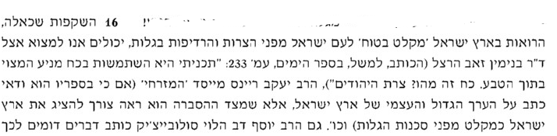
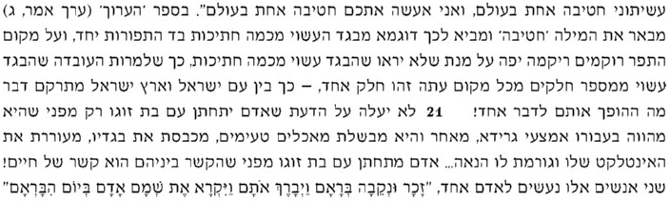
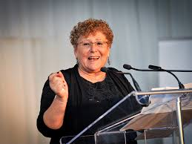
“Ladies and gentlemen, I stand humbly before my colleagues, honorable people who created, wrote, studies and invented, people of vision, creation and faith. I am not worthy, I don’t have a creation. I can’t point to a revelation I made or a formula I cracked.” “I have a heart that was broken three times with terrible announcements: The loss of my eldest son Uriel in battle in Lebanon, the death of my partner Eliezer due to a broken heart, and the loss of my second son in battle in Gaza,” she recalled. “With that heart I came to my nation and in simple words, in the language of a broken heart, I spoke of this land and its legacy, of choosing goodness, of happiness, of devotion to life, of responsibility, of social involvement, and out of that heart which beats with faith in this country and this nation, out of the great depth of pain flowed springs of love. “When the heart is full of faith, it can withstand great challenges. I turned my grief into a new melody."
"אם רק נכיר בכך שרב המשותף בינינו על המפריד. כולנו בארץ הזאת חפצי חיים. כולנו חפצי שלום. זה הבית של כולנו, ואין בלעדיות של אהבת העם והמולדת לצד מסויים"
"If only we recognize that there is more that unites us than divides us. All of us in this country are seekers of a meaningful life. We are all seekers of peace. This is the home that belongs to all of us and no side has exclusivity over the love of the people or the love of our land "
"וגם אם יש בינינו תהומות נוכל לבנות עליהם גשרים"
"...and even if there are abysses between the different parts of our nation, we can build bridges between them"

https://www.jta.org/2005/03/21/archive/orthodox-jews-in-israel-oppose-withdrawal-but-differ-on-protest
https://www.commentarymagazine.com/articles/ariel-sharon-his-eye-was-not-dim/
https://www.jewishlinknj.com/features/24503-it-is-no-dream-the-man-who-created-today-s-aliyah
https://bina.org.il/en/mk-dr-ruth-calderons-inaugural-knesset-speech/
https://theliberal.co.il/ruth-gavison-israeliness-instead-jewishness/
https://www.nytimes.com/2018/04/17/opinion/jewish-state-israel-70th-anniversary.html

