Fertility Treatments in Halacha
Rabbi Gershon Albert – Beth Jacob Congregation of Oakland

Validating the Pain
- Bereishit / Genesis – Chapter 30 Verse 1
When Rachel saw that she had borne Jacob no children, she became envious of her sister; and Rachel said to Jacob, “Give me children, or I shall die.” | וַתֵּרֶא רָחֵל כִּי לֹא יָלְדָה לְיַעֲקֹב וַתְּקַנֵּא רָחֵל בַּאֲחֹתָהּ וַתֹּאמֶר אֶל־יַעֲקֹב הָבָה־לִּי בָנִים וְאִם־אַיִן מֵתָה אָנֹכִי׃

- Talmud Bavli – Masechet Shabbat 31a
And this is the question that Turnus Rufus the wicked asked Rabbi Akiva: If your God loves the poor, for what reason does He not support them Himself? Rabbi Akiva said to him: He commands us to sustain the poor, so that through them and the charity we give them we will be saved from the judgment of Gehenna.  Turnus Rufus said to Rabbi Akiva: On the contrary, it is this charity which condemns you, the Jewish people, to Gehenna because you give it. I will illustrate this to you with a parable. To what is this matter comparable? It is comparable to a king of flesh and blood who was angry with his slave and put him in prison and ordered that he should not be fed or given to drink. And one person went ahead and fed him and gave him to drink. If the king heard about this, would he not be angry with that person? And you, after all, are called slaves, as it is stated: “For the children of Israel are slaves to Me” (Leviticus 25:55). If God decreed that a certain person should be impoverished, one who gives him charity defies the will of God.  Rabbi Akiva said to Turnus Rufus: I will illustrate the opposite to you with a different parable. To what is this matter comparable? It is comparable to a king of flesh and blood who was angry with his son and put him in prison and ordered that he should not be fed or given to drink. And one person went ahead and fed him and gave him to drink. If the king heard about this once his anger abated, would he not react by sending that person a gift? And we are called sons, as it is written: “You are sons of the Lord your God” (Deuteronomy 14:1). | וזו שאלה שאל טורנוסרופוס הרשע את ר"ע אם אלהיכם אוהב עניים הוא מפני מה אינו מפרנסם אמר לו כדי שניצול אנו בהן מדינה של גיהנם  אמר לו [אדרבה] זו שמחייבתן לגיהנם אמשול לך משל למה הדבר דומה למלך בשר ודם שכעס על עבדו וחבשו בבית האסורין וצוה עליו שלא להאכילו ושלא להשקותו והלך אדם אחד והאכילו והשקהו כששמע המלך לא כועס עליו ואתם קרוין עבדים שנאמר (ויקרא כה, נה) כי לי בני ישראל עבדים  אמר לו ר"ע אמשול לך משל למה הדבר דומה למלך בשר ודם שכעס על בנו וחבשו בבית האסורין וצוה עליו שלא להאכילו ושלא להשקותו והלך אדם אחד והאכילו והשקהו כששמע המלך לא דורון משגר לו ואנן קרוין בנים דכתיב (דברים יד, א) בנים אתם לה' אלהיכם

Defining Infertility (and whether there is an obligation to treat it)
- World Health Organization Clinical Definition:
Infertility is “a disease of the reproductive system defined by the failure to achieve a clinical pregnancy after 12 months or more of regular unprotected sexual intercourse…”
- Primary vs. secondary infertility: both carry difficult, often silent burdens
- Rav Moshe Feinstein (Quoted by R’ Baruch Simon): Pru Urvu is the one mitzvah that we don’t have control over.

- Talmud Bavli – Masechet Shabbat 31a
Rava said: After departing from this world, when a person is brought to judgment for the life he lived in this world, they say to him in the order of that verse: Did you conduct business faithfully? Did you designate times for Torah study? Did you engage in procreation? Did you await salvation? Did you engage in the dialectics of wisdom or understand one matter from another? | אמר רבא בשעה שמכניסין אדם לדין אומרים לו נשאת ונתת באמונה קבעת עתים לתורה עסקת בפריה ורביה צפית לישועה פלפלת בחכמה הבנת דבר מתוך דבר
- This is a Mitzvah where one is judged not by whether they succeeded, but by whether they tried.

- Rav Eliezer Waldenberg – Tzitz Eliezer 15:45 (Quoted in R’ Jachter’s Grey Matter)
What does one gain by presenting way to create children in this manner, if the creators of this child will not fulfill any Divine command and the practice of IVF will create profound and complex problems, which have the potential to cause the level of human morality to deteriorate more than a thousandfold? (Cloning)
- Rav Baruch Simon: There is no obligation to perform medical interventions, but if a couple does succeed, they fulfill the Mitzvah of Pru Urvu.

Genetic Testing Before Marriage
- Rav Moshe Feinstein: (Igrot Moshe Even Ha’ezer 4:10) – testing for Tay-Sachs
  - Miyut Hamatzuy vs. obvious danger
  - Dor Yesharim – The Charedi world’s approach to solving genetic challenges
    - Avoids negative self-image for positive carriers, and protects their and their families’ reputations
- Rabbi J. David Bleich (Tradition – Spring 2000)
  - “. . .in refusing to divulge the results of genetic tests to either the young men and women affected or to their parents, a negative stereotype is dramatically reinforced. The hocus-pocus of assigning numbers and later announcing that the prospective marriage of the bearers of matched numbers will either be propitious or will not be propitious imbues the process with a Byzantine-like quality.”
  - JScreen.com

An Overview of the Options
- IUI (Intrauterine Insemination aka. Artificial insemination)
- IVF (In Vitro Fertilization)
- IVF with ICSI
- IVF with PGD Testing
- Pregnancy through a Sperm Donor
- Pregnancy through an Egg Donor
- Pregnancy through a Surrogate
- Adoption
- Freezing Eggs (Cryopreservation)

Fertility in Halacha:
- Halachic Infertility
- Wasting Seed
- Nida (Laws of Family Purity)
- Yichus (Halachic lineage)
  - Determining Paternity in Halacha
  - Determining Maternity in Halacha
- Mamzerut
- Hashgacha (Rabbinic supervision)
- Abortion-related questions: Destroying Fetal material / pregnancy reductions
- Sex Selection
- Single parent families

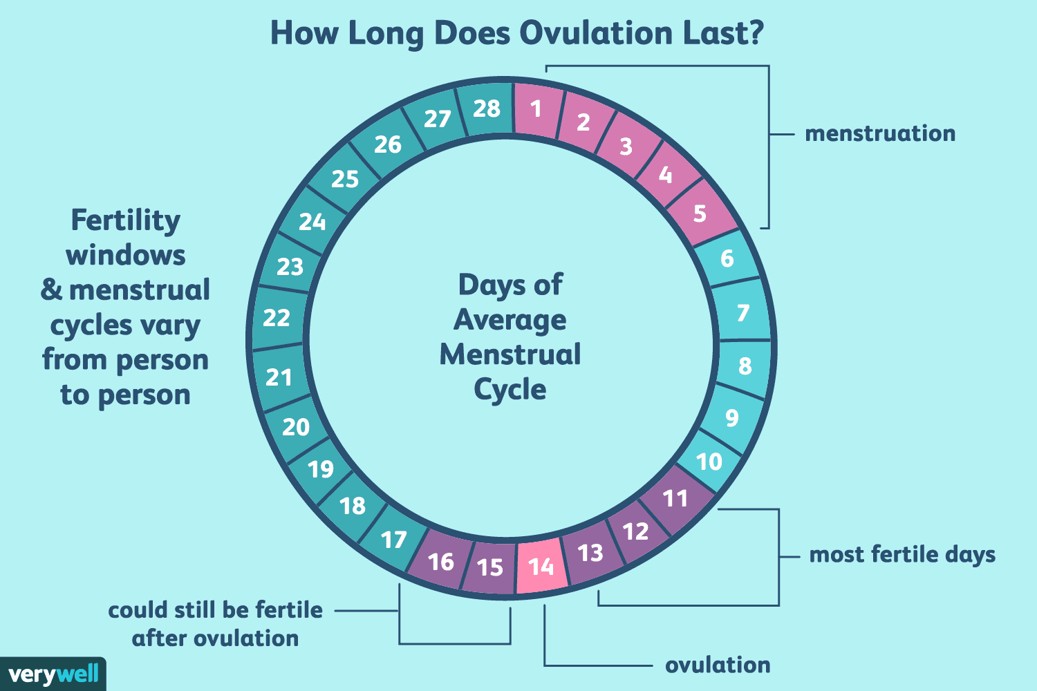
Halachic Infertility

- Vayikra / Leviticus – Chapter 15 Verses 19, 25
When a woman has a discharge, her discharge being blood from her body, she shall remain in her impurity seven days; whoever touches her shall be unclean until evening….  When a woman has had a discharge of blood for many days, not at the time of her impurity, or when she has a discharge beyond her period of impurity, she shall be unclean, as though at the time of her impurity, as long as her discharge lasts. | וְאִשָּׁה כִּי־תִהְיֶה זָבָה דָּם יִהְיֶה זֹבָהּ בִּבְשָׂרָהּ שִׁבְעַת יָמִים תִּהְיֶה בְנִדָּתָהּ וְכָל־הַנֹּגֵעַ בָּהּ יִטְמָא עַד־הָעָרֶב׃...  וְאִשָּׁה כִּי־יָזוּב זוֹב דָּמָהּ יָמִים רַבִּים בְּלֹא עֶת־נִדָּתָהּ אוֹ כִי־תָזוּב עַל־נִדָּתָהּ כָּל־יְמֵי זוֹב טֻמְאָתָהּ כִּימֵי נִדָּתָהּ תִּהְיֶה טְמֵאָה הִוא׃

Zava vs. Nida:
- Normal timing vs. abnormal timing
- When does the seven day count begin?

- Talmud Bavli – Masechet Nidda 66a
Rabbi Zeira says: Jewish women were stringent with themselves to the extent that even if they see a drop of blood the size of a mustard seed, they sit seven clean days for it. By Torah law, a woman who experiences menstrual bleeding waits seven days in total before immersing, regardless of whether she experienced bleeding on those days. If she experiences bleeding during the eleven days when she is not expected to experience menstrual bleeding, she is a lesser zava and waits one day without bleeding and then immerses. The Jewish women accepted upon themselves the stringency that if they experience any bleeding whatsoever, they treat it as the blood of a greater zava, which obligates one to count seven clean days before immersing (see Leviticus 15:25). | אמר ר' זירא בנות ישראל החמירו על עצמן שאפילו רואות טפת דם כחרדל יושבות עליה שבעה נקיים
Ramban: This is Halacha Pesuka (adopted as uncontested law),
- Starting the Count: Four or Five Days: Poletet Shichvat Zera (3 additional days)
  - Shulchan Aruch: 4 Days
  - Rema: 5 Days
- The problem: women whose ovulation happens before they are able to enter the Mikvah
  - Additional challenges can occur for women who experience staining: extremely important to ask Halachic questions instead of making halachic assumptions to be stringent
- Options:
  - Leniency on when to begin the Count of Seven Days (Rav Ovadia Yosef, Rav Mordechai Eliyahu)
  - Artificial Insemination (Rav Moshe Feinstein, Rav Ovadia and others)

Wasting Seed
Rav Moshe Feinstein (Igerot Moshe 2:16) – Testing Semen:
- Ejaculation for the sake of Refuah is not spilling seed.
Halachic Options for testing of semen (in order of preference):
- Removing semen after intercourse
- Removing semen from a medical condom with a hole in it after intercourse
- Removing semen from a medical condom
- Manual ejaculation
Similarly, many Poskim permit freezing semen in cases of medical need.

Does One Fulfill Pru Urvu through Artificial Insemination?
- Talmud Bavli – Masechet Chagigah 15a (with regards to whether a virgin can become pregnant re: marrying a Kohen Gadol)
He (Ben Zoma) said to them: One like Shmuel is not common, and we are concerned that she may have conceived in a bath. | אמר להו דשמואל לא שכיח וחיישינן שמא באמבטי עיברה
- One fulfills Pru Urvu through IUI
- One can perform artificial insemination during Zayin Neki’im.
- If one needs donor sperm, consensus strongly discourages using a Jewish egg donor. (Igrot Moshe Even Ha’ezer 1:71)
  - Concerns of Eishet Ish and Mamzerut.
  - Similarly, it avoids questions of “lest two siblings marry each other”

Establishing Halachic Maternity
Establishing Paternity: Vast majority of Poskim assume that the sperm donor is the father. However, when it comes to maternity, there are two possibilities: the egg donor, or the gestational carrier.
- Bereishit / Genesis – Chapter 30 Verse 21
Last, she bore him a daughter, and named her Dinah. | וְאַחַר יָלְדָה בַּת וַתִּקְרָא אֶת־שְׁמָהּ דִּינָה׃

- Targum Yonatan ben Uziel on Bereishit 30:21
And afterward she bare a daughter, and called her name Dinah; for she said, Judgement is from before the Lord, that there shall be from me a half of the tribes; but from Rahel my sister shall go forth two tribes, even as they shall proceed (in like manner) from each of the handmaids. And the prayer of Leah was heard before the Lord; and the infants were changed In their wombs; and Joseph was given to the womb of Rahel, and Dinah to the womb of Leah. | וּמִן בָּתַר כְּדֵין יְלֵידַת בְּרַת וּקְרַת יַת שְׁמָהּ דִינָה אֲרוּם אַמְרַת דִין הוּא מִן קֳדָם יְיָ דִיהוֹן מִנִי פַּלְגוּת שִׁבְטַיָא בְּרַם מִן רָחֵל אַחֲתִי יִפְקוּן תְּרֵין שִׁבְטִין הֵיכְמָא דִנְפָקוּ מִן חָדָא מִן אַמְהָתָא וּשְׁמִיעַ מִן קֳדָם יְיָ צְלוּתָא דְלֵאָה וְאִיתְחַלְפוּ עוּבָּרַיָא בִּמְעֵיהוֹן וַהֲוָה יָהִיב יוֹסֵף בִּמְעָהָא דְרָחֵל וְדִינָא בִּמְעָהָא דְלֵאָה
Other possible proofs:
- The Talmud’s assumption that a fetus for the first 40 days is only “Maya Be’alma”.
- The Talmud suggests that twins whose mother converted when they were in utero are halachically brothers.
Machloket HaPoskim:
- Initially, many Poskim suggested that the gestational carrier should be considered the Halachic mother. More recently, the trend in Poskim tends towards the egg donor.
  - Major Implications for surrogacy and egg donation
    - Should one try to find a Jewish egg donor? A Jewish surrogate (extremely difficult)
    - Should the donor / surrogate be single or can she be married?
  - Contemporary Poskim try to either ensure that both are Jewish, or do a Giyur LeChumra

Sex Selection through IVF with PGD Testing
- Generally viewed as unethical
  - Religious exceptions: fulfilling Pru Urvu by having children of both genders? Rav Ovadia permitted when a couple had six children of one gender, and could only handle one more.
    - Kohen whose wife conceived with a sperm donor, didn’t want others to know about it.
Other Resources:
- Machon Puah
- Yoetzet.org
- Yesh Tikvah
- Hasidah
- A Jewish Blessing

