Class # 5- Part 2: Workshop on Tefilla: Prayer vs Crying out
Senior Fellowship Leadership Program
Rabbi Pinny Rosenthal - prepared collaboratively with Rabbi Yoni Sacks

10 Steps to Redemption

Megillat Esther Chapter 4
1. When Mordecai learned all that had happened, Mordecai tore his clothes and put on sackcloth and ashes. He went through the city, crying out loudly and bitterly,

2. until he came in front of the palace gate; for one could not enter the palace gate wearing sackcloth. —

3. Also, in every province that the king’s command and decree reached, there was great mourning among the Jews, with fasting, weeping, and wailing, and everybody lay in sackcloth and ashes. —

4. When Esther’s maidens and eunuchs came and informed her, the queen was greatly agitated. She sent clothing for Mordecai to wear, so that he might take off his sackcloth; but he refused.

5. Thereupon Esther summoned Hathach, one of the eunuchs whom the king had appointed to serve her and sent him to Mordecai to learn the why and wherefore of it all.

6. Hathach went out to Mordecai in the city square in front of the palace gate;

7. and Mordecai told him all that had happened to him, and all about the money that Haman had offered to pay into the royal treasury for the destruction of the Jews.

8. He also gave him the written text of the law that had been proclaimed in Shushan for their destruction. [He bade him] show it to Esther and inform her and charge her to go to the king and to appeal to him and to plead with him for her people.

9. When Hathach came and delivered Mordecai’s message to Esther,

10. Esther told Hathach to take back to Mordecai the following reply:

11. “All the king’s courtiers and the people of the king’s provinces know that if any person, man or woman, enters the king’s presence in the inner court without having been summoned, there is but one law for him—that he be put to death. Only if the king extends the golden scepter to him may he live. Now I have not been summoned to visit the king for the last thirty days.”

12. When Mordecai was told what Esther had said,

13. Mordecai had this message delivered to Esther: “Do not imagine that you, of all the Jews, will escape with your life by being in the king’s palace.

14. On the contrary, if you keep silent in this crisis, relief and deliverance will come to the Jews from another quarter, while you and your father’s house will perish. And who knows, perhaps you have attained to royal position for just such a crisis.”

15. Then Esther sent back this answer to Mordecai:

16. “Go, assemble all the Jews who live in Shushan, and fast in my behalf; do not eat or drink for three days, night or day. I and my maidens will observe the same fast. Then I shall go to the king, though it is contrary to the law; and if I am to perish, I shall perish!”

17. So Mordecai went about [the city] and did just as Esther had commanded him.

Questions:
- In everyday prayer, we awaken from our sleep to attain kavanah, and recognize Hashem’s sovereignty and Kingship by requesting success in all areas of our life. Is that the same request that was done by the people in Shushan in response to Haman’s genocidal decree?
- Why are they fasting and wearing sackcloth? Why not just pray?
- Why did Esther specifically ask for everyone to fast for three days?!?

Eleven people were shot to death in the Tree of Life Synagogue in Pittsburgh, PA on Shabbos of October 27th, 2018.
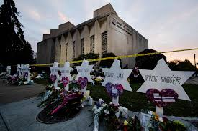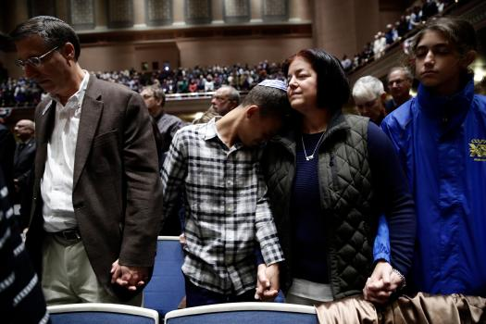

- What mistake about US Jewish life did the attack on Pittsburgh reveal?
- What security measures should we be taking in our Jewish institutions? How much of a change in mentality would it take to implement these changes?
- Read the security measures being implemented in the Pittsburgh synagogue—[see below] Why would we find these changes so hard to think about and implement? Are the people in Pittsburgh so different than us?
- Imagine that attacks like the one in Pittsburgh started occurring on a monthly basis, as a regularity. What would the proper Jewish response be?
- Could a fast day help in accomplishing the proper response? How? Should we wait until attacks become a regularity, or should we act NOW?
- Formulate the prayer to be added to the Shomea Tefillah blessing in the Amidah we should say to gain clarity in making the proper response to our post Pittsburgh reality?

Rambam, Laws of Fast Days Ch.1:1-3
Halachah 1

It is a positive Torah commandment to cry out and to sound trumpets in the event of any difficulty that arises which affects the community, as [Numbers 10:9] states: "[When you go out to war... against] an enemy who attacks you and you sound the trumpets...."
[This commandment is not restricted to such a limited scope; rather] the intent is: Whenever you are distressed by difficulties - e.g., famine, plague, locusts, or the like - cry out [to God] because of them and sound the trumpets.

Halachah 2
This practice is one of the paths of repentance, for when a difficulty arises, and the people cry out [to God] and sound the trumpets, everyone will realize that [the difficulty] occurred because of their evil conduct, as [Jeremiah 5:25] states: "Your sins have turned away [the rains and the harvest climate]." This [realization] will cause the removal of this difficulty.

Halachah 3
Conversely, should the people fail to cry out [to God] and sound the trumpets, and instead say, "What has happened to us is merely a natural phenomenon and this difficulty is merely a chance occurrence," this is a cruel conception of things, which causes them to remain attached to their wicked deeds. Thus, this time of distress will lead to further distresses.
This is implied by the Torah's statement [Leviticus 26:27-28]: "If you remain indifferent to Me, I will be indifferent to you with a vengeance." The implication of the verse is: When I bring difficulties upon you so that you shall repent and you say it is a chance occurrence, I will add to your [punishment] an expression of vengeance for that indifference [to Divine Providence].

