Class # 23 Parshat Vayikrah: Should the Sacrificial system be restored?
Advanced Fellowship Parsha Class - Sponsored in memory of Alice Toby Barbanel Z”l
Rabbi Pinny Rosenthal - prepared collaboratively with Rabbi Yoni Sacks

https://www.youtube.com/watch?v=ATAZrRfebiw

- What has modern agriculture and food production done to our eating experience?
- What is Oscar Meyer “Luncha-ables” highly effective at disguising?
- Why do we love the world of disguised foods?
- What is the difference between sublimation of an instinct and repression of an instinct?
- What instincts are involved in meat production?
- What explains the raucous excitement of the boxing knockout, the quarterback sack and 250 million owners of copies of “Call of Duty”?
- What is the moral question concerning slaughtering and consuming meat?

Proverb 12:10
יודע צדיק נפש בהמתו ורחמי רשעים אכזרי
A righteous man knows the needs of his beast, But the compassion of the wicked is cruelty.
8) What is the double entendre of this verse?
9) How does this apply to the issue of slaughtering and eating meat?

The beginning of the Book of Vayikrah – Leviticus – The Sacrificial system
1:1 God called to Moses, speaking to him from the Communion Tent. He said: 1:2 Speak to the Israelites, and tell them the following:
When one of you brings a mammal as an offering to God, the sacrifice must be taken from the cattle, sheep or goats.
1:3 If the sacrifice is a burnt offering taken from the cattle, it must be an unblemished male. One must bring it of his own free will to the entrance of the Communion Tent, before God. 1:4 He shall press his hands on the head of the burnt offering, and it shall then be accepted as an atonement for him. 1:5 He shall have the young bull slaughtered before God. Aaron's sons, the priests, shall then bring forth the blood, dashing it on all sides of the altar that is in front of the Communion Tent's entrance. 1:6 He shall have the burnt offering skinned and cut into pieces. 1:7 Aaron's sons shall place fire on the altar, and arrange wood on the fire. 1:8 Aaron's sons shall then arrange the cut pieces, the head, and the fatty intestinal membrane on top of the wood that is on the altar fire. 1:9 The inner organs and legs, however, must [first] be scrubbed with water.
The priest shall thus burn the entire [animal] on the altar as a completely burnt fire offering to God, an appeasing fragrance.

The Ramban explanation of sacrifices
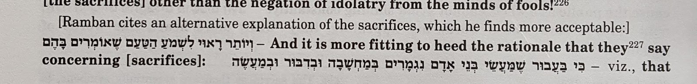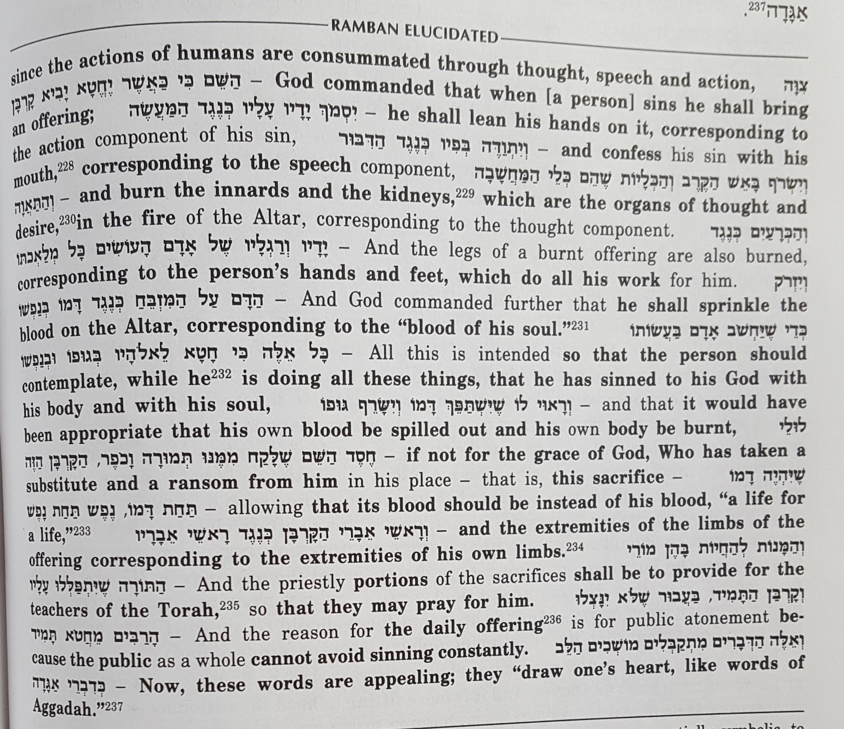
10) What is the psychological term that best describes the Korban/sacrifice experience?

