Class # 4–Parshat Vayeira- Your friend voted for “the enemy”, what do you do next?
Advanced Fellowship Parsha Class - Sponsored in memory of Alice Toby Barbanel Z”l
Rabbi Pinny Rosenthal - prepared collaboratively with Rabbi Yoni Sacks with ideas from Rabbi Mann

https://youtu.be/aJbnTPGWqgk - Growing up Democrat in a red state, Republican in a blue state | ABC News
- Why are people so aggressive with their political views?
- Why are the children of these same people so aggressive with their friends and classmates about their political views?
- Why are people particularly aggressive to family members who have different political views?
…Jocelyn Kiley, associate director of research at the Pew Research Center, said political polarization is more intense now than at any point in modern history. Nearly 80% of Americans now have "just a few" or no friends at all across the aisle, according to Pew. And the animosity goes both ways.
Another recent poll by the Public Religion Research Institute shows that 8 in 10 Republicans believe the Democratic Party has been taken over by socialists, while 8 in 10 Democrats believe the Republican Party has been taken over by racists. The report is aptly named titled "Dueling Realities."
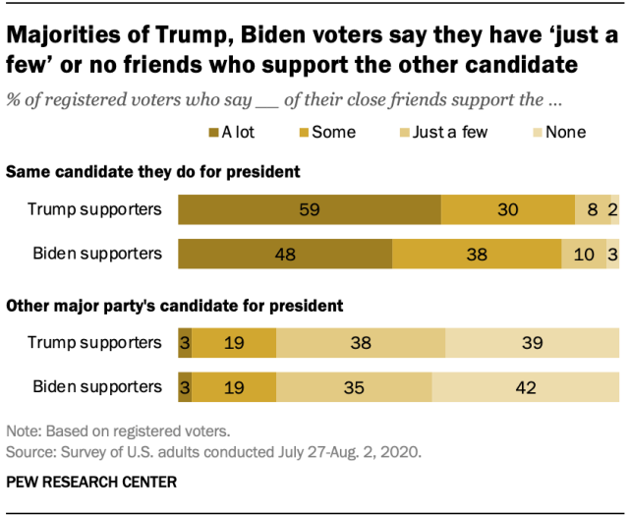

- Can a Republican and a Democrat be married to each other?
https://m.youtube.com/watch?v=IeqyHE0sAiY
Sarah and Avimelech
20:1 Abraham migrated from there to the land of the Negev, and he settled between Kadesh and Shur. He would often visit Gerar.
20:2 [There] he announced that his wife Sarah was his sister, and Avimelech, king of Gerar, sent messengers and took Sarah.
20:3 God came to Avimelech in a dream that night. 'You will die because of the woman you took,' He said, 'She is already married.'
20:4 Avimelech had not come near her. He said, 'O Lord, will You even kill an innocent nation?
20:5 Didn't [her husband] tell me that she was his sister? She also claimed that he was her brother. If I did something, it was with an innocent heart and clean hands.'
20:6 God said to him in the dream, 'I also realize that you have done this with an innocent heart. That is why I prevented you from sinning against Me, not giving you an opportunity to touch her.
20:7 Now return the man's wife, for he is a prophet. He will pray for you, and you will live. But if you do not return [her], you can be sure that you will die - you and all that is yours.'
20:8 Avimelech got up early in the morning, and he summoned all his servants. He discreetly repeated all these words to them, and the men were very frightened.
20:9 Avimelech summoned Abraham and said to him, 'How could you do this to us? What terrible thing did I do to you that you brought such great guilt upon me and my people? The thing you did to me is simply not done!'
20:10 Avimelech then asked Abraham, 'What did you see to make you do such a thing?'
20:11 Abraham replied, 'I realized that the one thing missing here is the fear of God. I could be killed because of my wife.
20:12 In any case, she really is my sister. She is the daughter of my father, but not the daughter of my mother. She [later] became my wife.
20:13 When God made me wander from my father's house, I asked her to do me a favor. Wherever we came, she was to say that I was her brother.'
20:14 Avimelech took sheep, cattle, and male and female slaves, and he gave [them] to Abraham. He [also] returned [Abraham's] wife Sarah to him.
20:15 Avimelech said, 'My whole land is before you. Settle wherever you see fit.'
20:16 To Sarah he said, 'I am giving your 'brother' a thousand pieces of silver. Let it be compensation for you and all who are with you for all that has been done. You can stand up tall.'
20:17 Abraham prayed to God, and God healed Avimelech, as well as his wife and slavegirls, so that they were able to have children.
20:18 God had previously sealed up every womb in Avimelech's house, because of Abraham's wife Sarah.
Rashi
בתם לבבי IN THE INTEGRITY OF MY HEART – I did not intend to sin.
ובנקיון כפי AND IN THE INNOCENCY OF MY HANDS – I am innocent of this sin because I have not touched her.
(6) 'ידעתי כי בתם לבבך וגו I KNOW THAT IN THE INTEGRITY OF THY HEART etc. – It is true that at first you had no intention of sinning, but you cannot claim innocency of hands (Genesis Rabbah 52:6) —
because לא נתתיך I PERMITTED YOU NOT – It was not of your own will that you did not touch her, but it was "I" who withheld you from sinning, and "I" did not permit you the possibility to touch her (Genesis Rabbah 52:7).
- What part of Avimelech’s claim of innocence is valid according to Rashi? What part of his claim is not valid?
- In what sense was Avimelech “guilty” of sin?
- How did Avimelech justify his claim of righteousness? What was his blind spot about himself and his countries righteousness? In what sense is Avimelech creating a “bubble” which justifies his righteousness?
- How does Avimelech’s bubble justify a system in which the women of others are treated unfairly once they enter his country?
- How might Avimelech’s bubble cause him to unfairly judge other nations way of life?
- What bubble of [self] righteousness do both Democrats and Republicans live in?
- How does the bubble cause such aggressive behavior?
- What is amazing about Avraham’s ability to daven for the welfare of Avimelech?
- Why is this the “gold-standard” of reaching a reconciliation with someone who has harmed you?
- How does the principle of “Who is Wise – One who learns from all people” apply to our current state of politics?

