Class # 22 Parshat Vayakel -Pekudai: - How to throw an awesome party?
Advanced Fellowship Parsha Class - Sponsored in memory of Alice Toby Barbanel Z”l
Rabbi Pinny Rosenthal - prepared collaboratively with Rabbi Yoni Sacks

https://www.youtube.com/watch?v=QMkmZXYbHng

- Why are these conversations about work or arcane topics such party killers?
- What other activities kill the vibe of a party? Why?
- What activities promote the party vibe?

Parshat Vayakel
The Sabbath
35:1 Moses assembled the entire Israelite community and said to them, 'These are the words that God has commanded for [you] to do: 35:2 'You may do work during the six weekdays, but Saturday must be kept holy as a Sabbath of Sabbaths to God. Whoever does any work on [that day] shall be put to death. 35:3 Do not ignite any fire on the Sabbath, no matter where you may live.'

4) Why is igniting fire being separated out from the 39 melachot - prohibited forms of work?

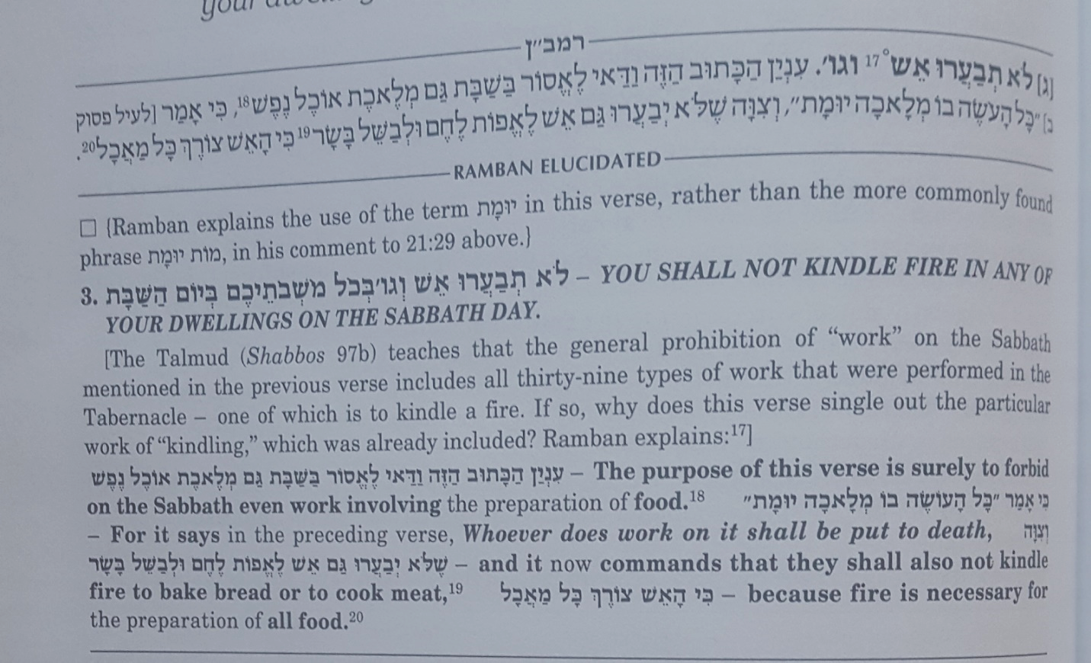

5) What holiday allows you to cook?
6) Why would you think that Shabbat should be the same?

Sephorno – Vayikra 23:1
…The Torah spoke of the festivals, days on which one abstains from the pursuit of secular matters. On some of these days one has to abstain from such activities completely, on others only partially. For instance, on the Sabbath as well as on the Day of Atonement there is a total cessation of everything which is called מלאכה, work, in the sense of a productive activity. These days are meant for us to occupy ourselves exclusively with Torah and other sacred tasks. To this effect the Torah wrote (Exodus 20,9-10) “you shall labour for six days and conduct all your activities, whereas the seventh day is a Sabbath of the Lord your God.” On that day your activities should concern spiritual matters. On some of the days described as holy convocations there is a partial prohibition of work, desisting basically from the kind of activity related to the kind of labour involved in earning one’s livelihood. One is to enjoy these days. Concerning such days, our sages coined the phrase חציה לה' וחציה לכם, “half for God and half for you.” (Pesachim 68) There is no doubt that when the Jewish people conduct themselves in this fashion that the Divine Presence will be at home among them….

