Parashat Lech-Lecha- Did our Forefathers make mistakes?
- Bereishit Ch. 12
1 The LORD said to Abram, “Go forth from your native land and from your father’s house to the land that I will show you. 2 I will make of you a great nation, And I will bless you; I will make your name great, And you shall be a blessing. 3 I will bless those who bless you And curse him that curses you; And all the families of the earth Shall bless themselves by you.” 4 Abram went forth as the LORD had commanded him, and Lot went with him. Abram was seventy-five years old when he left Haran. 5 Abram took his wife Sarai and his brother’s son Lot, and all the wealth that they had amassed, and the persons that they had acquired in Haran; and they set out for the land of Canaan. When they arrived in the land of Canaan, 6 Abram passed through the land as far as the site of Shechem, at the terebinth of Moreh. The Canaanites were then in the land. 7 The LORD appeared to Abram and said, “I will assign this land to your offspring.” And he built an altar there to the LORD who had appeared to him. 8 From there he moved on to the hill country east of Bethel and pitched his tent, with Bethel on the west and Ai on the east; and he built there an altar to the LORD and invoked the LORD by name. 9 Then Abram journeyed by stages toward the Negeb. 10 There was a famine in the land, and Abram went down to Egypt to sojourn there, for the famine was severe in the land.
- Ramban (R. Moshe b. Nachman, Spain, 1194-1270), Bereishit Ch. 12
...And you should know that our father Avraham committed a great sin unintentionally, in which he brought his righteous wife to stumble into transgression because of his fear of getting killed, and he should have trusted the Name to have saved him, his wife and all that was his, because Elohim has power to help and to save. Also his going out from the land - of which he had been commanded at the beginning - due to famine was a transgression that he committed, because Elohim would have saved him from dying (even) in a famine. And because of this deed it was decreed that his seed would be in exile in Egypt under the hand of Pharaoh.
- Radak (R. David Kimhi, France, 1160-1235), Bereishit Ch. 12
והיה כי יראו אותך המצרים ...As to why he did not trust G’d, Who had promised to make him into a great nation, a promise that had not yet begun to be fulfilled, and preferred to resort to subterfuge, this is not surprising. We find that Yaakov also took extreme precautions in spite of having been given many assurances by G’d. The promises by G’d are based on man having taken every reasonable precaution not to require a miracle to save him from danger. When one is aware that one finds oneself in a situation where danger to one’s life is likely, one must first take every precaution at one’s disposal to counter such danger. Our sages (Pessachim 64) have told us that it is inadmissible to sit with one’s hands in one’s hands, waiting for G’d to perform a miracle to save one’s life... One must not leave matters to miracles.
- R. Samson Raphael Hirsch (Germany, 1808-1888), Bereishit Ch. 12
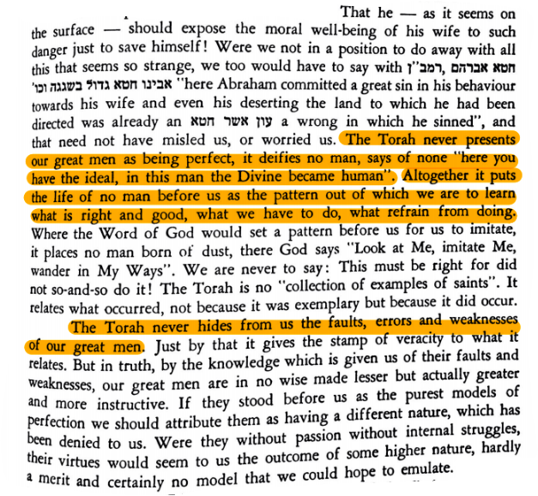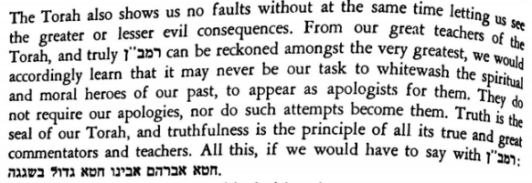
- Bereishit Ch. 16
1 Now Sarai, Abram's wife, had not borne to him, and she had an Egyptian handmaid named Hagar. 2 And Sarai said to Abram, "Behold now, the Lord has restrained me from bearing; please come to my handmaid; perhaps I will be built up from her." And Abram hearkened to Sarai's voice. 3 So Sarai, Abram's wife, took Hagar the Egyptian, her handmaid, at the end of ten years of Abram's dwelling in the land of Canaan, and she gave her to Abram her husband for a wife. 4 And he came to Hagar, and she conceived, and she saw that she was pregnant, and her mistress became unimportant in her eyes. 5 And Sarai said to Abram, "May my injustice be upon you! I gave my handmaid into your bosom, and she saw that she had become pregnant, and I became unimportant in her eyes. May the Lord judge between me and you!" 6 And Abram said to Sarai, "Here is your handmaid in your hand; do to her that which is proper in your eyes." And Sarai afflicted her, and she fled from before her. 7 And an angel of the Lord found her by a water fountain in the desert...
- Radak, Bereishit Ch. 16
ותענה שרי 6, Sarai overburdened her with work, and made her perform the work in an intolerably harsh manner. It is even possible that the word ותענה includes physical as well as verbal abuse of Hagar by Sarai. The Torah testifies that Sarai did not act piously toward her, Although Avram had given her a free hand when he said "do to her as appears fit in your eyes," from a moral point of view she should have treated Hagar in a manner befitting her status as a wife or legal companion of Avram...
- Ramban, Bereishit Ch. 16
And Sarai oppressed her and she fled from her presence (literally face): Our mother sinned in this oppression, and also Abraham in permitting her to do so. And Hashem heard her [Hagar's] oppression and gave her a son who would be a wild ass of a man to oppress the descendants of Abraham and Sarah in all kinds of oppression.
- Mishnat Rebbe Aharon (R. Aharon Kotler, USA, 1891-1962), III, p. 179
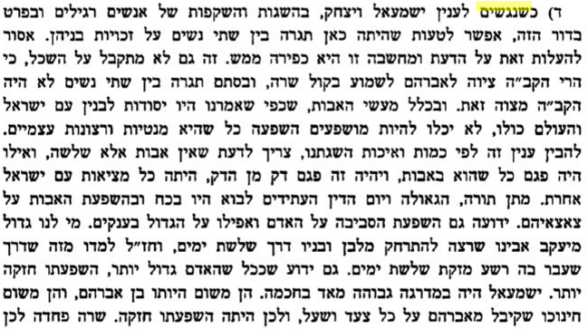
- Bereishit Ch. 27; Rashi; Midrash Sechel Tov
19 וַיֹּ֨אמֶר יַעֲקֹ֜ב אֶל־אָבִ֗יו אָנֹכִי֙ עֵשָׂ֣ו בְּכֹרֶ֔ךָ עָשִׂ֕יתִי כַּאֲשֶׁ֥ר דִּבַּ֖רְתָּ אֵלָ֑י קֽוּם־נָ֣א שְׁבָ֗ה וְאָכְלָה֙ מִצֵּידִ֔י בַּעֲב֖וּר תְּבָרֲכַ֥נִּי נַפְשֶֽׁךָ׃
אנכי עשו בכרך I AM ESAU THY FIRST-BORN — I am he that brings food to you, and Esau is your first-born.
ודאי אמר שהוא עשו, ומבוראו למד לשנות מפני דרכי שלום [לשקר עבור השלום], כמו שמצינו בשרה שאמרה [כשהמלאכים בשרו לאברהם על לידת יצחק] " אַחֲרֵי בְלֹתִי הָיְתָה לִּי עֶדְנָה וַאדֹנִי זָקֵן" (בראשית יב), ודבר הקודש אמר: "לָמָּה זֶּה צָחֲקָה שָׂרָה לֵאמֹר הַאַף אֻמְנָם אֵלֵד וַאֲנִי זָקַנְתִּי" (בראשית יג), וזה אבינו [יעקב] נתכוין לשם שמים לקנות הברכות ולהאכיל אביו במצות אמו:
- "הם אינם בני אדם כמונו" (הרב שלמה אבינר, ארץ ישראל)
הם אינם בני אדם כמונו ולא מהנמכתם נקבל השפעה רוחנית. קודם כול, הם ענקי רוח גדולי עולם. "האבות הם הם המרכבה" (בראשית רבה פב, ו), אמרו רבותינו. השכינה שורה בהם, במעשיהם, באישיותם, בנפשם, ברוחם, בנשמתם ובאיבריהם. לא במקרה ריבונו של עולם גזר בחכמתו שהם יהוו ראשית האומה הישראלית, כלומר, שנתחיל את ההיסטוריה שלנו בענקי עולם… הם ענקי עולם ויש להם חסרונות. חסרונות של גדולי עולם. כך אמרו רבותינו: "מפני מה לא נתגלו טעמי תורה? הרי שני מקראות נתגלו טעמן, ונכשל בהן גדול העולם. כתיב: לא ירבה לו נשים, לא ירבה לו סוסים" (סנהדרין כא ב)... הם אינם בני אדם כמונו.
- The Faith of a Heretic (Walter Kaufmann, USA, 1921-1980), p. 200
In India, the Jina and the Buddha, founders of two new religions in the sixth century BCE, came to be worshipped later by their followers. In China, Confucius and Lao-tze came to be deified. To the non-Christian, Jesus seems to represent a parallel case. In Greece, the heroes of the past were held to have been sired by a god or to have been born of goddesses, and the dividing line between gods and men became fluid. In Egypt, the Pharaoh was considered divine… In Israel, no man was ever worshiped or accorded even semi-divine status.
- Meshech Chochma (R. Meir Simcha, Lithuania, 1843-1926), Devarim Ch. 34
(ו) ולא ידע איש את קבורתו. בספרי (שנז): יש אומרים, אף משה עצמו אינו יודע מקום קבורתו שנאמר "ולא ידע איש" ואין "איש" אלא משה (שנאמר "והאיש משה עניו מאוד"). אבל 'האיש משה' שאינו שייך אל הגשם (physicality) כלל בחייו, והיה נבדל מאשה, וארבעים יום בלא לחם ומים, ודבר ה' עמו פנים אל פנים, הוא תיכף משנפסק ההתקשרות (combining) בין הנפש לגשמו, תיכף (immediately) עלה בין אראלי (elevations) קודש. "ולא ידע" היינו כמו לא הכיר [וכמו (בראשית יח, יט) "כי ידעתיו", וכיוצא בזה הרבה] שלא היה שייך אל מקום קבורתו כלל. והוא מטעם שהיה "איש אלקים" בחייו, ועניו מאוד, ולא היה מקושר ומסובך אל החומר (materialism) ועניניו כלל בחייו ככל האדם. וזה שאמרו "ולא ידע איש" - אפילו משה.
- A Storied Life (R. Emanuel Feldman, USA), pgs. 71-72
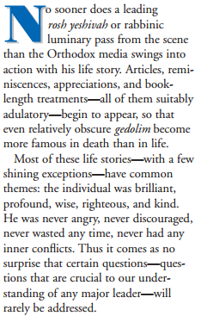 | 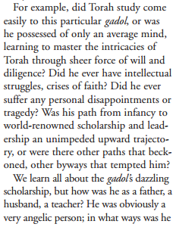 | 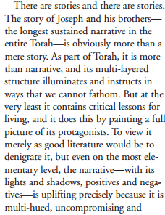 | 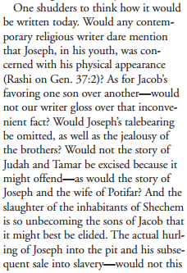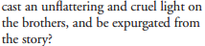

Quoted in http://www.rabbisacks.org/perfect-matriarchs-patriarchs-lech-lecha-5775/
See Hirsch further on Bereishit 25:27 (“ויגדלו הנערים”), and Bereishit 27:1 (“ויהי כי זקן יצחק ותכהין”)
Printed in Jewish Action Magazine, Summer 2002

