Moshe @Sinai: A Closer Look
- Rashi (R. Shlomo b. Yitzchak, France, 1040-1105), Shemot 24
the stone tablets, the Law and the commandments, which I have written to instruct them: All 613 mitzvot are included in the Ten Commandments. In the “Azharot” that he composed for each commandment [of the Ten], Rabbenu Saadiah [Goan] explained the mitzvot dependent upon it [each commandment].

- 13 Principles of Faith (R. Moses b. Maimon, Egypt, 1135-1204)
אני מאמין באמונה שלמה שכל התורה המציוה עתה בידינו היא הנתונה למשה רבינו עליו השלום.
I believe with perfect faith that the entire Torah now in our hands is the same one that was given to Moses, our teacher, peace be upon him.

- Introduction to Chelek (R. Moses b. Maimon, Egypt, 1135-1204)
The eighth fundamental principle is that the Torah is from heaven, that we should believe that the entire Torah that we possess today is the Torah that was given to Moses, and that it is of Godly origin in its entirety. [The Torah as a comprehensive whole] was granted [to Moses] by God. The manner in which it was granted to him we call - by analogy - speech.
The only one who knows the nature of this process of communication is Moses, the one to whom it was granted. Nevertheless, metaphorically he can be compared to a scribe taking dictation, writing down all the events that took place, the stories and the mitzvot. For this reason, he is referred to as “the scribe.”
And thus, there is no difference between the verses: “And the sons of Cham were Kush, Mitzrayim, Put and Canaan,” and “Timna was a concubine,” and “I am God your Lord,” and “Hear Israel, God is our Lord, God is one.” All is from the Almighty; all is His perfect Torah, pure, holy and true… Our Sages state: “To anyone who says the entire Torah originated from God, with the exception of a single verse that Moses himself wrote, is applied the verse, ‘He defamed the word of God.’” May God be blessed and uplifted above those who deny Him. ...Similarly, the interpretation of the Torah transmitted by tradition also stems from the Almighty. The manner in which we make a sukkah, lulav, shofar, tzitzit, tefillin and the like is exactly the same as God told Moses, who communicated it to us. He was merely a messenger, carrying out a mission, which he performed faithfully. The verse that reflects this eighth principle is: “With this, you shall see that God sent me; it is not of my own initiative.”

- Ikkarim (R. Joseph Albo, Spain, 1380-1444), Part 3, Ch. 23
Perfection means that no enhancement or flaw is imaginable. Since King David described the Torah as being “perfect” (Tehillim 19:8), it must contain no flaw that would prevent it from being absolutely perfect. Now, any written document is liable to various, opposing interpretations, to the extent that one person will espouse a certain argument and another will contradict it… Therefore, in order for God’s Torah to be perfect and understood correctly it is a logical imperative that when God gave Moshe the Written Law He must have explained to him the correct meaning. Moshe must have likewise done so to Yehoshua, and Yehoshua to the elders and the elders to the prophets, and so on through the generations, so that no uncertainty should arise as to the correct meaning of the written text.
This explanation of the Written Law, which was transmitted from Moshe to Yehoshua, and by Yehoshua to those that followed him, is called the “Oral Law,” because it is impossible to write down this explanation. For any written text would render itself open to variant interpretations, as explained above in reference to the original text, and consequently a further explanation will be required of this “interpretation” and so on ad infinitum.
This is precisely what occurred to the text of the Mishnah, which is an explanation of the Written Law. Its meaning became unclear, such a super-commentary was required, which the Talmud, authored by Rav Ashi to clarify the Mishnah. Likewise, the Talmud, which was meant to clarify the Mishnah, itself required a further explanation, and many commentaries were authored offering variant interpretations. These commentaries then engendered further commentary, and so on.
Thus we have explained that it would be impossible for the Written Law to be perfect unless it were accompanied by an oral interpretation, which is what we refer to as the “Oral Law”.

- Mishna Avot, Ch. 1:1
משה קבל תורה מסיני (פירוש רבינו יונה- בין תורה שבכתב בין תורה שבע"פ)
- Faith (Jacob Newman), p. 60-61
The version [of the Torah] in our hands today is identical with that which Moses received… The entire text, in every detail, now in our possession is the one given to Moses at Sinai.’
- Torah (Louis I. Rabinowitz), p. 39-40
The Masoretic text is the sole textus receptus of the Torah. All other readings represent man-altered variations from that authentic text.

- Avraham Kushelevsky, Meetings
The text of the Torah has been preserved as it was given more than 3,000 years ago, without an addition or deletion of a verse, a single word, or even a single letter.

- Talmud Yerushalmi, Sukkah Ch. 4:3
חנניה בן אחי ר' יהושע אומר [שמות כ ב] אנכי ה' אלקיך אשר הוצאתך מארץ מצרים. הוצאתיך כתיב.

- Beit HaBechira (R. Menachem Meiri, 14th c.), Kiddushin 30a
שאחר כן נתחדשו ספקות בדבר ולא ידענו וא"ו דגחון אי מהאי גיסא אי מהאי גיסא ואין לומר ניתי ספר תורה דאנהו בקיאי בחסרות ויתרות אנן לא בקיאינן וזה שאנו מוצאין תקונים ביד הסופרים שעל פיהם אנו סומכין בכתיבת ספר תורה אינם אלא כפי מה שמצאו בספרים המוחזקים במדויקים לא שיהא הדבר ברור כל כך ומתוך כך אני חוכך להקל בענין זה שלא לפסול ספר תורה בכך שלא נאמר כן אלא למה שבקיאים בו ואף ספרי המסרות אין לסמוך עליהם כל כך ואף לא המדרשות
- Marc Shapiro, The Limits of Orthodox Theology, pgs. 94, 96, 102
In a famous responsum, R. Solomon b. Aderet (Rashba, c. 1235-1310) discussed when Torah scrolls should be corrected in accordance with the Talmud’s pentateuchal text (in footnote- Rashba contended that, when the Talmud dervied halakhot from words, these words should then appear in our Torah scrolls as they do in the Talmud)
...Indeed, that there were differences in pentateuchal texts in Temple days is indisputable. It was because of this that R. Akiva and R. Ami emphasized the importance of using a corrected text. According to a number of midrashic sources, R. Meir himself had a Torah text that differed from that of his colleagues. For example, while the standard version of Genesis 1:31 reads: ‘And God saw every thing that He had made, and, behold, it was very good’ (טוב מאד), R. Meir’s text read: ‘Behold, death was good’ (טוב מות).
...Acceptance of Maimonides’ Principle presumably means that the extra inverted nuns at the end of the tenth chapter of Numbers are also Mosaic. However, the unknown author of Ginzei mitsrayim (eleventh century) quotes ‘some midrashim’ which state that it was the sages who added the inverted nuns. R. Solomon Luria describes twelve different ways of writing them, and adds that the entire notion of inverted nuns has no basis in the Talmud but is rather based on the kabbalah. Furthermore, according to Luria, the way in which the inverted nuns are currently written, with the addition of two exra letters, invalidates the Torah scroll! In other words, there is no question according to Luria and the midrashim referred to above that present-day Torah scrolls are not identical to the Torah given to Moses.

- Ginat Veradim (R. Abraham b. Mordechai HaLevi, 17th c.), kelal 2, no. 6
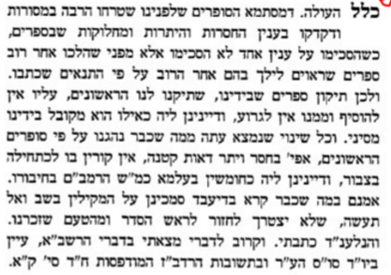
- Chumash: Stone Edition, p. xix
Rambam sets forth at much greater length the unanimously held view that every letter and word was given to Moses by God.
- Rashi, Devarim Ch. 34:5
And Moses… died there: Is it possible that Moses died, and [then] wrote, “And Moses… died there”? But [the answer is:] Moses wrote up to that juncture, and Joshua wrote from then on. Says Rabbi Meir: But is it possible that the Torah Scroll would be lacking anything at all, and yet Scripture states (Deut. 31:26),“Take this Torah Scroll” [and Moses commanded this to the Levites; so, according to the above opinion, is it possible that the Torah Scroll referred to there was an incomplete one, up to the juncture of Moses’s death? This cannot be!] Rather, [continues Rabbi Meir, we must say that] The Holy One, blessed is He, dictated this [i.e., the verse “And Moses… died there”], and Moses wrote it in tears. — [B.B. 15b, Sifrei 33:34]
- Ibn Ezra (R. Avraham b. Ezra, Spain, 1089-1167), Devarim Ch. 34
(א) ויעל משה - לפי דעתי, כי מזה הפסוק כתב יהושע, כי אחר שעלה משה לא כתב, ובדרך נבואה כתבו. ויראהו ה' גם ויאמר ה' אליו, גם ויקבור:
- Nefesh HaRav (Rav Herschel Schachter), p. 322
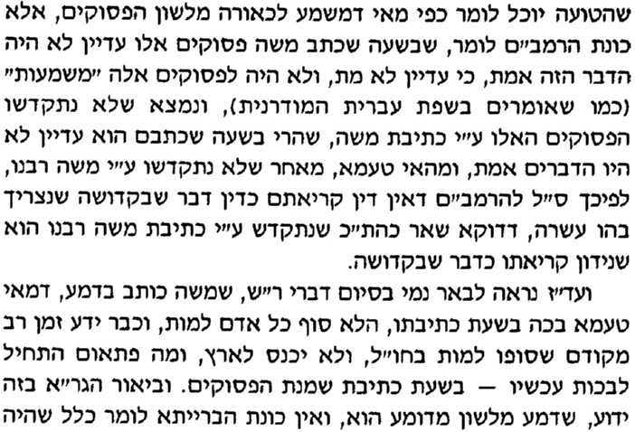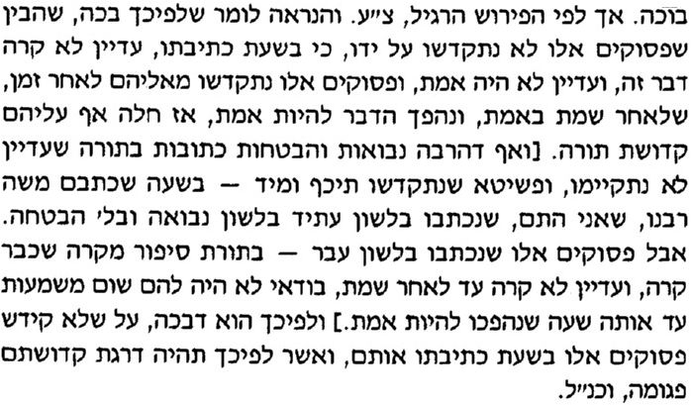
- Ibn Ezra (R. Avraham b. Ezra, Spain, 1089-1167), Devarim Ch. 1
ואם תבין סוד (השרים) [צ"ל: השנים] עשר, גם ויכתוב משה (דברים לא, כב), והכנעני אז בארץ (ברא' יב, ו), בהר ד' יראה (שם כב, יד), והנה ערשו ערש ברזל, (דברים ג, יא) תכיר האמת.

- Talmud Bavli, Gittin 60b
א"ר יוחנן משום רבי בנאה: תורה - מגילה מגילה ניתנה, שנא': (תהלים מ') אז אמרתי הנה באתי במגילת ספר כתוב עלי; ר"ש בן לקיש אומר: תורה - חתומה ניתנה, שנאמר: (דברים ל"א) לקוח את ספר התורה הזאת.

- Rav Yaakov Weinberg (1923-1999), Fundamentals and Faith, p. 90-91
Rambam knew very well that these variations existed when he defined his Principles. The words of Ani Ma’amin and the words of the Rambam, ‘the entire Torah in our possession today’, must not be taken literally, implying that all the letters of the present Torah are the exact letters given to Moshe Rabbeinu. Rather, it should be understood in a general sense that the Torah we learn and live by for all intents and purposes the same Torah that was given to Moshe Rabbeinu.

- Pirkei Machshava (Rav Ezriel Tauber), p. 208
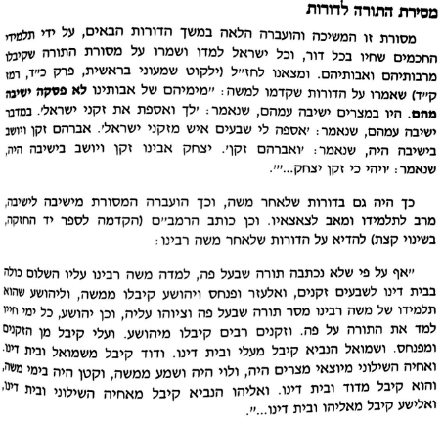

Rabbi Eliyahu Touger translation (https://www.amazon.ca/Pirkei-Avot-Shemona-Thirteen-Principles/dp/094011898X)
I.e., Moses did not hear God talking as one hears another human being. Nevertheless, the term speech serves as an appropriate metaphor for the communication of the Torah’s wisdom to him.
Bamidbar 15:31
Following the Koren Sacks Siddur (Jerusalem, 2009), pp. 204-205
Talmud Bavli, Sanhedrin 99a
“It is possible that some of the scholars we have quoted understood this passage as condemning, not the denial of the complete Mosaic authorship, but the denial of divine inspiration. That is, what the Talmud regards as heresy is the assertion that Moses composed the Torah on his own, without receiving it from God. Yet once the Torah’s divinity is acknowledged, it is not heretical to posit that some verses were revealed to post-Mosaic prophets. Indeed, the Mishnah includes in its lists of heretics ‘he who says that the Torah is not from Heaven’. In other words, the stress is on the divine origin of the Torah, not on whether Moses alone received the revelation.” (The Limits of Orthodox Theology, pgs. 112-113)
Talmud Bavli, Pesachim 112a
Bereishit Rabbah 9:5, 20:12, 94:9
Moreh Nevukhim III, 10: The book which enlightened the darkness of the world says therefore, "And God saw everything that He had made, and, behold, it was very good" (Gen. i. 31). Even the existence of this corporeal element, low as it in reality is, because it is the source of death and all evils, is likewise good for the permanence of the Universe and the continuation of the order of things, so that one thing departs and the other succeeds. Rabbi Meir therefore explains the words "and behold it was very good" (tob me’od); that even death was good in accordance with what we have observed in this chapter.

