The Millie Arbesfeld
בס"ד

Midreshet Yom Rishon Sunday Morning Learning Program for Women

W W W.MidreshetYOMRISHON.ORG

A Stricture Named Desire:
Last Stop on the Decalogue

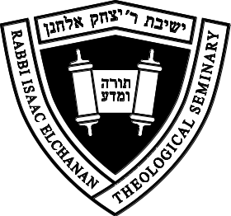

Rebbetzin Peshi Neuburger
January 27, 2013•טז' שבט תשע"ג



