Class # 17 – Inspiration and Insight for your Seder
Advanced Fellowship Parsha Class - Sponsored in memory of Alice Toby Barbanel z”l
Rabbi Pinny Rosenthal - prepared collaboratively with Rabbi Yoni Sacks

Yaakov Shwekey featuring Shlomi Shabat – Vehi Sheamda
https://www.youtube.com/watch?v=qnnKFpiP1hs
He covers the matza and lifts up the cup and says:
וְהִיא שֶׁעָמְדָה לַאֲבוֹתֵינוּ וְלָנוּ. שֶׁלֹּא אֶחָד בִּלְבָד עָמַד עָלֵינוּ לְכַלּוֹתֵנוּ, אֶלָּא שֶׁבְּכָל דּוֹר וָדוֹר עוֹמְדִים עָלֵינוּ לְכַלוֹתֵנוּ, וְהַקָּדוֹשׁ בָּרוּךְ הוּא מַצִּילֵנוּ מִיָּדָם.
And it is this [promise] that has stood for our ancestors and for us; since it is not [only] one [person or nation] that has stood [against] us to destroy us, but rather in each generation, they stand [against] us to destroy us, but the Holy One, blessed be He, rescues us from their hand.
- What is the basic message of the declaration of “Vehi Sheamda”?
- Why do you cover the Matzah and lift your glass of wine?
וגם את הגוי AND ALSO THAT NATION – The word וגם and also—(that nation also will I judge)—suggests that other nations will be judged as well: it is used here to include the four Monarchies (of the book of Daniel) who also will perish because they enslaved Israel (Genesis Rabbah 44:19).
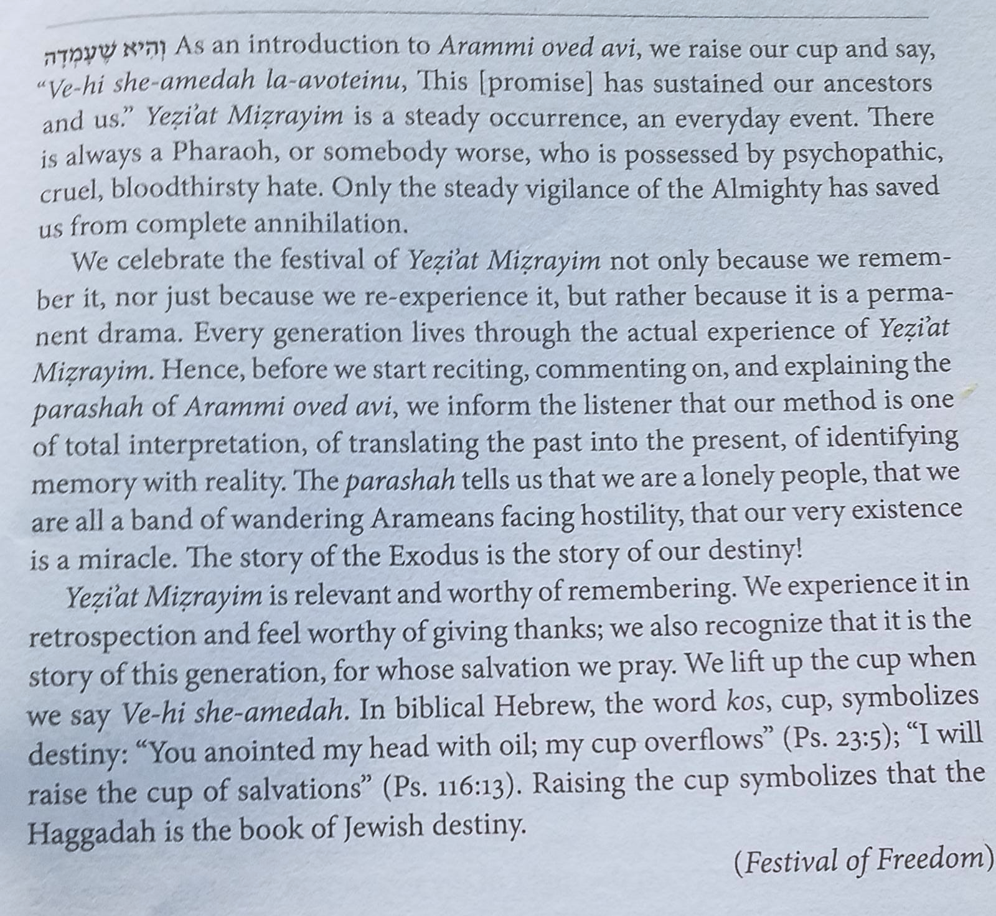

- Does Vehi Sheamda’s message regarding “crisis” apply to our worldwide Corona virus epidemic? Why or Why Not?
- How does Vehi Sheamda’s message fit into the flow of the Haggadah?
Flow of Haggadah:
…..Blessed be the One who keeps His promise to Israel, blessed be He; since the Holy One, blessed be He, calculated the end [of the exile,] to do as He said to Avraham, our father, in the Covenant between the Pieces, as it is stated (Genesis 15:13-14), "And He said to Avram, 'you should surely know that your seed will be a stranger in a land that is not theirs, and they will enslave them and afflict them four hundred years. And also that nation for which they shall toil will I judge, and afterwards they will go out with much property.'"
And it is this [promise] that has stood for our ancestors and for us; since it is not [only] one [person or nation] that has stood [against] us to destroy us, but rather in each generation, they stand [against] us to destroy us, but the Holy One, blessed be He, rescues us from their hand.
Go out and learn what Lavan the Aramean sought to do to Ya'akov, our father; since Pharaoh only decreed [the death sentence] on the males but Lavan sought to uproot the whole [people]. As it is stated (Deuteronomy 26:5), "An Aramean was destroying my father and he went down to Egypt, and he resided there with a small number and he became there a nation, great, powerful and numerous."…
Using the Vehi Sheamda Principle apply it to the following cases:
- The Holocaust
- The establishment of the state of Israel
- The Six Day War
- The Yom Kippur
- Soviet and Ethiopian Jews emigrate to Israel
- The Palestinian Conflict
- The Corona Virus

