**DREYFUS AFFAIR**

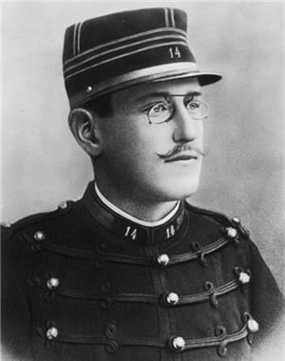

Capt. Alfred Dreyfus (1859-1935)

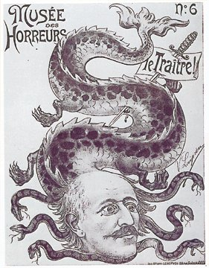

[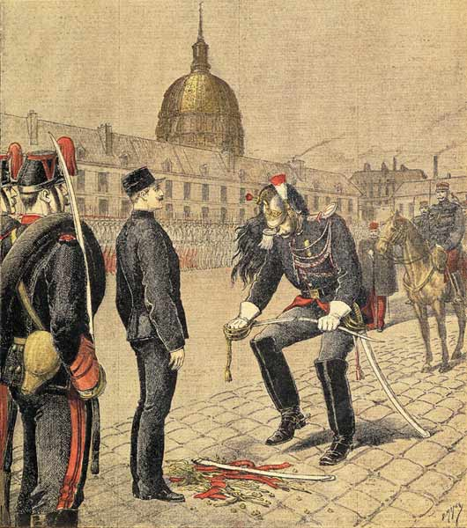](http://upload.wikimedia.org/wikipedia/commons/5/52/Degradation_alfred_dreyfus.jpg)

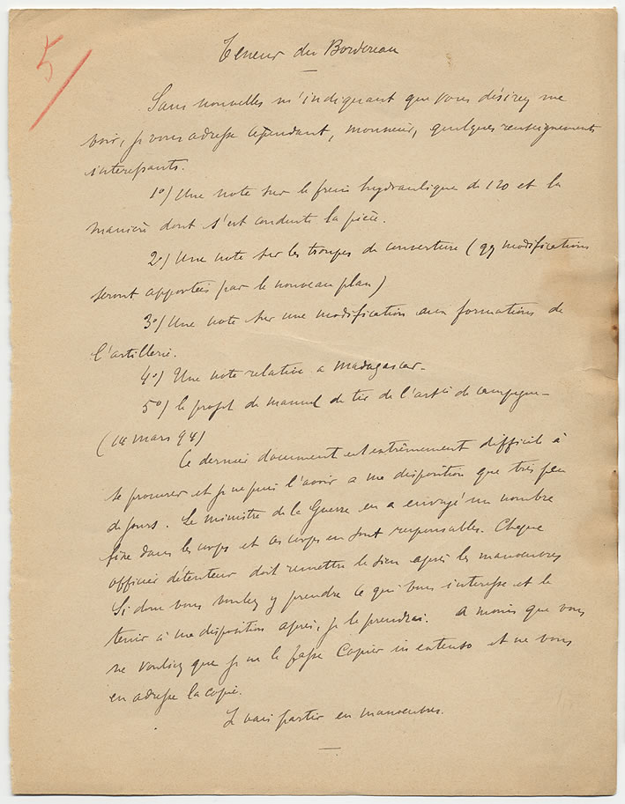

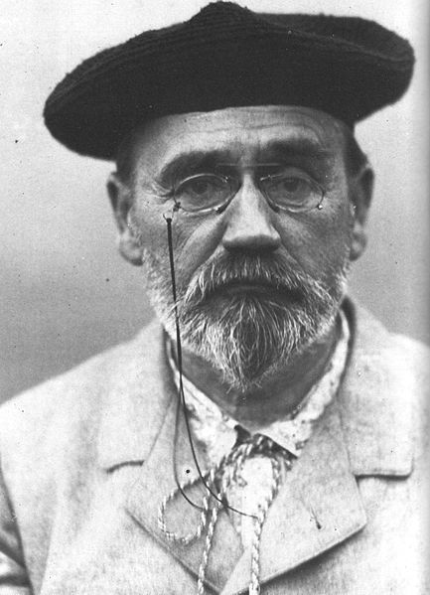

Emile Zola (1840-1902)

Jan 13, 1898

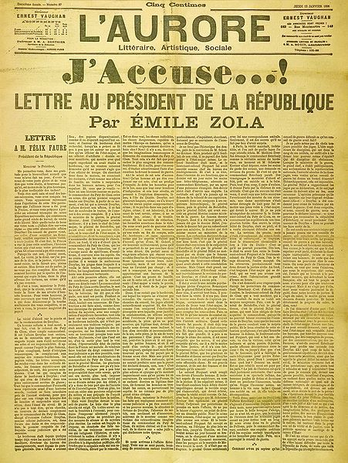

http://en.wikisource.org/wiki/J'accusea

