A Divine Play in Five Acts: The Torah
Rabbi Jonathan Ziring: jziring@torontotorah.com
- Structure of Bereishit
Literary Organization: The Toladot (Generations of the World)  1. Introduction the Generations, 1:1-2:3  2. Heaven and Earth, 2:4-4:26  3. Adam, 5:1-6:8  4. Noah, 6:9-9:29  5. Sons of Noah, 10:1-11:9  6. Shem, 11:10-26  7. Terah, 11:27-25:11  8. Ishmael, 25:12-18  9. Isaac, 25:19-35:29  10. Esau, 36:1-37:1  11. Jacob, 37:2-50:26. | Thematic Summary  From Creation to Avraham:  A. Creation (Genesis 1-2)  B.Sin(Genesis 3-5)  C. Flood (Genesis 6-9)  D. Tower of Bavel (Genesis 10-11)  2. The Creation of the Jewish People  A. Abraham (Genesis 12-24)  B. Isaac (Genesis 25-26)  C. Jacob (Genesis 27-36)  D. Joseph (Genesis 37-50)

- Structure of Shemot (tanach.org – Rabbi Menachem Leibtag)
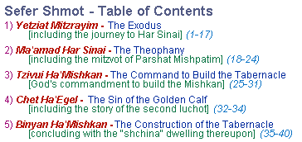 | The Double Ending of Sefer Shemot  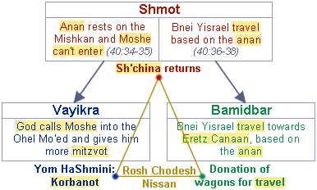

- Structure of Vaykira (Wikipedia)
Laws on sacrifice (1:1–7:38)
A. Instructions for the laity on bringing offerings (1:1–6:7)
1–5. The types of offering: burnt, cereal, peace, purification, reparation (or sin) offerings (ch. 1–5)
B. Instructions for the priests (6:1–7:38)
1–6. The various offerings, with the addition of the priests' cereal offering (6:1–7:36)
7. Summary (7:37–38)
II. Institution of the priesthood (8:1–10:20)
A. Ordination of Aaron and his sons (ch. 8)
B. Aaron makes the first sacrifices (ch. 9)
C. Judgement on Nadab and Abihu (ch. 10)
III. Uncleanliness and its treatment (11:1–15:33)
A. Unclean animals (ch. 11)
B. Uncleanliness caused by childbirth (ch. 12)
C. Unclean diseases (ch. 13)
D. Cleansing of diseases (ch. 14)
E. Unclean discharges (ch. 15)
IV. Day of Atonement: purification of the tabernacle from the effects of uncleanliness and sin (ch. 16)
V. Prescriptions for practical holiness (the Holiness Code, chs. 17–26)
A. Sacrifice and food (ch. 17)
B. Sexual behaviour (ch. 18)
C. Neighbourliness (ch.19)
D. Grave crimes (ch. 20)
E. Rules for priests (ch. 21)
F. Rules for eating sacrifices (ch. 22)
G. Festivals (ch.23)
H. Rules for the tabernacle (ch. 24:1–9)
I. Blasphemy (ch. 24:10–23)
J. Sabbatical and Jubilee years (ch. 25)
K. Exhortation to obey the law: blessing and curse (ch. 26)
VI. Redemption of votive gifts (ch. 27)

- Structure of Bamidbar – Rabbi Menachem Leibtag
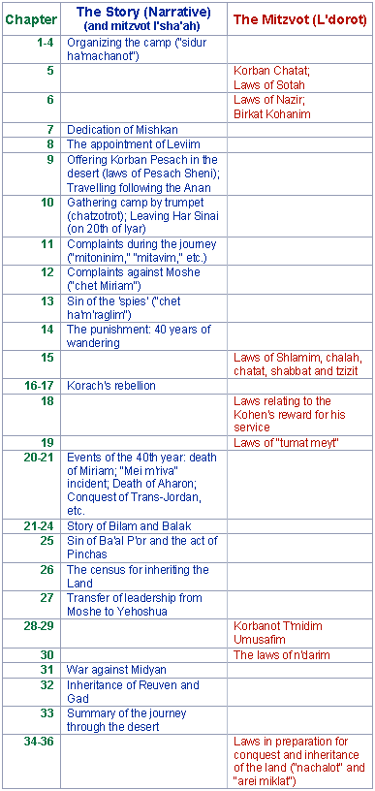
- Structure of Devarim: 4 Speeches
Speech 1 | Chaps. 1-4 | Introductory speech
Speech 2 | Chaps. 5-26 | Main speech
Speech 3 | Chaps. 27-28 | Tochacha & Covenant
Speech 4 | Chaps. 29-30 | Teshuva

