R Yonosan Eibshitz
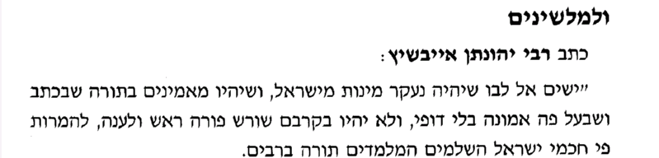

Brachos 28b
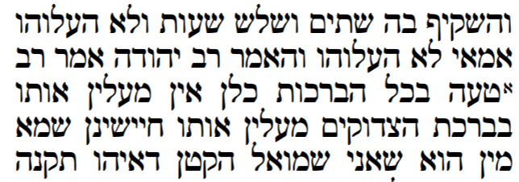

Rambam Hilchos Tefilah
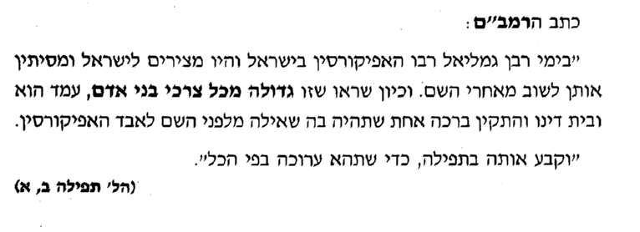

Sifsei Chaim
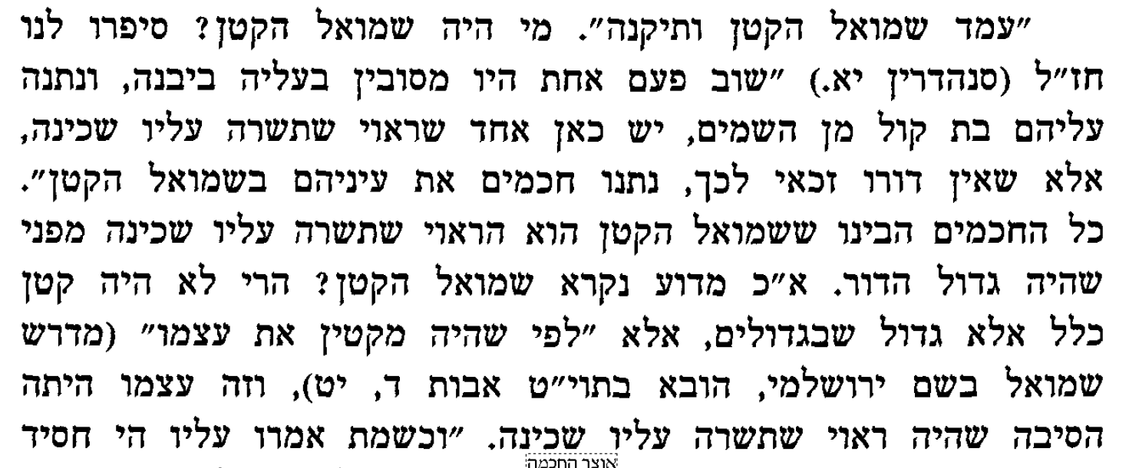

avos
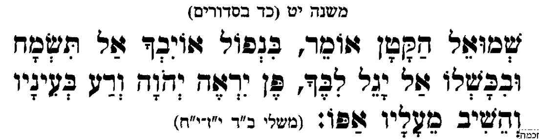

MEforshei Avos
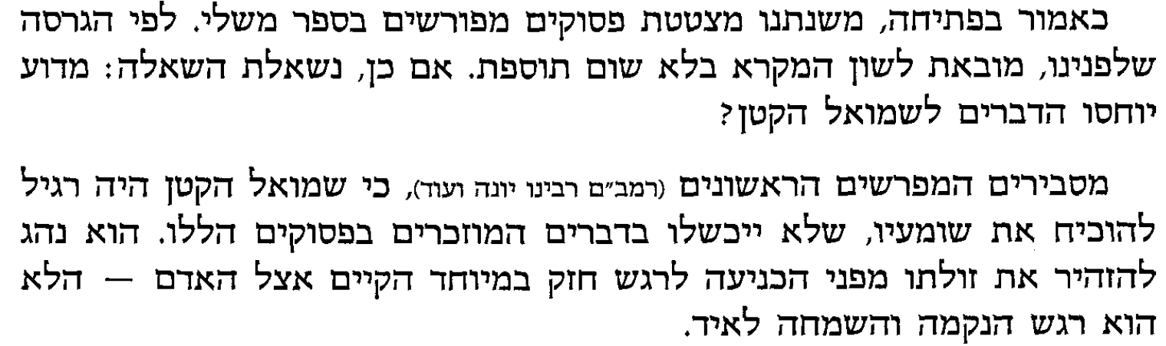

Rashbatz
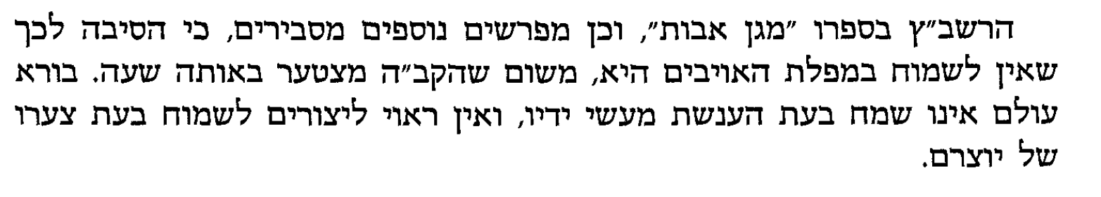

Yacehl Yisrael
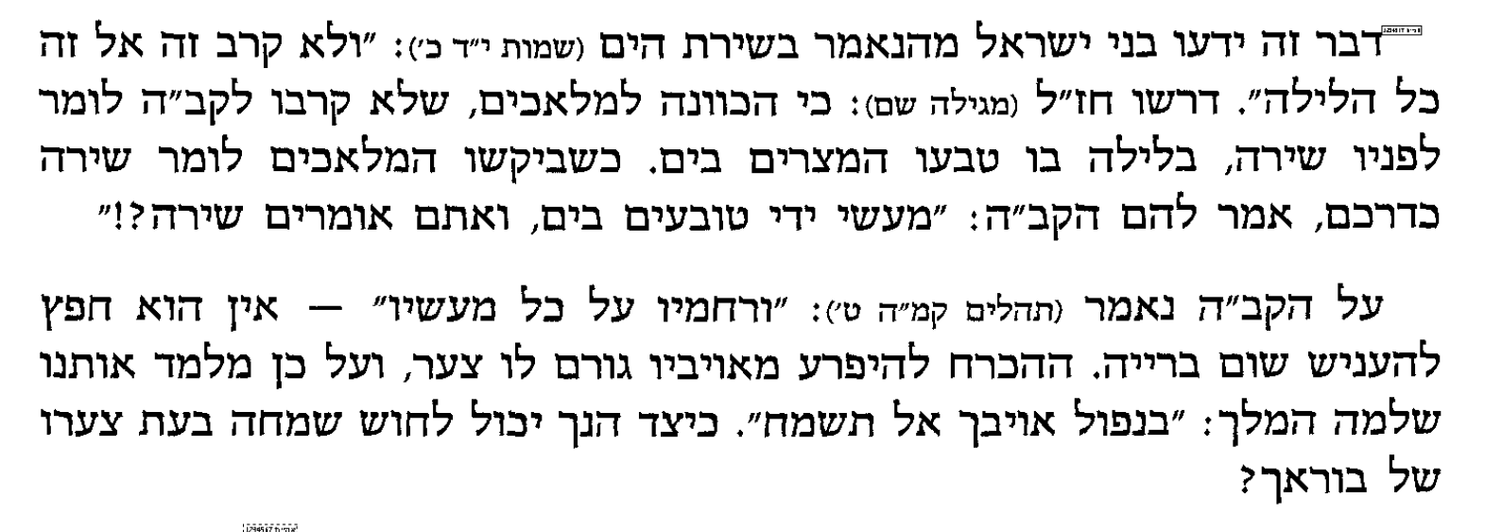

Sfisei chaim
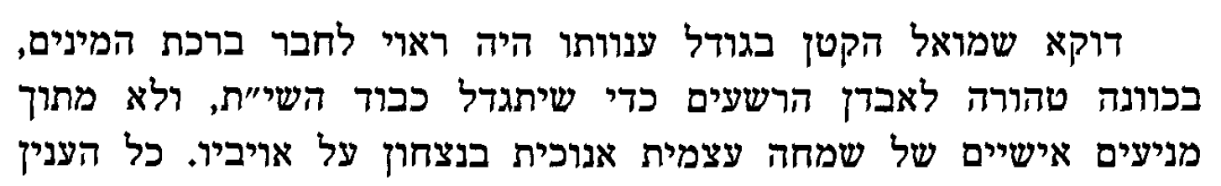

Rav Kook
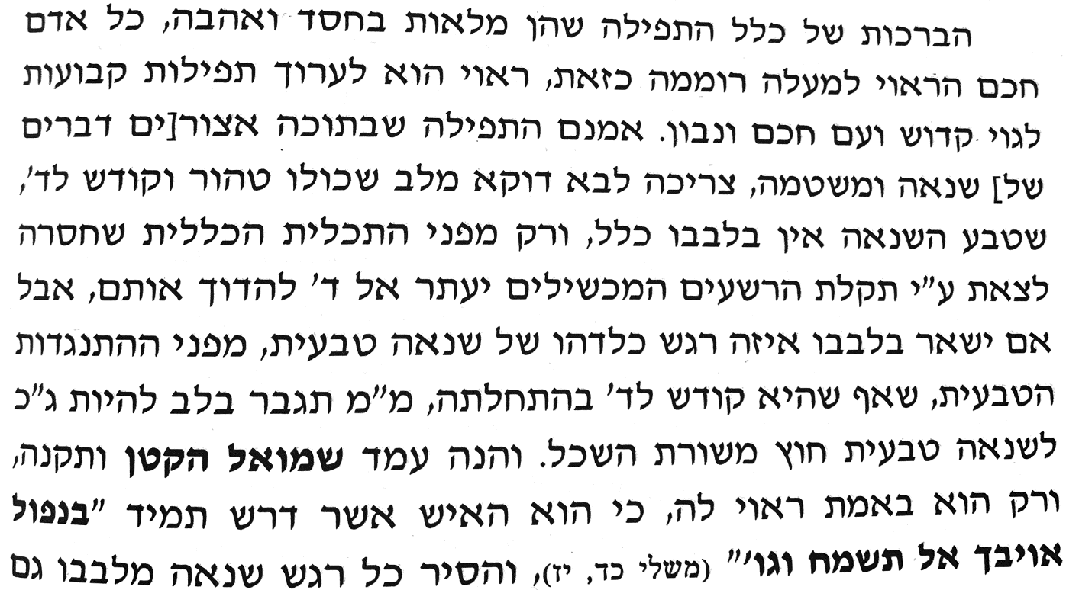

Yachel Yisrael
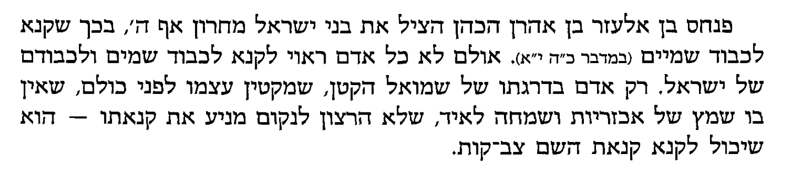

Baruch Sheamar
