Asking Forgiveness in the Digital Age
- Yechave Da’at (R. Ovadia Yosef, Baghdad-Israel, 1920-2013), 5-44
One who sins against their friend and harmed them with words, and now regrets his actions and wants to ask forgiveness before Yom HaKippurim, but he is embarassed to confront his friends on his own; can he send a messenger or a letter, or does he have to go himself?
- Vayikra Ch. 16
ל כִּי בַיּוֹם הַזֶּה יְכַפֵּר עֲלֵיכֶם לְטַהֵר אֶתְכֶם מִכֹּל חַטֹּאתֵיכֶם לִפְנֵי יְהוָֹה תִּטְהָרוּ:
30 For on this day He shall effect atonement for you to cleanse you. Before the Lord, you shall be cleansed from all your sins.
- Mei Marom (R. Ya’akov Moshe Charlap, Israel, 1882-1951) vol. 7 p. 349
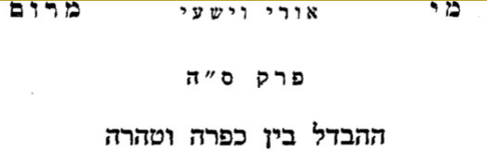
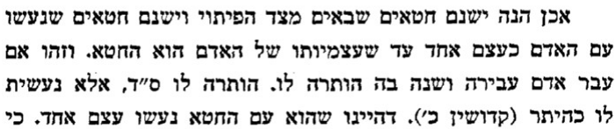
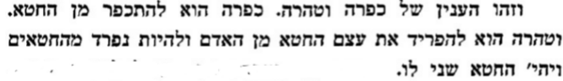
- Mishna Yoma 8:9
עבירות שבין אדם למקום. יום הכפורים מכפר. עבירות שבין אדם לחבירו. אין יום הכפורים מכפר. עד שירצה חברו. את זו דרש רבי אלעזר בן עזריה (ויקרא טז, ל) מכל חטאתיכם לפני ה' תטהרו. עבירות שבין אדם למקום יום הכפורים מכפר. עבירות שבין אדם לחברו. אין יום הכפורים מכפר. עד שירצה את חברו. אמר רבי עקיכא אשריכם ישראל לפני מי אתם מיטהרין. מי מטהר אתכם אביכם שבשמים...
Yom Kippur atones for transgressions between a person and God, but for a transgression against one's neighbor, Yom Kipur cannot atone, until he appeases his neighbor. Thus R. Eleazar ben Azariah expounds the text, "From all your sins before the Lord shall ye be clean": For transgressions between a person and God, Yom Kippur atones, for transgressions against one's neighbor, Yom Kippur cannot atone, until he appeases his neighbor. R. Akiva says, Happy are you, Israel! Before whom are you purified, and who purifies you [of your transgressions]? Your Father Who is in heaven…
- Mishna, Masechet Bava Kamma 8:7
Even when he gives him [the payment], he will not be forgiven until he seeks it [pardon] from him, as it says, "Therefore, restore [Abraham's] wife[—he is a prophet and will intercede for you]" (Genesis 20:7). And from where do we know the forgiver should not be cruel? As it says, "Abraham prayed to God and God healed Avimelech" (Genesis 20:17).
- Rif on Ein Ya’akov (R. Yoshiyahu Pinto, Damascus, 16th century) Yoma 85b
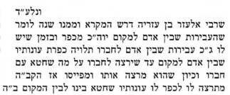 | 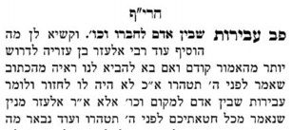
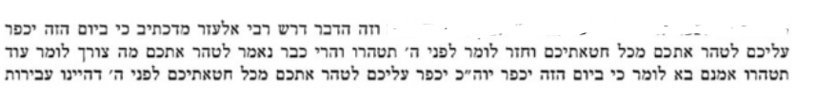
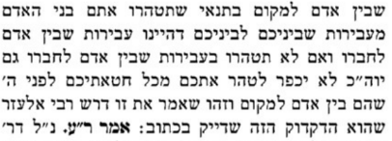
- Rambam (R. Moshe b. Maimon, Egypt, 1135-1204) Laws of Teshuva 2:9, 11
Halacha 9: Teshuva and Yom Kippur only atone for transgression between man and God, such as one who eats a forbidden food, or has a forbidden sexual relationship, etc. But transgressions between man and his fellow, such as hurting his fellow, or cursing his fellow, or stealing from him, etc, those are never forgiven until he gives his fellow what he owes him, and [his fellow] is appeased. Even if he returned the money he owed his [fellow], he must appease him and ask him to forgive him. Even if he only perturbed his fellow verbally, he must make amends and meet with him until he forgives him. If his fellow does not wish to forgive him, he should bring a line of three people who are friends with him and they will approach him and ask [forgiveness] from him. If he does not give in to them, he must bring people a second and third time. If he still does not give in, they should leave him alone, and that person who did not forgive – he is the sinner. But if it was his teacher, he must come and go even a thousand times until he forgives him.
Halacha 11: If a person wronged a colleague and the latter died before he could ask him for forgiveness, he should take ten people and say the following while they are standing before the colleague's grave: "I sinned against God, the Lord of Israel, and against this person by doing the following to him...."

- Pachad Yitzchak (R. Yitzhak Hutner, USA, 1906-1980), Yom Kippur, Ma’amar #2
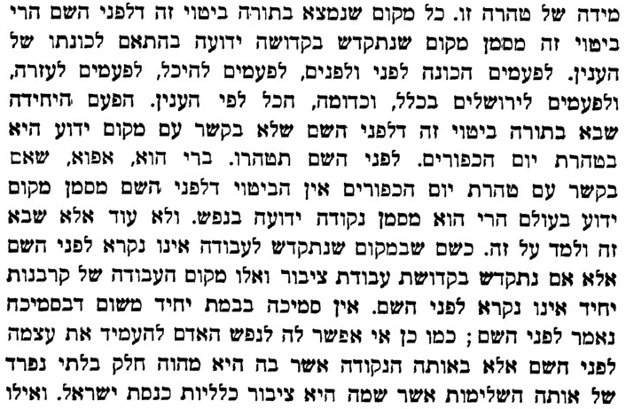
- Peri Chadash (R. Hizkiya Da Silva, Italy-Israel, 1659-1698), O”C 606
ומה שכתב אין יום הכפורים מכפר עד שיפייסנו. כתב מוהר"ש גרמיזאן ז"ל, שעבירה שבין אדם לחבירו יש בה חלק למקום, כגון אם ביזהו בדברים הרי עבר א"ואהבת לרעך כמוך" וכיוצא, וכל זמן שלא הרצה את חבירו אפילו מה שבין אדם למקום אינו מכפר:
- Masechtot Ketanot, Avot D’Rabbi Natan Ch. 12
Hillel taught: Be among the students of Aaron: Loving and pursuing peace, loving people and bringing them closer to the Torah. Two people had quarreled with one another. Aaron went and sat with one of them. He said to him: My son, look what your friend has done, his heart is distraught and he has torn his clothes (out of sorrow regarding the quarrel), and he is saying: Woe is to me, how will I raise up my head and look at my friend? I am embarrassed in his presence, because I am the one who wronged him. And he [Aaron] sits with him until he removes the jealousy from his heart. And Aaron then goes and sits with the other party and says to him: My son, see what your friend has done, his heart is distraught and he has torn his clothes and he is saying: Woe is to me, how will I raise up my head and look at my friend? I am embarrassed in his presence, because I am the one who wronged him. And he [Aaron] sits with him until he removes the jealousy from his heart. And when they met [the two opponents who carried on the dispute between them], they embraced and kissed one another.
- Mishna Berura (R. Israel Kagan, Poland, 1838-1933), O”C 606:2
(ב) לפייסו - ונכון שילך בעצמו אליו ולא ישלח תחלה אמצעי שירצה לקבל פיוסים ואם קשה עליו לילך בעצמו תחלה או שיודע שיותר קרוב הפיוס ע"י איש אמצעי שיתווך ביניהם יכול לעשות ע"י אמצעי:

