Class #14- Parshat Mishpatim – Are you an Enabler?
Advanced Fellowship Parsha Class - Sponsored in memory of Alice Toby Barbanel z”l
Rabbi Pinny Rosenthal - prepared collaboratively with Rabbi Mann & Rabbi Yoni Sacks

Dr. Phil: Why Enabling A Child Is More About You Than Them
https://youtu.be/8JENqy8DvBE
- Why are the parents always bailing out the child?
- Why the parents can’t they cut him off?
- How will the child react?
- What is the best solution to stop being an enabler?

Shemot 22:19-23
(19) “He who sacrifices to any god, except to Hashem only, shall be utterly destroyed. (20) “You shall not afflict a convert [Ger], neither shall you oppress him, for you were strangers in the land of Egypt. (21) “You shall not take advantage of any widow or fatherless child. (22) If you take advantage of them at all, and they cry at all to me, I will surely hear their cry; (23) and my wrath will grow hot, and I will kill you with the sword; and your wives shall be widows, and your children fatherless.

- What is the connection between Avodah Zara and oppression of the weak?
- Why do you need a reason not to oppress the convert? Is it not intrinsically wrong?

Rashi
גר לא תונה – means, do not vex him with words (referring to the fact that he is a stranger); ….

ולא תלחצנו NOR OPPRESS HIM – by robbing him of money (Mekhilta d’Rabbi Yishmael 22:20).

כי גרים הייתם FOR YOU WERE STRANGERS – If you insult him he can insult you also by saying to you: “You also descend from strangers”. Do not reproach thy fellow-man for a fault which is also yours (Mekhilta d’Rabbi Yishmael 22:20). Wherever גר occurs in Scriptures it signifies a person who has not been born in that land (where he is living) but has come from another country to sojourn there.

- What is Rashi’s rationale for not verbally afflicting the convert?

- The Ramban’s understanding for the prohibition of not afflicting the convert. How does he differ from Rashi’s rationale?

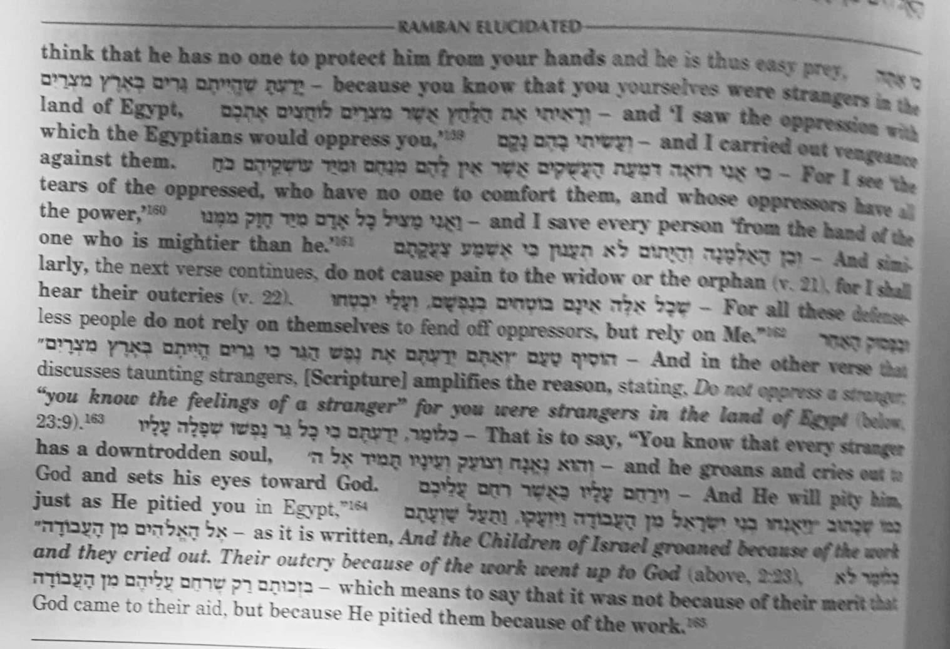

Rashi comments:
והיו נשיכם אלמנות AND YOUR WIVES SHALL BE WIDOWS [AND YOUR CHILDREN FATHERLESS] – From what is implied in the words, "I will kill you with the sword" do I not know that "your wives shall be widows and your children orphans"? But the explanation of the latter words is not that implied by your question; it is quite a different curse: that the wives will be "fettered" for life — "as living widows" (Rashi is imitating a Biblical phrase, II Samuel 20:3, used in a somewhat similar sense) — that there will be no witnesses who can testify to the death of their husbands, and so they will be forbidden to re-marry. In which case the children will be destitute orphans, for the court will not allow them to take possession of the chattels of their fathers, since they do not know whether they have died or have only been taken captives (Mekhilta d'Rabbi Yishmael 22:23; Bava Metzia 38b).

- Why are the wife and kids purposely being targeted?

- Aren’t the family members of a person who receives a capital punishment always victims? What is Rashi take on this?

- What is “enabling” for the good? And “enabling for bad?

