Discovering Seder Secrets: 10 Insights for a More Meaningful Pesach
Rabbi Pinny Rosenthal - prepared collaboratively with Rabbi Yoni Sacks

Successful Seder Strategies:
- Failing to plan is planning to FAIL!
- Games
- Seder Dollars
- Good snacks during maggid – small knishes, meatball

What is a Seder Nugget?
- Relevant to your crowd
- Starts with a good hook
- Short
- Meaningful
- Likely have a story component

The underlying principle of the Seder Nugget
Is reading the Haggadah and the mitzvah of Sippur Yitziyat Mitzrayim – one and the same thing? What is their relationship to each other?

- What is the top question about the order of the seder that everyone is thinking - but not asking at the Seder?
רמב"ם הלכות חמץ ומצה פרק ח:א
"סדור עשיית מצוות אלו בליל חמשה עשר כך הוא"
קַדֵּשׁ וּרְחַץ כַּרְפַּס יַחַץ מגִּיד רַחְצָה מוֹצִיא מַצָּה מָרוֹר כּוֹרֵךְ שֻׁלְחָן עוֹרֵךְ צָפוּן בָּרֵךְ הַלֵּל נִרְצָה

- Can I say “Shelo Asani Aved” as a slave to the Nazis?
“We Jews of the Kovno ghetto were completely enslaved by the German, we worked to the bone night and day without rest; we were starved and paid nothing. The German enemy decreed our total annihilation. We were completely dispensable. And, in the end, most of us would die. One morning during prayer, Reb Avrohom Yosef, who was leading the congregation in the morning service, reached the blessing, Who has not made me a slave," and shouted bitterly to the Master of all masters, "How can I recite the blessing of a free man? How can a hungry slave, repeatedly abused and demeaned, praise his Creator by uttering Who has not made me a slave?
Every morning as Reb Avrohom Yosef led the prayers, he let out the same
cry! And many of those who joined him in prayer felt the same way. I was then asked for the Torah ruling on this question: Should the blessing be omitted because it seemed to be a travesty--in which case it would be forbidden to recite it or was it forbidden to alter or skip any part prayer text established by our sages?
Response:
One of the earliest commentators on the prayers points out that this blessing Was not formulated in order to praise Gd for our physical liberty but rather for
spiritual liberty. I therefore ruled that we could not skip or alter this blessing under any circumstances. On the contrary, despite our physical captivity, we were more obligated than ever to recite the blessing to demonstrate to our enemies that even if physically we were slaves, as a people we remained spiritually free.”
-Responsa from the Holocaust, Rabbi Ephraim Oshry, pg. 86

הגדה מגיד: והיא שעמדה
וְהִיא שֶׁעָמְדָה לַאֲבוֹתֵינוּ וְלָנוּ שֶׁלֹּא אֶחָד בִּלְבָד עָמַד עָלֵינוּ לְכַלּוֹתֵנוּ אֶלָּא שֶׁבְּכׇל דּוֹר וָדוֹר עוֹמְדִים עָלֵינוּ לְכַלּוֹתֵנוּ, וְהַקָּדוֹשׁ בָּרוּךְ הוּא מַצִּילֵנוּ מִיָּדָם
And it [The Covenant] is what stood for our fathers and for us, for not one alone stood against us to destroy us; for, rather, in each and every generation do they stand against us to destroy us and the Holy One, may He be blessed, saves us from their hand.
- What is the cause of the eternity of Anti-Semitism?
- What is the basic message of Vehi Sheamda and Ari Oved Avi?
  - Why do we cover the Matzah and lift your glass of wine?
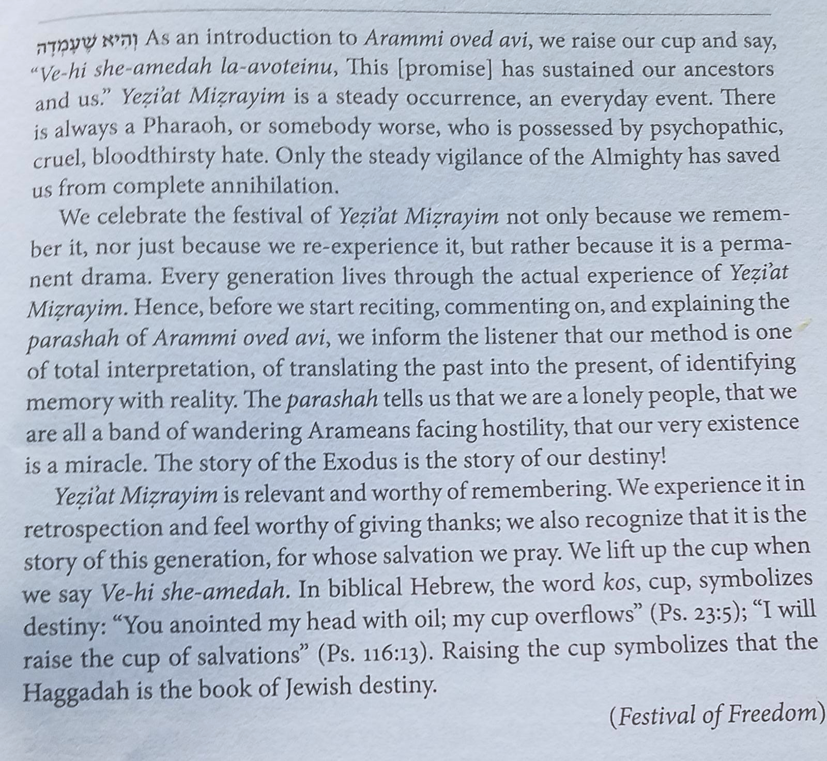
- Who is your favorite coach -college or pro? What are this coach’s special talents?
  - How was Hashem like your favorite Coach during יציאת מצרים?
הגדה מגיד: ארמי אבד אבי
'וָרָֽב – כְּמָה שֶׁנֶּאֱמַר: רְבָבָ֗ה כְּצֶ֤מַח הַשָּׂדֶה֙ נְתַתִּ֔יךְ וַתִּרְבִּי֙ וַֽתִּגְדְּלִ֔י וַתָּבֹ֖אִי בַּעֲדִ֣י עֲדָיִ֑ים שָׁדַ֤יִם נָכֹ֙נוּ֙ וּשְׂעָרֵ֣ךְ צִמֵּ֔חַ וְאַ֖תְּ עֵרֹ֥ם וְעֶרְיָֽה (יחזקאל ט"ז:ז'). וָאֶעֱבֹ֤ר עָלַ֙יִךְ֙ וָֽאֶרְאֵ֔ךְ מִתְבּוֹסֶ֖סֶת בְּדָמָ֑יִךְ וָאֹ֤מַר לָךְ֙ בְּדָמַ֣יִךְ חֲיִ֔י וָאֹ֥מַר לָ֖ךְ בְּדָמַ֥יִךְ חֲיִֽי (יחזקאל ט"ז:ו').
“And flourishing” – as it says, “I made you proliferate like the flora of the field and you flourished and matured and became charming; your breasts formed and your hair sprouted, and you were naked and bare” (Yechezkel 16:6). “And I passed over you and I saw you wallowing in your blood, and I said to you, ‘By your blood you shall live!’ and I said to you, ‘By your blood you shall live!’” (Yechezkel 16:6).
- If Hashem is hardening Pharoh’s heart, why not have the Jews go free after one Plague? Why go through all 10 plagues? Or soften his heart and let them go immediately?
וְאֵלוּ הֵן: דָּם, צְפַרְדֵּעַ, כִּנִּים, עָרוֹב, דֶּבֶר, שְׁחִין, בָּרָד, אַרְבֶּה, חשֶׁךְ, מַכַּת בְּכוֹרוֹת
הגדה מגיד: מתחילה:א'
מִתְּחִלָּה עוֹבְדֵי עֲבוֹדָה זָרָה הָיוּ אֲבוֹתֵינוּ, וְעַכְשָׁו קֵרְבָנוּ הַמָּקוֹם לַעֲבֹדָתוֹ.....
הגדה מגיד: ברוך שומר הבטחתו:ד'
וְגַ֧ם אֶת⁠־הַגּ֛וֹי אֲשֶׁ֥ר יַעֲבֹ֖דוּ דָּ֣ן אָנֹ֑כִי וְאַחֲרֵי⁠־כֵ֥ן יֵצְא֖וּ בִּרְכֻ֥שׁ גָּדֽוֹל

- Thinking of Vehi Sheamda: In what ways is Yahya Sinwar, the head of Hamas in Gaza a much more dangerous enemy than Pharoh?
וַיָּרֵ֧עוּ אֹתָ֛נוּ הַמִּצְרִ֖ים – כְּמָה שֶׁנֶּאֱמַר: הָבָה נִּתְחַכְמָה לוֹ פֶּן יִרְבֶּה וְהָיָה כִּי תִקְרֶאנָה מִלְחָמָה וְנוֹסַף גַּם הוּא עַל שׂנְאֵינוּ וְנִלְחַם בָּנוּ וְעָלָה מִן הָאָרֶץ
שמות ז':כ"ב
וַיַּעֲשׂוּ כֵן חַרְטֻמֵּי מִצְרַיִם בְּלָטֵיהֶם וַיֶּחֱזַק לֵב פַּרְעֹה וְלֹא שָׁמַע אֲלֵהֶם כַּאֲשֶׁר דִּבֶּר יְהֹוָה. (כב)
(כג) וַיִּפֶן פַּרְעֹה וַיָּבֹא אֶל בֵּיתוֹ וְלֹא שָׁת לִבּוֹ גַּם לָזֹאת

- The matza is a symbol of the Exodus. The reason is because the redemption came about suddenly, and without prior notice so that the Jews did not have enough time to allow the dough to rise. However, why didn't the Jews know that the redemption was imminent? Moshe told them in advance to prepare a sheep for the Korban Pesach and to sprinkle the blood and that God would pass over their houses and slay the first born of Egypt. They knew that the big night was coming, and freedom was at hand. Why didn't they have enough time to prepare normal, leavened bread? [Question from Rabbi Mann]
הגדה מגיד: רבן גמליאל:ג'
מַצָּה זוֹ שֶׁאָנוּ אוֹכְלִים, עַל שׁוּם מָה? עַל שׁוּם שֶׁלֹּא הִסְפִּיק בְּצֵקָם שֶׁל אֲבוֹתֵינוּ לְהַחְמִיץ עַד שֶׁנִּגְלָה עֲלֵיהֶם מֶלֶךְ מַלְכֵי הַמְּלָכִים, הַקָּדוֹשׁ בָּרוּךְ הוּא, וּגְאָלָם, שֶׁנֶּאֱמַר: וַיֹּאפ֨וּ אֶת⁠־הַבָּצֵ֜ק אֲשֶׁ֨ר הוֹצִ֧יאוּ מִמִּצְרַ֛יִם עֻגֹ֥ת מַצּ֖וֹת כִּ֣י לֹ֣א חָמֵ֑ץ כִּֽי⁠־גֹרְשׁ֣וּ מִמִּצְרַ֗יִם וְלֹ֤א יָֽכְלוּ֙ לְהִתְמַהְמֵ֔הַּ וְגַם⁠־צֵדָ֖ה לֹא⁠־עָשׂ֥וּ לָהֶֽם
- In each and every generation a person must see himself as if he had gone out of Egypt, as it says, “And you shall tell your son on that day saying, ‘On account of this God acted for me when I left Egypt.’” (Shemot 13:8). How is this possible to accomplish?
- How do the prohibition of chametz and the positive command to eat matzah relate to each other? Which takes precedence? Is the prohibition the main element and matzah simply a substitute for those who want to eat "bread"? Or is eating matzah the focus, while the prohibition of chametz serves only to highlight it? [Al-HaTorah.org]

