Rabbi Shlomo Riskin שליט"א
The Pure Joy of Yom Kippur
The Eva and Jakob Blank Yamim Noraim Lecture Series
“When I was growing up, these Holidays were really days of awe. They were scary. Then Rav Riskin introduced to me and my co-congregants that Yom Kippur was a day of opportunity and showed G-d’s love. That was a 180 degree turn.”
Joel Wachs a’h
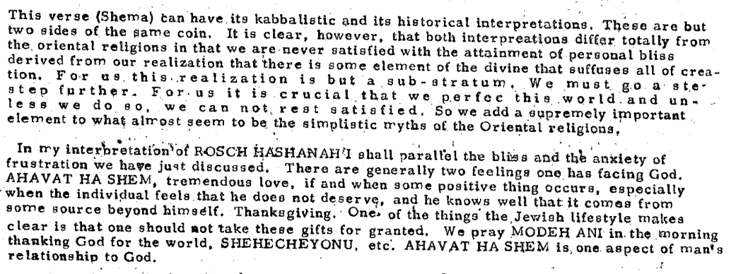
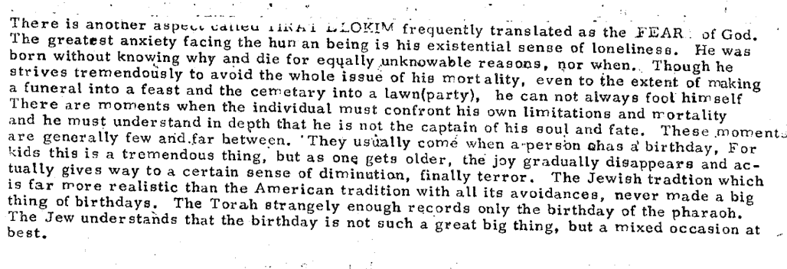
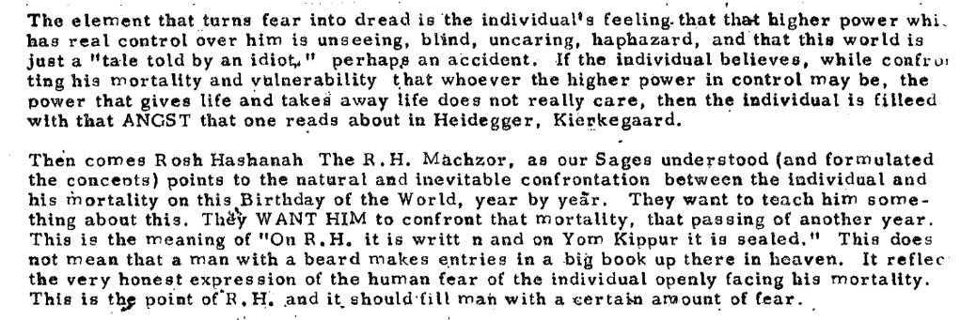
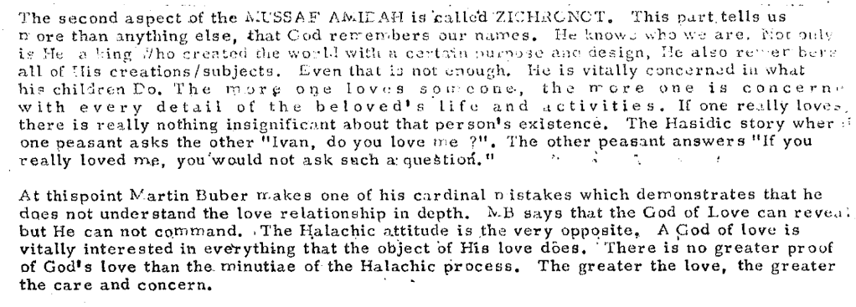
“Oriental Religion, Mysticism, The Musaf Amidah For Rosh Hashanah” - undated transcript, (late 1970s?) Found in LSS Archives.

Afflict Your Souls?
Yom Kippur, the Day of Atonement, is the great white fast of the Jewish Year. And since there are also additional prohibitions on that day – no sexual relations, no anointing the body with oils, no bathing and no wearing of leather shoes– one might assume that Yom Kippur is basically a day of awe and anxiety, of despair and dread – certainly not a day of joy and celebration.
However, the last Mishna of the Tractate Ta’anit declares that “there were no more joyous days for Israel than Yom Kippur and the Fifteenth Day of Av.” Furthermore, Yom Kippur, like all the other festivals of the Jewish calendar, has the power to cut short and even entirely cancel the mourning period of a mourner.
To explore this issue, we should first take a closer look at the word ‘v’initem’–usually translated as “you shall afflict”. In fact, the three letter root is anah (ayin, nun, heh) has two distinct meanings, virtually the opposite of each other. Early in Exodus, we read how the Egyptian taskmasters afflicted (same root) the Israelites [Ex. 1:11-12], and indeed the Hebrew word ‘oni’ means poverty.
However, several Biblical verses earlier in Parashat Ki Tavo, the same root word has nothing at all to do with affliction. We read about the commandment to bring the first fruits: “And you shall sing out [v’anitah] and say before the Lord your G d…” [Deut. 26:5] which our Sages interpret means to chant with a tune of cantillation. And it is apparently on this basis that our Sages differ as to the translation – and therefore the major characteristic – of the Passover matzah, Biblically referred to as lehem oni: there are those who take the words “bread of affliction”, and there are others who insist that it is the “bread over which many words are sung”.
I would even like to suggest an alternative meaning, which is entirely positive. V’initem need not mean you shall ‘afflict’ your souls; it can also be translated :’ You shall enable your souls to sing, to rejoice.’ You shall free your souls, allow your souls to be rid of all of the usual bodily needs, constraints and desires and dedicate a 25 hour period to the spirit and the Divine. Indeed, Maimonides codifies the laws of Yom Kippur as enabling our bodies to rest (lishbot) from food, drink and sex – not in the sense of prohibition but rather in the sense of re-creation and repair (Laws of Shvitat HaAsor 1,12). Within the comforting embrace of a G-d of love and forgiveness on Yom Kippur, my bodily needs becomes of almost no account as my soul takes over my personality and my person – my soul which soars, my soul which sings. On this Sabbath of Sabbaths I feel the eternity of the world of the spirit and this joy is greater than any other.

Therefore in the context of Yom Kippur, the ‘v’initem et nafshotaichem’ doesn’t have to mean, ‘You shall afflict your souls.’ As we’ve been demonstrating, one possible understanding is that it’s a combination word. On the one hand it’s the Tenth Day of Repentance, and I can’t mask over the fact that I’ve looked deeply into my soul over these last few days, I’ve exposed my weaknesses and shortcomings, and that causes me to weep with anxiety and dread lest I be found wanting on the Day of Judgment. But Yom Kippur is also the Day of Atonement, when all sincere penitents are guaranteed absolution, the possibility of starting a new slate, “standing pure before the Divine”. It’s this most comforting element of Yom Kippur that allows me to rejoice during the Festival of Forgiveness.
I would even like to suggest an alternative meaning, which is entirely positive. V’initem need not mean you shall ‘afflict’ your souls; it can also be translated :’ You shall enable your souls to sing, to rejoice.’ You shall free your souls, allow your souls to be rid of all of the usual bodily needs, constraints and desires and dedicate a 25 hour period to the spirit and the Divine. Indeed, Maimonides codifies the laws of Yom Kippur as enabling our bodies to rest (lishbot) from food, drink and sex – not in the sense of prohibition but rather in the sense of re-creation and repair (Laws of Shvitat HaAsor 1,12). Within the comforting embrace of a G-d of love and forgiveness on Yom Kippur, my bodily needs becomes of almost no account as my soul takes over my personality and my person – my soul which soars, my soul which sings. On this Sabbath of Sabbaths I feel the eternity of the world of the spirit and this joy is greater than any other.

Experiencing Death
God is also teaching that He is willing to overlook the evil Assyria has committed if she will indeed repent.Jonah refuses to accept this. He is after all the son of Amitai, a name which is derived from emet, truth. Truth, as Jonah understands it, demands that evil never be overlooked; evil must be punished. This is how Jonah explains why he refused God’s mission: “...This is why I hastened to flee to Tarshish; I knew that you are a gracious and merciful God, slow to anger, abundant in loving- kindness and forgiving of evil” (Jonah 4:2). This is not the God in whom I want to believe, the God who described Himself earlier to Moses as the God who is “abundant in loving kindness and truth” (Exodus 34:6).Jonah has forgotten that his first name means dove, and that just as the dove was saved from the flood so was he, Jonah, undeservedly saved from the raging waters. God is teaching him that the God of compassion will bestow His life-giving purity even upon those who have sinned.On Yom Kippur, each of us descends into the “waters of death.” We wear white, reminiscent of shrouds, we remove ourselves from all physical necessities and pleasures such as food, drink and sex, and we wear the non-leather shoes of the mourner. For whom are we mourning? We’re mourning for ourselves, for our own deaths due to our sins.However, God in his compassion returns us to life on Yom Kippur, reborn and purified. God sprinkles upon us His life-giving waters “because on this day you shall be forgiven of all your sins; before God shall you stand pure.”All of us experience the death and the rebirth of Jonah.

PEAK JUDAISM

Yom Kippur demonstrates the very essence of Judaism, a vision of the world with law and love held in balance. Certainly our Day of Atonement is a day of laws and demands - fasting for 25 hours, no leather shoes, no sexual relations, total abstinence from the physical world as Jews give their total selves over to God for a day. Yom Kippur sends out two messages: love and forgiveness side by side with laws and commandments.

The most universal love relationship is the parent-child one. A better understanding of the Jewish concept of our relationship to God, the Creator of us all, can come from a better understanding of how the parent-child relationship works.

Such diverse figures as Rabbi Joseph B. Soloveichik, in classes and lectures, and Erich Fromm (who studied Talmud from a private tutor during his years at the University of Heidelberg) in The Art of Loving, have isolated the same dynamics in the parent-child relationship: two typologies, the dynamic of father love and the dynamic of mother love.

Implicit in this dichotomy is the legacy a child must receive from its parents: love and limits, unconditional love and consistent requirements. If a child grows up in a home which never makes demands on him, his parents anticipating and providing his every need, the child will
end up a spoiled egoist who believes everything is coming to him.

The other side of this coin is a sense of inadequacy. The child will begin to believe that everything is being done for him because he is incapable of doing it himself. This causes a lack of self-respect, a feeling of impotence. The results? A person unable to do anything
for himself, or even make an independent decision.

At the heart of Yom Kippur is the most complete expression of the father-mother forces of God toward us, the balanced mixture of love and law. Yom Kippur takes us to the limit; in terms of law it asks the maximum. There is no other day in the Jewish year quite as intense and
demanding.

But in terms of love, it also gives the maximum. God's right hand is always extended to accept the penitent. Ideally, the Jews should purify themselves, but if not, God Himself will pour the waters of purification. Can there be a greater joy than the knowledge of Divine forgiveness
and purification?

The Essence of The Day
וַיֹּאמַ֑ר הַרְאֵ֥נִי נָ֖א אֶת־כְּבֹדֶֽךָ׃
He said, “Oh, let me behold Your Presence!”
וַיֵּ֤רֶד ה' בֶּֽעָנָ֔ן וַיִּתְיַצֵּ֥ב עִמּ֖וֹ שָׁ֑ם וַיִּקְרָ֥א בְשֵׁ֖ם ה׃
וַיַּעֲבֹ֨ר ה ׀ עַל־פָּנָיו֮ וַיִּקְרָא֒ ה ׀ ה אֵ֥-ל רַח֖וּם וְחַנּ֑וּן אֶ֥רֶךְ אַפַּ֖יִם וְרַב־חֶ֥סֶד וֶאֱמֶֽת׃
נֹצֵ֥ר חֶ֙סֶד֙ לָאֲלָפִ֔ים נֹשֵׂ֥א עָוֺ֛ן וָפֶ֖שַׁע וְחַטָּאָ֑ה וְנַקֵּה֙ לֹ֣א יְנַקֶּ֔ה פֹּקֵ֣ד ׀ עֲוֺ֣ן אָב֗וֹת עַל־בָּנִים֙ וְעַל־בְּנֵ֣י בָנִ֔ים עַל־שִׁלֵּשִׁ֖ים וְעַל־רִבֵּעִֽים׃

And the Lord descended in the cloud, and stood with him there, and proclaimed the name of the Lord.
And the Lord passed by before him, and proclaimed, The Lord, The Lord, mighty, merciful and gracious, longsuffering, and abundant in love and truth,

I understand you may accept my arguments and therefore not destroy the nation
this time but is there a path to Teshuva? You know the Book of Genesis talks a great deal about sin and punishment and punishment is generally Midah Kneged Midah -measure for measure, built into society. According to the book of Berishit there's no real case of any individual saying i'm sorry and seeking Teshuva not in Genesis it's implied by some of the meforshim, but it's not in the pshat.

Moses here says to the jewish people you've sinned great sins, maybe I can seek absolution forgiveness for your sins. Moses wants to know from God is there forgiveness what kind of G-d are you?

And then moses wants to know from God you have to tell me your ways you have to tell me your traits - you have to tell me the things that define you as far as we can understand you in order that we may know how we must act in order to please you it's not enough for you to merely tell us do this and don't do this you have to tell us a little what are you like on the inside G-d?
Are you unforgiving or forgiving are you strength or are you merciful we have to know more so we can know more about how we must be…

And I even wanted to leave the Yeshiva and then this great Sage, shorter than I was, greatly respected by the entire world and always greeting even the youngest child, appeared out of nowhere and invited me to his home. Gently guided me holding my hand; both entered a two roomed hovel, the living room having not one piece of furniture that was whole. My hand was still in his, looked into my eyes and said but one word: ‘Shabbos!’ He then began to weep and if I live until 120 I will never stop feeling this scolding heat of these tears as they rested on my hand. He embraced me once again, repeated the word ‘Shabbos’ and took me to the door. At that moment I felt deeply in my soul that there was nothing more important than the Sabbath and this great Jew loved me and that I wished to be ordained by him….”

That's what Yom Kippur is. God comes down to us, G-d sits next to us and God leads us. And God changes us from the inside he takes us into his house in effect, He says to us no eating no drinking no sexual relations remove your shoes because you're standing in holy ground….
You are able to feel that you're in G-d's presence and that's what Yom Kippur is that's its magic 25 hours, you are together with God not physicality only spirituality.

Teshuva Lecture 2012

אֶת זוֹ דָּרַשׁ רַבִּי אֶלְעָזָר בֶּן עֲזַרְיָה, מִכֹּל חַטֹּאתֵיכֶם לִפְנֵי יְ-יָ תִּטְהָרוּ (ויקרא טז), עֲבֵרוֹת שֶׁבֵּין אָדָם לַמָּקוֹם, יוֹם הַכִּפּוּרִים מְכַפֵּר. עֲבֵרוֹת שֶׁבֵּין אָדָם לַחֲבֵרוֹ, אֵין יוֹם הַכִּפּוּרִים מְכַפֵּר, עַד שֶׁיְּרַצֶּה אֶת חֲבֵרוֹ. אָמַר רַבִּי עֲקִיבָא, אַשְׁרֵיכֶם יִשְׂרָאֵל, לִפְנֵי מִי אַתֶּם מִטַּהֲרִין, וּמִי מְטַהֵר אֶתְכֶם, אֲבִיכֶם שֶׁבַּשָּׁמַיִם, שֶׁנֶּאֱמַר (יחזקאל לו), וְזָרַקְתִּי עֲלֵיכֶם מַיִם טְהוֹרִים וּטְהַרְתֶּם. וְאוֹמֵר (ירמיה יז), מִקְוֵה יִשְׂרָאֵל יְ-יָ, מַה מִּקְוֶה מְטַהֵר אֶת הַטְּמֵאִים, אַף הַקָּדוֹשׁ בָּרוּךְ הוּא מְטַהֵר אֶת יִשְׂרָאֵל:

This was expounded by Rabbi Elazar b. Azariah: “From all your sins before the Lord you shall be clean” (Leviticus 16:30) for transgressions between man and God Yom HaKippurim effects atonement, but for transgressions between man and his fellow Yom HaKippurim does not effect atonement, until he has pacified his fellow. Rabbi Akiva said: Happy are you, Israel! Who is it before whom you become pure? And who is it that purifies you? Your Father who is in heaven, as it is said: “And I will sprinkle clean water upon you and you shall be clean” (Ezekiel 36:25). And it further says: “O hope (mikveh) of Israel, O Lord” (Jeremiah 17:13--just as a mikveh purifies the unclean, so too does he Holy One, blessed be He, purify Israel.

Neilah - Not The End

During the periods of our national sovereignty, with the closing of the day, the holy Temple doors would close as well. Post Temple, with the setting sun, the very heavens, the pathway to the Divine Throne, and the gateway to God seems to be closing. “Don’t lock me out” says the Jew during Ne’ilah. Don’t close the doors or the gates in my face as long as there is still time, let me come in.
But there is another way of looking at this, a very opposite way. “Don’t lock me in!” cries the Jew during Ne’ilah. Yes, I’ve been in the Temple, or I’ve been in the synagogue almost the entire day. I’ve truly felt God’s presence and I’ve truly been warmed by His loving embrace. I feel God’s divine and gracious acceptance and His total forgiveness. I’ve spent an entire twenty-five hours in His house, in which I’ve seen the sweetness of the Lord and visited in His tent.
But now, as the doors to His house are closing, I don’t want to be locked in. After all, I began this penitential period with Rosh Hashanah, the day of God’s kingship. The prayers on Rosh Hashanah taught me that God did not choose Israel to live with Him in splendid and glorious isolation; He chose Israel to be a “kingdom of priest-teachers and a holy nation” to bring the message of compassionate righteousness and moral justice as a blessing for all the families of the earth. We are meant to be a light unto the nations, a banner for all peoples.

