“Vi Elult’zich?”
Perspectives and Approaches to the month of Elul

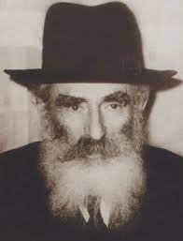
Rav Yechezkel Levenstein ztl.
התעוררות: “Head First”:The Mir/Ponovezh approach to Elul

- Siach Yitzchak Chagim U’Zmanim (Vol. 1 Rav Bordianski)

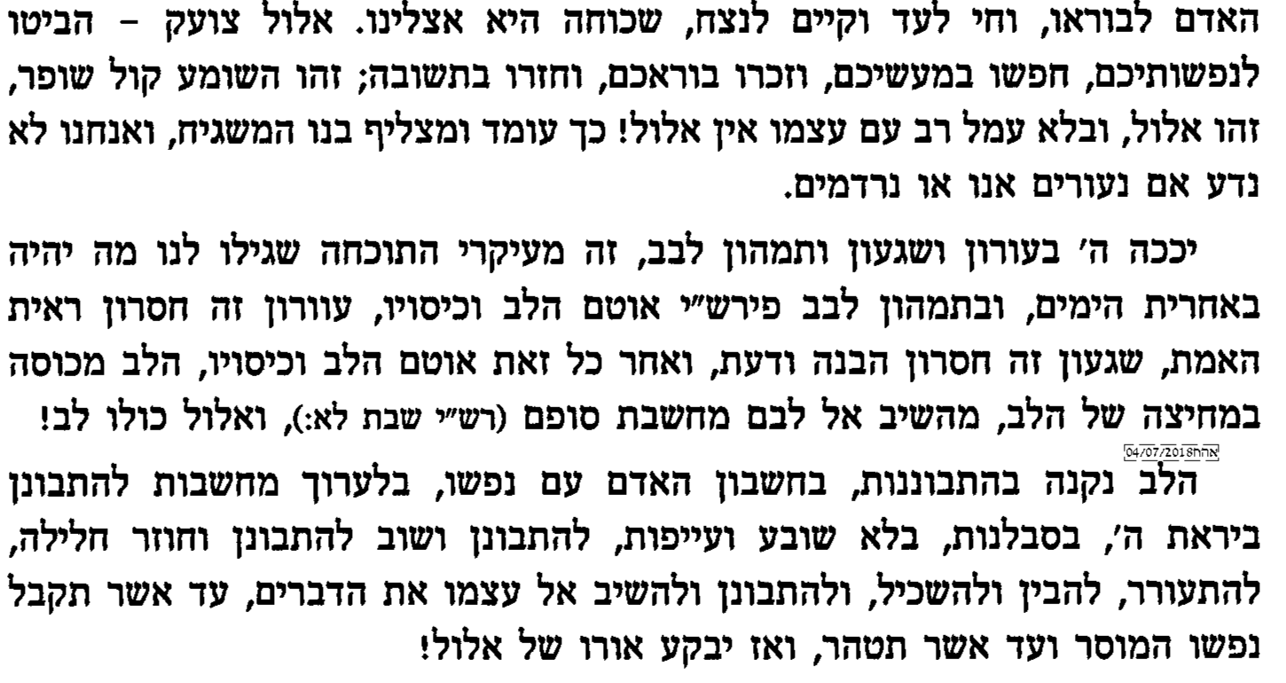
- One of the curses of the Tochacha is the covering of the heart. The heart is acquired through contemplation and not exhaustion.

1a) Or Yechezkel Elul
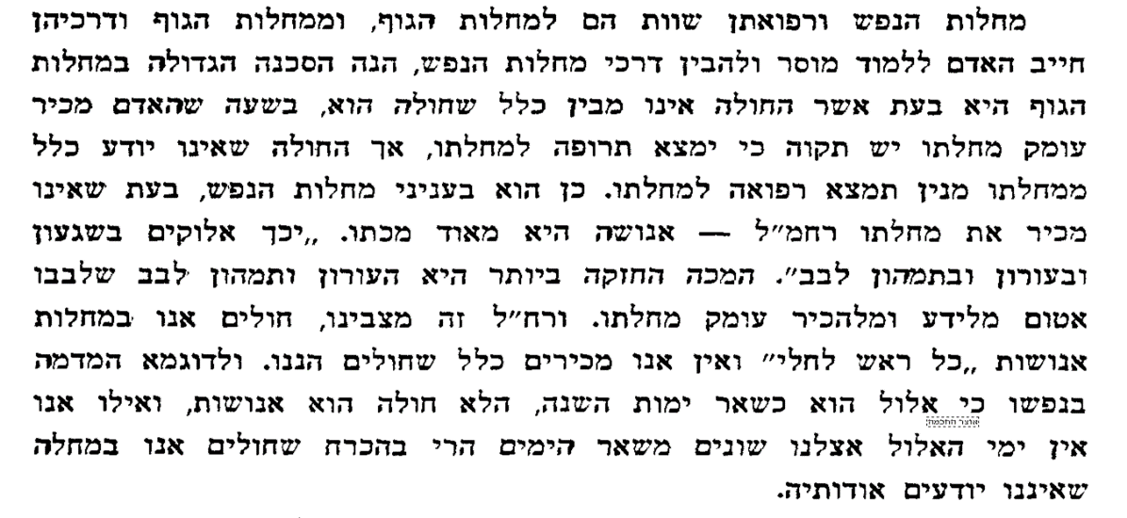
- As with physical Illness, awareness precedes diagnosis and proper treatment. We treat Elul too liberally – too much Hergel.
- (And consider what this meant – when Elul was in Shanghai Ghetto 1943 and the Mirrer Bochurim were starving and could not move and Rav Chatzkel ztl. saw them starving and still insisted that now was the time for working on spiritual growth. )

1b) Or Yechezkel Michtavim p. 65

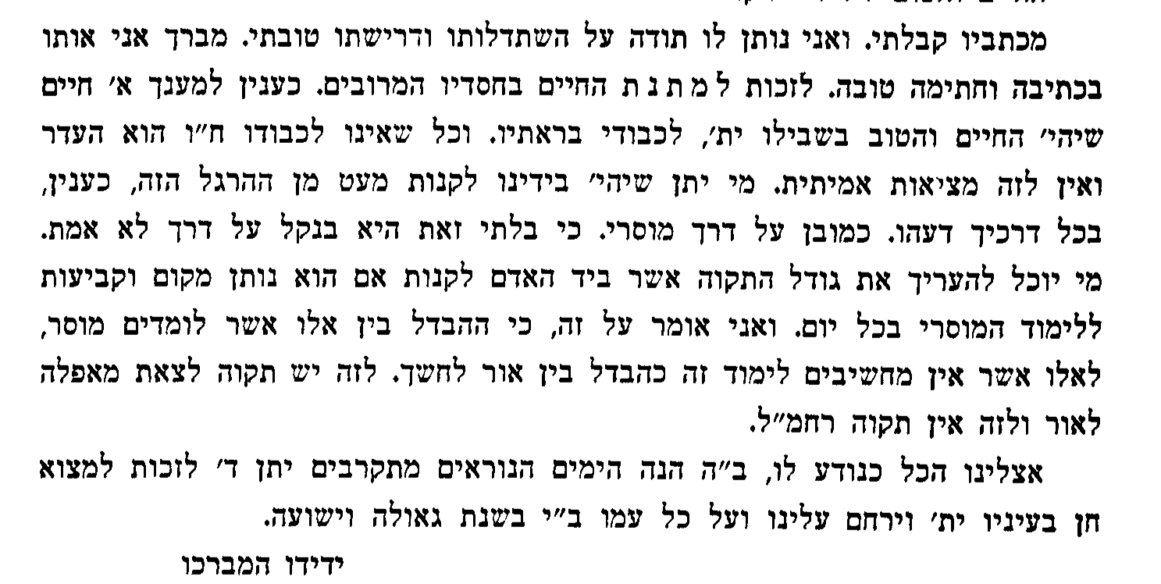
- We need a different Hergel – one where we see Hashem everywhere! (See his life and times—and he thought the Mirrer were lacking?!)

II. Regesh & Hergesh are opposites

- Or Yechezkel, Elul
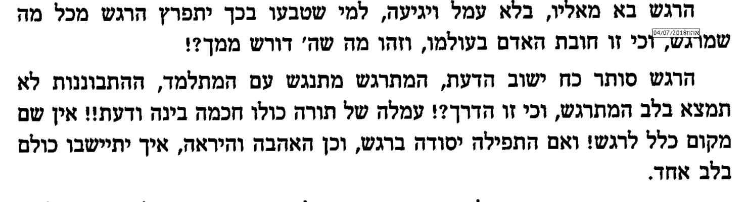
- Regesh is automatic and not good alone. Elul is head first

2a) Ibid

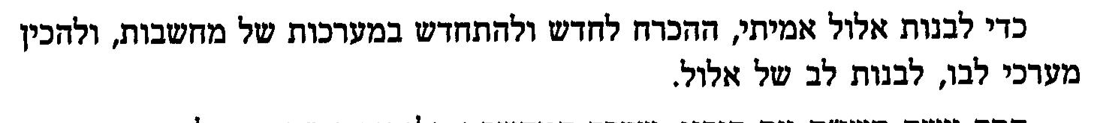
- Elul is built on renewed thought.

2b) Ibid

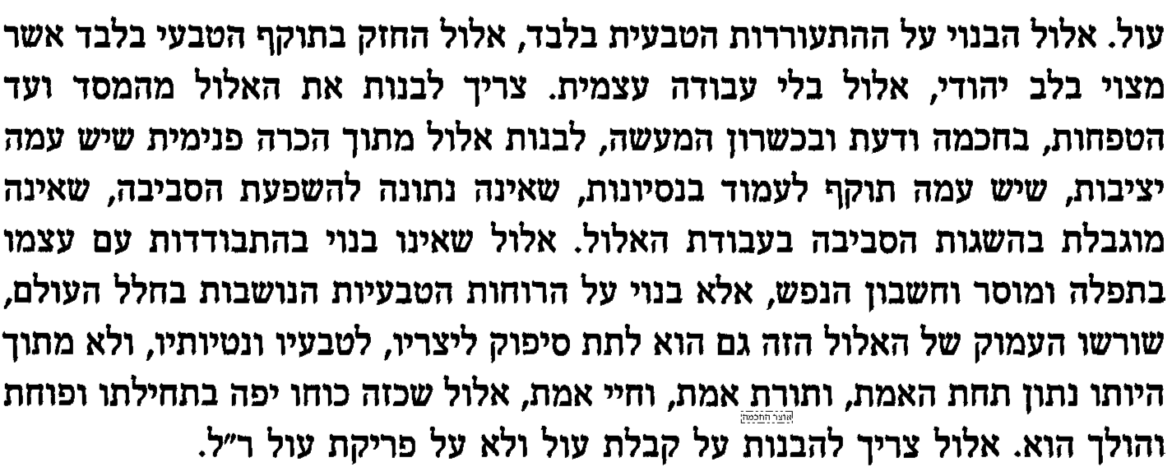
- Elul needs internal inspiration from contemplation not external fear

2c) Siach Yitzchak Chagim U’Zmanim (Vol. I Rav Bordianski)

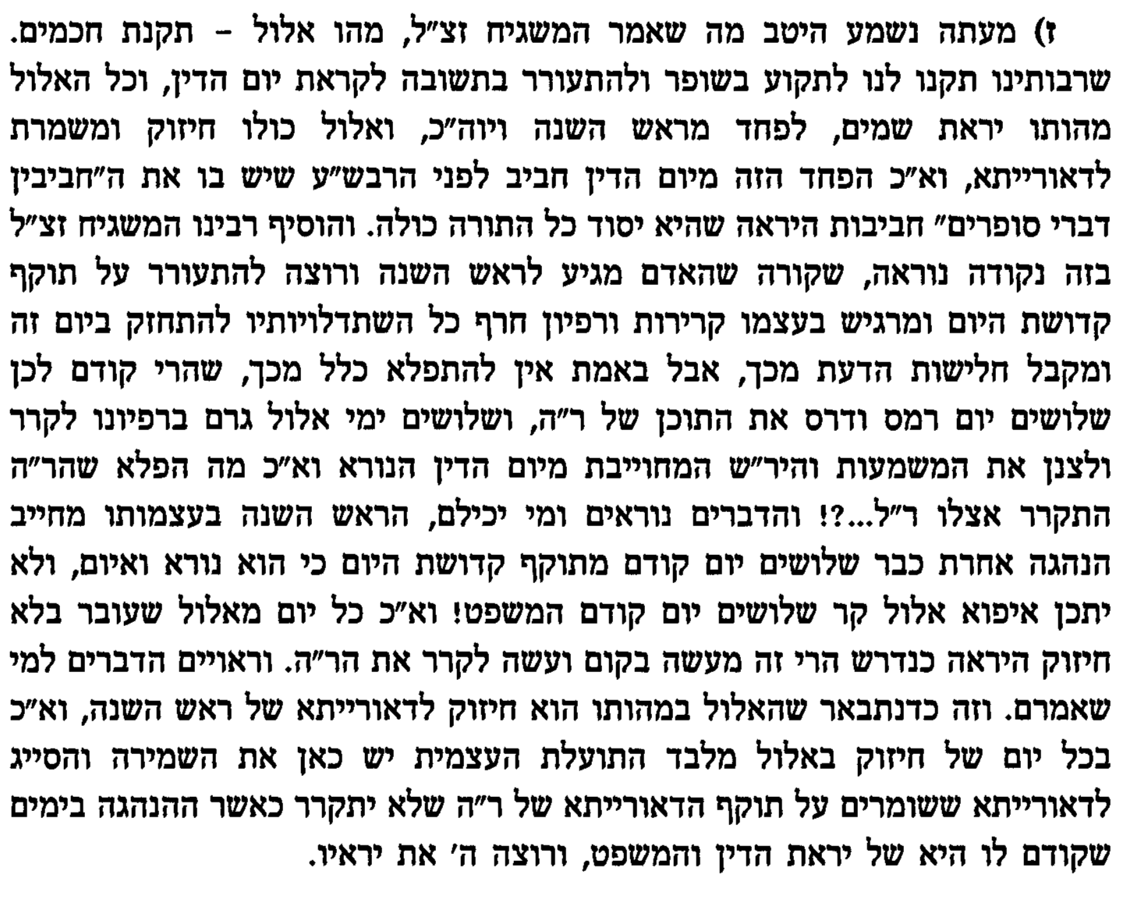
III. Where and how do we do the work?

- Or Yechezkel Michtavim p. 177
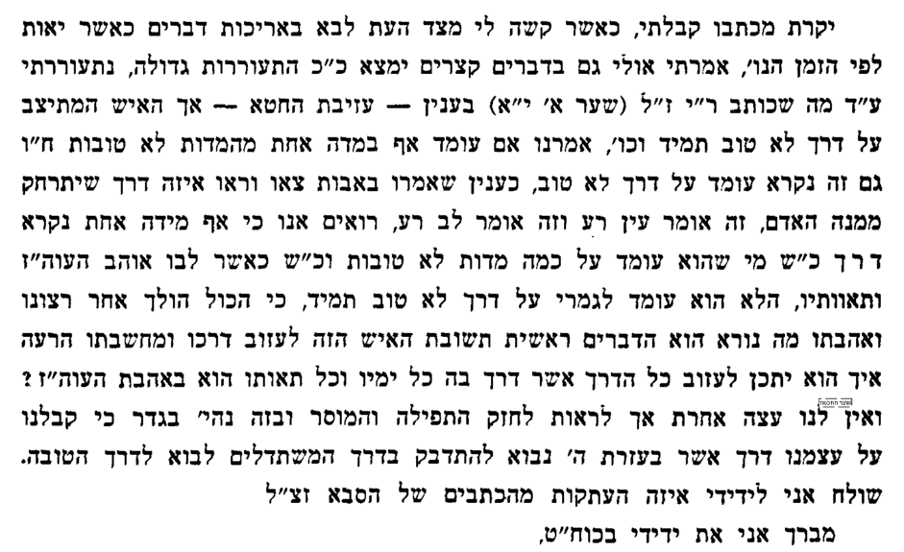
- Think “Sur M’Ra” Not just “Added Aseh Tov”

3a) Or Yechezkel Michtavim p. 233

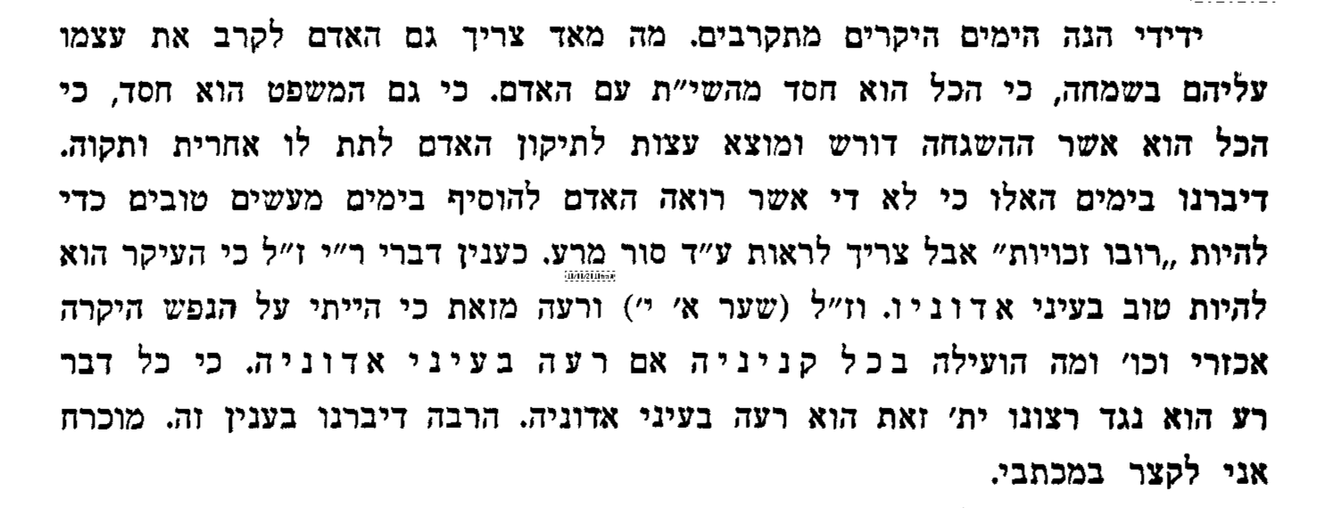
- Just adding onto a bad situation is dead weight.

- Or Yechezkel Elul
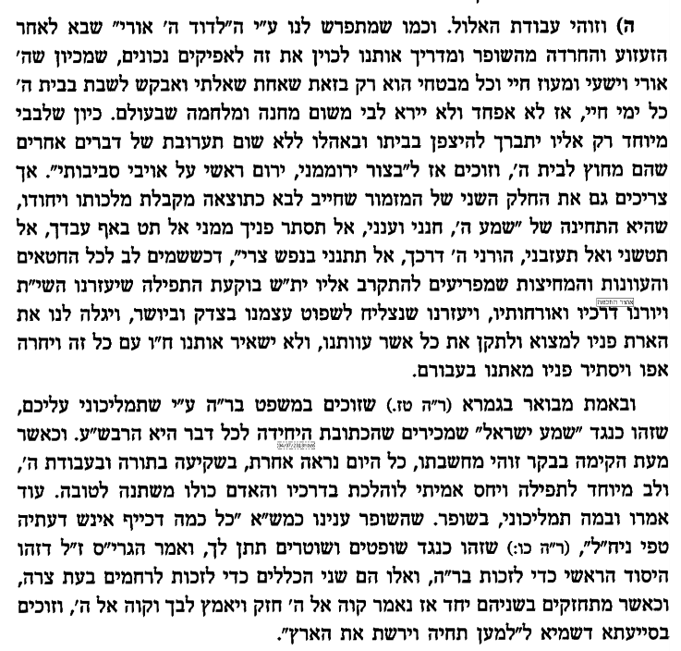
- The Shofar and the L’Dovid all remind us that we want to be B’Beis HaShem. That’s what it is all about

Literally translated as “How’s it Eluling?”- a reference to a mussar style utilized in Europe to refer to how one was doing with his/her preparations for the Yamim Noraim season. I thank Rabbi Henoch Plotkin for referencing the title.
The goal of this short series is to identify different approaches of the different Torah communities to the month of Elul.

